****2016 Census: Families, households and marital status; Language****

**Date Prepared:** August 3, 2017 (Revised September 14, 2017)

The 2016 Census was held on May 10, 2016. On August 2, 2017, Statistics Canada released data from the 2016 Census of Population on families, households and marital status, and on language.

On August 31, 2017, Statistics Canada released a revision to the language data that had been released. The data correction primarily affected French language speakers, and this backgrounder has been revised to reflect the updated data.

Key Points

* The number of families and households continues to grow in Toronto, but the City's proportion in the Greater Toronto Area continues to decline slightly.
* Common-law couples are the family type that has grown the fastest since the last Census. The percentage of couples with children continues to drop. This trend is seen across the City and the Greater Toronto Area. Over the past two decades, the number of married couples has remained stable in Toronto, while increasing significantly in the rest of the GTA.
* More people are living on their own. One-person households continue to increase.
* Multigenerational households (those with at least three generations of the same family) have seen significant increases in most areas of the GTHA with the exception of Toronto.
* Toronto continues to be a mosaic of languages. According to the 2016 Census, 43.9% of Toronto residents had a mother tongue other than English or French.
* Just over one half of all Toronto residents reported English as their mother tongue. An additional 3.4% of Toronto residents identified English and a non-official language as their multiple mother tongues.

Families, Households and Marital Status

## Families

* In 2016 there were 718,755 census families in Toronto (up 28,415 or 4.1% from 2011) and 1,767,145 in the Greater Toronto Area (GTA) – up 101,945 (or 6.1%) over 2011. Toronto housed 40.7% of the GTA total, but the City's proportion continues to decline slightly, from 44.0% in 2006 and 41.5% in 2011.
* Family structure continues to change. Since 2011, the number of common-law couples in Toronto increased by 21.6%, lone-parent families by 3.8%, whereas married couples showed a slight increase of 1.6%. The number of lone-parent families in the rest of the GTA, which had surpassed the total in the City of Toronto in 2011, continued to grow at a faster rate of 10.9%.
* Within Toronto, the largest concentrations of lone-parent families can be found in the Jane-Weston corridor in the city's northwest and in mid-Scarborough (see Map 1).
* The number of couple families with children in Toronto reversed the trend of decline seen in the past decade and grew slightly, at a rate of 1.4% since 2011, reaching a total of 316,070. However, because the number of couples without children grew at a faster rate (8.0%), the percentage of couples with children continued to drop. In Toronto in 2016, 55.8% of couples had children, down from 57.4% in 2011. In the rest of the GTA, the percentage of couple families with children also followed this downward trend, falling to 64.9% from 66.0% in 2011.
* Couples without children grew by 8.0% in Toronto and 10.5% in the rest of the GTA between 2011 and 2016. In the GTA outside of Toronto, most of the growth in the number of census families without children has been due to an increase in seniors 65 and older. Within Toronto, the increase in childless couples corresponds to an increase not only in seniors but also to an increase in the working age population (25-44 year olds).

## Households

* In 2016, the number of Toronto households stood at 1,112,930 growing 6.2% since 2011.
* Toronto households consist of 38.5% non-family households, 58.7 % single-family households and 2.8% multiple-family households. Since 2011, non-family households increased by 9.5%, single-family households increased by 4.4% while multiple-family households grew by 1.5%.
* As a percentage of all GTHA households, the highest proportion of non-family households is in Toronto (58.7%) while the highest proportion of single-family (61.6%) and multiple-family (69.2%) households are in the rest of the GTHA. The multiple-family household type was the fastest growing type of household across the GTHA over the past five years.
* In 2016, the number of one-person households in Toronto was 359,960 and the number of two-person non-family households was 68,010 which represented 58% of all one-person households and 65% of all two-person non-family households in the GTHA.
* In 2016, one quarter of all one-person households in Toronto were located in the Downtown and Centres. As can be seen in Map 3, the largest concentration of one- person households is in the Downtown, but can also be found in other areas of the City. (e.g., Liberty Village, Sheppard corridor east, Etobicoke Mimico area).
* The number of one-person households in Toronto grew by 28,780 (8.7%) between 2011 and 2016. Toronto's share of the increase in one-person households represented 52% of the growth in this household type across the GTHA.
* The number of two-person non-family households also grew more in Toronto than in the rest of the GTHA combined between 2011 and 2016. Toronto's share of the increase in two-person non-family households represented 72% of the growth in this household type across the GTHA.
* Multigenerational households (those with at least three generations of the same family) have seen significant increases in most areas of the GTHA while Toronto has seen a marginal increase since 2011. In Toronto, multigenerational households represent only 3.7% of all households. Between 2011 and 2016, the share of multigenerational households in Toronto dropped from 3.9% whereas all other GTHA regions saw increases in this household type.

## Marital status

* Toronto is home to 481,125 married couples, 85,030 common-law couples, and 152,600 lone-parent families. Over the past two decades, the number of married individuals had remained stable in Toronto, while increasing significantly in the rest of the GTA. This trend continued but at a slower pace in 2016, with couple families in Toronto increasing at 1.6%, compared to 6.6% for the rest of the GTA.
* From 2011 to 2016 in Toronto, the number of legally married people age 15 and older increased by 19,485 (or 2.0%), while the number of people living in common law relationships increased by 30,095 (or 21.5%).
* Toronto's number of single (and never married) people rose by 60,080 (up 8.1%). The number of divorced people also rose by a similar percentage, 8.4% (or 11,760 people). The number of separated and widowed people in Toronto dropped between 2011 and 2016, by 885 (-1.3%) for separated, and by 1,285 (-1.0%) for widowed people.
* Data about same-sex couples was released only at the Census Metropolitan Area (CMA) level. In the Toronto CMA in 2016, there were 9,750 same-sex married spouses and 16,675 same-sex common-law partners. This comprises 20.0% of all same-sex married spouses in Canada and 17.2% of all same-sex common-law partners in Canada, while the Toronto CMA population as a whole comprises 16.9% of the population of Canada.

## Family characteristics of children aged 0 to 14

* Children under the age of 15 in Toronto live in a variety of family settings. The 2016 Census identified 396,880 children under the age of 15 in Toronto. The majority of these children (73.5%) live in families where they are the biological or adopted child of both partners in a couple family. A further 3.3% live in a family with one biological or adoptive parent and one step-parent. Nearly a quarter, 22.2%, of children in Toronto live in a lone parent family. Of those, 88.5% (78,055 children) live with a female lone parent. Additionally, 1,360 (0.3%) children live with their grandparents without a parent present ("skip generation families"), and 2,105 (0.5%) live in other "non-census family" arrangements, such as, with other relatives, or foster families.
* A larger proportion of children in Toronto live in lone parent families than in other regions of the GTA. The 22.2% in Toronto is higher than the rest of the GTA municipalities, with Durham the next closest at 19.1%, followed by Peel at 16.4%, and York and Halton much lower at 12.2% and 11.8% respectively.
* Older children (age 10 to 14) in Toronto were more likely to be living in a lone parent family (26.3%), and less likely to be living with two biological or adoptive parents (67.8%). This trend is typical and not specific to Toronto.

## Family characteristics of young adults (aged 20 to 34)

* In Toronto, just over one third of single young adults aged 20 to 34 (34.3% or 222,655 people) were living within their parents' household. This proportion is almost unchanged from 2011, when 34.6% of single young adults lived with their parents. This rate is lower than the province of Ontario (39.5%), as well as the other GTA municipalities (52.3%), especially Peel Region (53.5%) and York Region (58.6%). With the City of Toronto, more young adults living with parents in the suburban areas of the city, with much lower rates of adults living at home in the downtown and centres (see Map 2).

## Family characteristics of older adults (aged 65 and older)

* There were 107,215 adults age 65 and over living alone in private households in Toronto in 2016, an increase of 12.6% over the 2011 Census. This translates into 26.7% of the population age 65 and older, which is a very slight 0.1% decrease from the 2011 of 26.8%.
* Toronto continues to have the highest share of people age 65+ living alone in the GTA (26.7% in Toronto, versus 16.4% in the rest of the GTA). However, at 26.6%, Hamilton has a comparable share of people aged 65 and over living alone.

Language

## Knowledge of Official Languages

* 4.9% of Torontonians had no knowledge of either official language, down slightly from 5.3% in 2011. Within the city, there is a high concentration of people with no knowledge of either official languages in north-west Scarborough (north of the 401 expressway, west of Markham Rd, east of the Don Valley and south of Steeles). This area is one of the City's traditional immigrant reception areas. Other smaller pockets can be found in the downtown such as Regent Park area; North York centre; and north Etobicoke (see Map 4).

## Mother Tongue

* Toronto continues to be a mosaic of languages. According to the 2016 Census, 43.9% of Toronto residents had a mother tongue other than English or French. This represents a decrease from the 2011 figure of 44.6%.
* The City of Toronto, York Region, and Peel Region have the highest proportion of non-official mother tongues in the Greater Toronto and Hamilton Area. Statistics Canada has identified over 140 mother tongues in the Toronto Census Metropolitan Area. This is a conservative estimate given the exclusion of some languages and dialects that are suppressed due to sampling purposes.
* Just over one half of all Toronto residents (50.9%) reported English as their mother tongue. An additional 3.4% of Toronto residents identified English and a non-official language as their multiple mother tongues.

## Languages spoken regularly at home (Home Language)

* 25.9% of people in Toronto regularly spoke a language other than English or French at home (down from the 2011 figure of 28.3%).
* 245,950 people, or 9.1% of Toronto residents reported regularly speaking multiple languages at home, up from 7.1% in 2011
* There are notable shifts among the number of speakers of Toronto's most spoken home languages. French saw an increase of 26% in speakers at home, despite only an 8% increase in native tongue French speakers. Losses in Tamil and Italian native speakers were accompanied by even larger drops in the number using these languages as their primary home language.
* Mandarin, Cantonese, Tagalog, Tamil, and Spanish were the top non-English languages spoken at home.

GLOSSARY

* Statistics Canada maintains a [Census Dictionary](http://www12.statcan.gc.ca/census-recensement/2016/ref/dict/index-eng.cfm) for the Census of Population, 2016, available online at: <http://www12.statcan.gc.ca/census-recensement/2016/ref/dict/index-eng.cfm>. Many more terms associated with the Census can be found there.
* **Age:** T**he age of a person on the day of the Census, May 10, 2016.**
* **Census family: is any of (1) a married couple and the children, if any, of either and/or both spouses; (2) a couple living common law and the children, if any, of either and/or both partners; or (3) a lone parent of any marital status with at least one child living in the same dwelling and that child or those children. All members of a particular census family live in the same dwelling. A couple may be of opposite or same sex. Children may be children by birth, marriage, common-law union or adoption regardless of their age or marital status as long as they live in the dwelling and do not have their own married spouse, common-law partner or child living in the dwelling. Grandchildren living with their grandparent(s) but with no parents present also constitute a census family.**
* **Census Metropolitan Area (CMA):** one or more adjacent municipalities centred on a core population centre. To be included in a CMA, the adjacent municipalities must have a high degree of integration with the core. Integration is measured by commuting flows.
* **Census Tract (CT):** a small, geographic area, typically with a population smaller than 10,000 persons. Their geography is relatively stable over time to allow for comparison of changes from Census to Census.
* **Centre:** as seen in the attached Maps, Centres are defined in the City of Toronto Official Plan. They play an important role in how the City manages growth. The Scarborough, North York, Etobicoke and Yonge-Eglinton Centres are places with excellent transit accessibility where jobs, housing and services will be concentrated in dynamic mixed use settings with different levels of activity and intensity. More information can be found in the [Toronto Official Plan](http://www1.toronto.ca/wps/portal/contentonly?vgnextoid=03eda07443f36410VgnVCM10000071d60f89RCRD).
* **Economic family: a broader definition of family than the census family concept, meaning a group of two or more persons who live in the same dwelling and are related to each other by blood, marriage, common-law union, adoption or a foster relationship. A couple may be of opposite or same sex. By definition, all persons who are members of a census family are also members of an economic family. Examples of the broader concept of economic family include: two co-resident census families who are related to one another are considered one economic family; co-resident siblings who are not members of a census family are considered as one economic family; and, nieces or nephews living with aunts or uncles are considered one economic family.**
* **GTA refers to the** Greater Toronto Area. This area is comprised of the single-tier municipality of Toronto, the regional municipalities of York, Durham, Peel, and Halton, and the cities and towns within the GTA regional municipalities. This is not the same geography as the Toronto Census Metropolitan Area as defined by Statistics Canada.
* **GTHA refers to the** Greater Toronto and Hamilton Area. This area is comprised of the single-tier municipalities of Toronto and Hamilton, the regional municipalities of York, Durham, Peel, and Halton, and the cities and towns within the GTHA regional municipalities. This is not the same geography as the Toronto Census Metropolitan Area as defined by Statistics Canada.
* **Home language**: Language spoken most often at home or on a regular basis at home**.**
* **Household**: refers to the division of living arrangements into census family and non-family households. **Family household** refers to a household that contains at least one census family. **One-family household** refers to a single census family (with or without other persons) that occupies a private dwelling. **Multiple-family household** refers to a household in which two or more census families (with or without additional persons) occupy the same private dwelling. Family households may also be divided based on the presence of persons not in a census family. **Non-family household** refers to either one person living alone in a private dwelling or to a group of two or more people who share a private dwelling, but who do not constitute a census family. **Multigenerational household** refers to a household with three or more generations. These households have at least one person who is the grandparent and the parent of someone in the household
* **Mother tongue:** First language learned at home in childhood and still understood at the time of the Census**.**
* **Undercoverage**: is the number of persons excluded by the Census who should have been counted, as determined by Statistics Canada. Although Statistics Canada makes a great effort to count every person, in each Census a notable number of people are left out for a variety of reasons. For example, people may be traveling, some dwellings are hard to find, and some people simply refuse to participate. Overcoverage can also occur, when people are counted more than once or should not have been counted in a given population. Undercoverage is generally more common than overcoverage. The total impact of the coverage errors is the net undercoverage.

Notes

All data in this backgrounder are based on geographic boundaries available at time of writing. In the event of any future boundary revisions, some data totals may change. This is especially the case for small area units such as Census Tracts.

The age and sex figures in this Backgrounder are not adjusted for undercoverage. See the Glossary for an explanation of undercoverage.

All figures in this backgrounder are randomly rounded to multiples of 5 by Statistics Canada as a privacy measure.

The information previously collected by the long-form Census questionnaire was collected in 2011 as part of the voluntary National Household Survey. In 2016, Statistics Canada restored the mandatory long-form Census questionnaire in an effort to improve data collection. The data reported in this backgrounder are based on the mandatory short-form component of the Census for both 2011 and 2016, and therefore can be compared.

This backgrounder was revised from a previous version in order to correct an error in Tables 6 and 7. Please use this version.

WARD PROFILES AND NEIGHBOURHOOD PROFILES

Ward Profiles are based on a series of custom tabulations from the Census.  City Planning staff will update the Ward Profiles when Statistics Canada can provide the necessary custom tabulations based on 2016 data, beginning in late 2017. The current Ward Profiles can be found at: <http://app.toronto.ca/wards/jsp/wards.jsp>

Neighbourhood Profiles are being redesigned to better respond to the information needs of the community. New profiles are anticipated to be available in late 2017. In the meantime, 2016 Census data will be made available via the Wellbeing online mapping application, available at: <http://www.toronto.ca/wellbeing>. The current Neighbourhood Profiles can be found at: <http://www.toronto.ca/demographics>.

FUTURE CENSUS RELEASES

The City of Toronto will be releasing more backgrounders coinciding with each Census release, except for the Census of Agriculture. The Census release schedule is available from Statistics Canada, online at: [https://www12.statcan.gc.ca/census-recensement/  
index-eng.cfm](https://www12.statcan.gc.ca/census-recensement/index-eng.cfm). The City of Toronto will be preparing backgrounders for the following releases:

|  |  |
| --- | --- |
| September 13, 2017 | Income |
| October 25, 2017 | Immigration and ethnocultural diversity  Housing  Aboriginal peoples |
| November 29, 2017 | Education  Labour  Journey to work  Language of work  Mobility and migration |

REFERENCES

Prepared by staff from:

* City Planning, Research and Information
* Social Development, Finance and Administration,   
  Social Policy Analysis and Research

With assistance by staff from:

* Children's Services, Policy & Planning
* Economic Development and Culture, Research & Information Services

Media contact: Bruce Hawkins, Strategic Communications, 416-392-3496, [bruce.hawkins@toronto.ca](mailto:bruce.hawkins@toronto.ca)

**Staff contact:** Harvey Low, Social Development, Finance & Administration, 416-392-8660, harvey.low@toronto.ca

Tables, Charts and Maps

Table 1: Census Families by Family Structure, Toronto & GTA, 1996-2016 10

Table 2: Lone Parent Families in the GTHA, 1996-2016 11

Table 3: Change in persons in Census Families without Children, GTA, 2011-2016 11

Table 4: Households by Household Type, GTHA, 2006 to 2016 13

Table 5: Households by Household Type, GTHA, 5 and 10 year Percent Change 13

Table 6: Households by Household Types, Including Multigenerational Households, Greater Toronto and Hamilton Area, 2011 – 2016 14

Table 7: Households by Household Types, Including Multigenerational Households, Rest of the Greater Toronto and Hamilton Area, 2011 - 2016 15

Table 8: Top 15 Mother Tongue Languages in the City of Toronto (Excluding English) 16

Table 9: Top 15 Home Languages in the City of Toronto (Excluding English) 16

Figure 1: Households by Household Type, City of Toronto, 2016 12

Figure 2: Top 75 Mother tongue languages, Toronto, 2016 (Excluding English) 17

Figure 3: Top 75 Home languages, Toronto, 2016 (Excluding English) 18

Map 1: City of Toronto Lone-Parent Families 2016……...……………………………….. 19

Map 2: City of Toronto Percent of Young Adults Living At Home 2016…………...……. 20

Map 3: City of Toronto Single-Person Households 2016………………………………… 21

Map 4: City of Toronto No Knowledge of Official Languages 2016…………………….. 22

Table 1: Census Families by Family Structure, Toronto & GTA, 1996-2016

Census families in Toronto and the Rest of the GTA, 1996-2016
This table displays data on census families in Toronto and the combined other municipalities in the Greater Toronto Area. It shows number and change in couple marital status and the presence of children for each Census year from 1996 to 2016. For more information about this table or to request this table in a machine readable format, please contact Harvey Low at 416-392-8660 or harvey.low@toronto.ca.

Table 2: Lone Parent Families in the GTHA, 1996-2016

Number and Change in Lone Parent Families, Greater Toronto and Hamilton Area, 1996-2016
This table displays data about lone parent families in Toronto and other Greater Toronto and Hamilton area municpalities. It shows the number of census families and the number of lone parent families, as well as the percent change in number those families for each Census year from 1996 to 2016. It also shows the percentage of census families that are lone parent families for each Census year. For more information about this table or to request this table in a machine readable format, please contact Harvey Low at 416-392-8660 or harvey.low@toronto.ca.

Table 3: Change in persons in Census Families without Children, GTA, 2011-2016

This image is a table showing the change in the number of people in census famillies without children by age group for Toronto and other GTA municipalities. For more information about this table or to request this table in a machine readable format, please contact Harvey Low at 416-392-8660 or harvey.low@toronto.ca.

Figure 1: Households by Household Type, City of Toronto, 2016

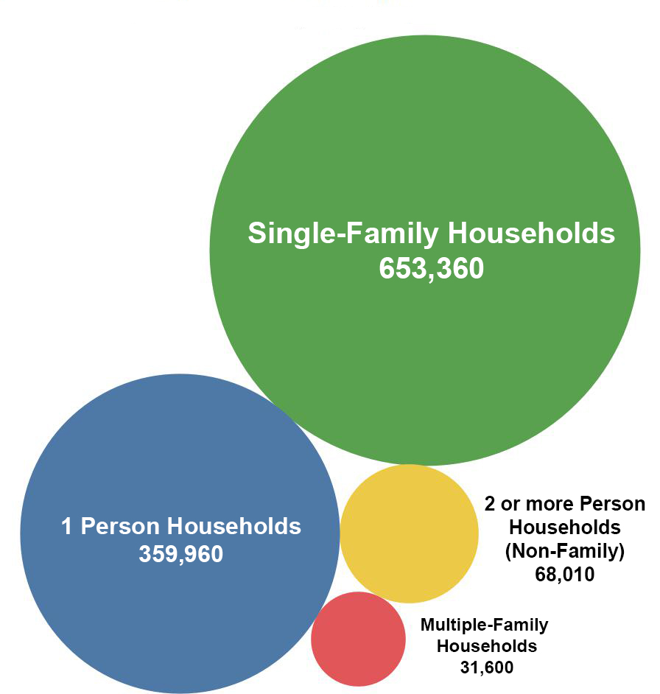

Table 4: Households by Household Type, GTHA, 2006 to 2016

This image is a table with household counts for All Households Types; including Non-Family Households, Single-Family Households and Multiple-Family Households. The number of 1 person and 2 person Non Family Households is also included. The data is for the regional and single tier municipalities in the Greater Toronto and Hamilton Area and covers the year 2006, 2011 and 2016. The proportion of each household type as a percentage of all GTHA households is also included for each municipality. An electronic version of this data set is available and can be requested from Michael.Wright@toronto.ca.Source: Statistics Canada, Censuses 2006-2016

Note: Table totals may vary slightly due to rounding.

Table 5: Households by Household Type, GTHA, 5 and 10 year Percent Change

This image is a table with counts and percentage distribution for All Household Types; including Non-Family Households, Single-Family Households and Multiple-Family Households. The counts and percentage distributions for 1 person and 2 person Non-Family Households are also included. The data is for the city of Toronto and the Greater Toronto and Hamilton Area and covers the year 2006, 2011 and 2016. The table shows a count and percentage change over five years and ten year periods. An electronic version of this data set is available and can be requested from Michael.Wright@toronto.ca.

Source: Statistics Canada, Censuses 2006-2016

Note: Table totals may vary slightly due to rounding.

Table 6: Households by Household Types, Including Multigenerational Households, Greater Toronto and Hamilton Area, 2011 – 2016

This image is a table with counts and percentage distribution for All Household Types;One-Census Family Households without additional persons; Mulitgenerational households, Other census family households and Non-Census Family Households. The data is for the city of Toronto and the Greater Toronto and Hamilton Area and covers the year 2011 and 2016. The table shows a count and percentage change over five years and ten year periods. An electronic version of this data set is available and can be requested from Michael.Wright@toronto.ca.

Source: Statistics Canada, Censuses 2011-2016, Highlight Tables – Families, Households and Marital Status Highlight Tables, Census year 2016, Catalogue 98-402-X2016004

Note: Table totals may vary slightly due to rounding.

Table 7: Households by Household Types, Including Multigenerational Households, Rest of the Greater Toronto and Hamilton Area, 2011 - 2016

This image is a table with counts and percentage distribution for All Household Types; One-Census Family Households without additional persons; Mulitgenerational households, Other census family households and Non-Census Family Households. The data is for the rest of the Greater Toronto and Hamilton Area and covers the year 2011 and 2016. The table shows a count and percentage change over five years and ten year periods. An electronic version of this data set is available and can be requested from Michael.Wright@toronto.ca.

Source: Statistics Canada, Censuses 2011-2016, Highlight Tables – Families, Households and Marital Status Highlight Tables, Census year 2016, Catalogue 98-402-X2016004 Note: Table totals may vary slightly due to rounding

Table 8: Top 15 Mother Tongue Languages in the City of Toronto (Excluding English)

op 15 Mother Tongue Languages in the City of Toronto (Excluding English and multiple languages)
This table displays count, rank, and change since 2011 on the top 15 mother tongue languages in Toronto for 2016. For more information about this table or to request this table in a machine readable format, please contact Harvey Low at 416-392-8660 or harvey.low@toronto.ca.

Table 9: Top 15 Home Languages in the City of Toronto (Excluding English)

Top 15 Home Languages in the City of Toronto (Excluding English and multiple languages)
This table displays count, rank, and change since 2011 on the top 15 languages most often spoken at home in Toronto for 2016. For more information about this table or to request this table in a machine readable format, please contact Harvey Low at 416-392-8660 or harvey.low@toronto.ca.

* Note: for the 2016 Census, new instructions in the electronic questionnaire resulted in a sharp increase in certain Chinese languages, particularly Mandarin and Cantonese. For this reason, 2011 totals are not directly comparable.

Figure 2: Top 75 Mother tongue languages, Toronto, 2016 (Excluding English)

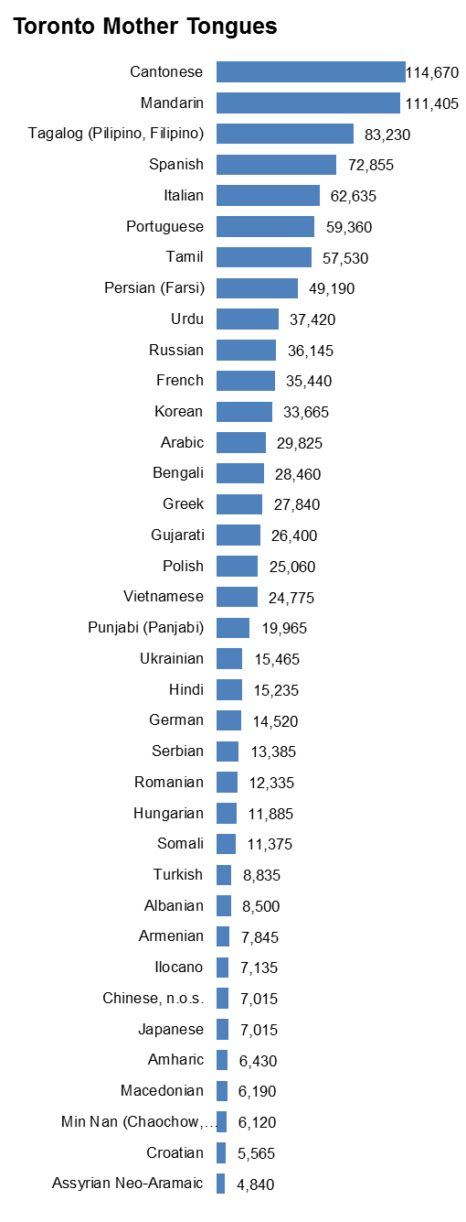

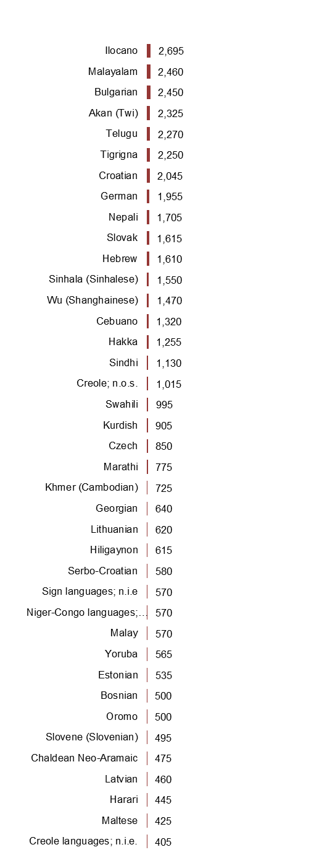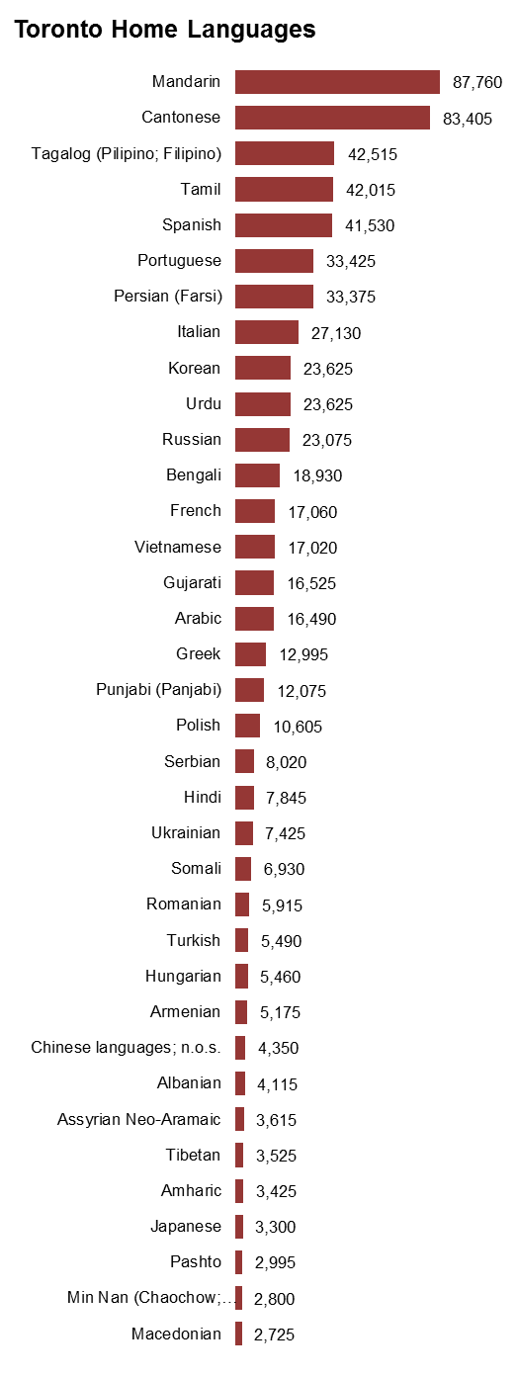

Figure 3: Top 75 Home languages, Toronto, 2016 (Excluding English)

City of Toronto Lone-Parent Families 2016
Summary of the Map:
The map shows the number of lone-parent families by Census Tract for the City of Toronto. The largest concentrations are in the Jane-West corridor in the northwest and in the middle parts of Scarborough. 
For more information, please contact Harvey Low at 416-392-8660 or harvey.low@toronto.ca.


City of Toronto Percent of Young Adults Living At Home 2016
Summary of the Map:
The map shows the percentage of single young adults aged 20-34 living within parental households by Census Tract for the City of Toronto. 
For more information, please contact Harvey Low at 416-392-8660 or harvey.low@toronto.ca.


City of Toronto Single-Person Households 2016
Summary of the Map:
The map shows the number of single-person households by Census Tract for the City of Toronto. The largest numbers occur downtown, along Yonge St, and in the West Queen West, Mimico and Sheppard East corridors.
For more information, please contact Harvey Low at 416- 392-8660 or harvey.low@toronto.ca.

City of Toronto No Knowledge of Official Languages 2016
Summary of the Map:
The map shows the knowledge of neither official languages for the total population excluding institutional residents by Census Tract for the City of Toronto. There is a higher concentration of no knowledge of either official languages in the area north of the 401 expressway, west of Markham Rd, East of Don Valley Parkway, and South of Steeles Ave.
For more information, please contact Harvey Low at 416-392-8660 or harvey.low@toronto.ca.