February 9, 2017
2016 Census: Population and Dwelling Counts
The 2016 Census Day was May 10, 2016. On February 8, 2017, Statistics Canada released its first set of data from this Census, on population and dwelling counts.
Key Points

Population
- The 2016 population of Toronto is 2,731,571, or 7.8% of Canada's total population of 35,151,728. The data is not adjusted for undercoverage (see Glossary).
- Toronto's population grew by 116,511 residents between 2011 and 2016, an increase of 4.5%. This is more than the number of people added between 2006 and 2011 of 111,779 or 4.5%.
- Three cities in Canada saw their population grow by more than 100,000 people between 2011 and 2016: Calgary, up by 142,387; Edmonton, up by 120,345; and Toronto with 116,511 more people.
- 228,290 more people live in Toronto than were here a decade ago.
- The 2016 population of the Greater Toronto and Hamilton Area (GTHA) is 6,954,433, or 19.8% of Canada's population. The city of Toronto accounts for 39.3% of the GTHA's population. This is down slightly from 39.8% of the GTHA in 2011.
- Between 2011 and 2016, the GTHA's population increased by 5.8% or by 380,293 persons. Toronto accounts for about 30.6% of the GTHA's growth. This is compared to 21.8% of the GTHA growth between 2006 and 2011. The city's share of the GTHA growth has increased by 40.4%.
- The growth rates of the GTHA regions and single-tier municipalities ranged between 3.3% and 9.3%. Halton Region had the strongest growth rate at 9.3%, followed by York Region at 7.5%, Peel Region at 6.5%, Durham Region with 6.2% and Hamilton at 3.3%.
- Growth rates varied across the GTHA's 26 municipalities, ranging from 0.2% to 30.5%. This includes the single-tier municipalities of Toronto and Hamilton and the cities and towns in the GTHA.
- The five fastest-growing municipalities in the GTHA with a population growth rate of more than 10% include Milton at 30.5%, followed by King at 23.2%, Whitchurch-Stouffville at 21.8%, Brampton at 13.3% and Caledon at 11.8%.
- Although Statistics Canada makes a great effort to count every person, in each Census a notable number of people are left out for a variety of reasons. For example, people may be travelling, some dwellings are hard to find, and some people simply refuse to participate. Statistics Canada takes this into account and for each Census estimates a net ‘undercoverage’ rate for the urban region, the Toronto Census Metropolitan Area (CMA), but not for the city. The 2011 rate for the Toronto CMA was 3.72% ± 0.53%. The 2016 rate is not yet available. If the rate were the same for 2016, the city’s actual population could be 2,853,000.
- The city’s population is on track with the population forecast in the Provincial Growth Plan for the Greater Golden Horseshoe (GGH).The Growth Plan as amended in 2013 includes population forecasts to 2041 which are used for planning and growth management. The forecasts supporting the Growth Plan anticipated a 2016 population including undercoverage for the city of Toronto of 2,865,000. The city's estimated actual population in 2016 of 2,853,000 is very close to the level anticipated by the forecasts supporting the Growth Plan.
- The total population has changed unevenly across the city. About half of the population growth in the city of Toronto from 2011 to 2016 was south of Bloor Street, between Victoria Park Avenue in the east and the Humber River in the west.
- Toronto's highest growth neighbourhoods are located in Downtown, especially the Waterfront Communities-The Island, Bay Street Corridor, and Moss Park neighbourhoods. High growth was also seen west of Downtown in Niagara and Little Portugal, and further west in the Mimico and Islington-City Centre West neighbourhoods. Another cluster of neighbourhoods that experienced high population growth is along the north side of Highway 401, especially along the Sheppard West corridor. Further west along Highway 401, Pelmo Park-Humberlea also saw very high growth.
- The Weston-Pelham Park neighbourhood experienced the greatest drop in population as a percentage, but the largest total population declines were in the neighbourhoods of Malvern and Agincourt North. Other neighbourhoods with population declines are on the edges of Downtown e.g. Kensington-Chinatown and Cabbagetown-South St. James Town and various other neighbourhoods across the city such as Glenfield-Jane Heights and West Humber-Clairville.
- Map 1 shows population counts by Census Tract for the city of Toronto.
- Maps 2 and 3 show population change across the GTHA and the city of Toronto.
- Maps 4 and 5 show population and population change by city of Toronto neighbourhoods.

Dwellings
- The number of occupied private dwellings in Toronto grew from 1,047,877 in 2011 to 1,112,929 in 2016.
- Occupied private dwellings in the city of Toronto increased by 65,052 between 2011 and 2016. This represents 6.2% growth since 2011. This compares with an increase of 68,547 occupied dwellings or 7.0% growth between 2006 and 2011, and an added 36,250 occupied dwellings or 3.8% between 2001 and 2006.
- According to the Canada Mortgage and Housing Corporation (CMHC), there were 84,748 dwelling completions in the city during a similar period as the 2016 Census, May 1, 2011 to April 30, 2016. CMHC also reports that 96.2% of units completed between 2011 and 2016 inclusive were absorbed, meaning that they were bought or rented. This indicates that there is a strong market for the units that are being built in the city, even if all of them have not yet become occupied.
- Between 2011 and 2016, occupied dwellings in the GTHA increased by 6.8% from 2,370,924 to 2,532,672. In 2016, the city of Toronto was home to 43.9% of all GTHA dwellings.
- Toronto accounted for 40.2% of the GTHA's increase in occupied dwelling units between 2011 and 2016. This compares to a 32.5% share of the increase between 2006 and 2011.
- In the GTHA, York Region showed the largest growth in occupied dwelling units, an increase of 10.4%, followed by Halton Region at 7.8%, Peel Region at 6.8%, Durham Region at 6.6% and Hamilton at 3.8%. The city of Toronto's growth rate was 6.2%. At 65,052 occupied dwellings, the city's growth in occupied units is much higher than that of any other municipality in the GTHA.
- The growth in occupied units in the GTHA was lower over the 2011-2016 period than the previous five years. The greatest declines were York Region at 10.4%, down from 17.4% and Halton Region at 7.8%, down from 14.1% five years earlier.
- The average number of persons per occupied dwelling in the city of Toronto has declined slightly from 2.50 in 2011 to 2.45 in 2016. This average has also declined in many other GTHA municipalities.
- There are strong prospects for continued population growth in the city of Toronto. The City tracks all applications for proposed residential development. There were 321,200 residential units in active development projects between July 1, 2011 and June 30, 2016. Of these, approximately 127,200 proposed units were approved but not yet built. Most of these proposed units are apartments. If these proposed units were occupied at the same rate as apartments in buildings of 5 or more storeys built between 2006 and 2011, they would house about 213,500 persons. These units represent some of the potential for additional population in the near future.
GLOSSARY
Statistics Canada maintains a Census Dictionary for the Census of Population, 2016, available online at: http://www12.statcan.gc.ca/census-recensement/2016/ref/dict/
index-eng.cfm. Many more terms associated with the Census can be found there.
Census Metropolitan Area (CMA): one or more adjacent municipalities centred on a core population centre. To be included in a CMA, the adjacent municipalities must have a high degree of integration with the core. Integration is measured by commuting flows.
Census Tract (CT): a small, geographic area, typically with a population smaller than 10,000 persons. Their geography is relatively stable over time to allow for comparison of changes from Census to Census.
Centre: as seen in Maps 1 and 2, Centres are defined in the City of Toronto Official Plan. They play an important role in how the City manages growth. The Scarborough, North York, Etobicoke and Yonge-Eglinton Centres are places with excellent transit accessibility where jobs, housing and services will be concentrated in dynamic mixed use settings with different levels of activity and intensity. More information can be found in the Toronto Official Plan.
GTHA refers to the Greater Toronto and Hamilton Area. This area is comprised of the single-tier municipalities of Toronto and Hamilton, the regional municipalities of York, Durham, Peel, and Halton, and the cities and towns within the GTHA regional municipalities. This is not the same geography as the Toronto Census Metropolitan Area as defined by Statistics Canada.
Neighbourhood: The City of Toronto identifies 140 social planning neighbourhoods to help government and community agencies with their local planning. These neighbourhoods allow the provision of socio-economic data at a meaningful geographic area. Not all people define neighbourhoods the same way, but for the purposes of statistical reporting these neighbourhoods were defined based on Statistics Canada census tracts. More information about City of Toronto neighbourhoods can be found on the City's website.
Undercoverage: is the number of persons excluded by the Census who should have been counted, as determined by Statistics Canada. Although Statistics Canada makes a great effort to count every person, in each Census a notable number of people are left out for a variety of reasons. For example, people may be traveling, some dwellings are hard to find, and some people simply refuse to participate. Overcoverage can also occur, when people are counted more than once or should not have been counted in a given population. Undercoverage is generally more common than overcoverage. The total impact of the coverage errors is the net undercoverage.
NOTES
All data in this backgrounder are based on geographic boundaries available at time of writing. In the event of any future boundary revisions, some data totals may change. This is especially the case for small area units such as Census Tracts.

The information previously collected by the long-form Census questionnaire was collected in 2011 as part of the voluntary National Household Survey. In 2016, Statistics Canada restored the mandatory long-form Census questionnaire in an effort to improve data collection. The numbers reported in this backgrounder are based on the mandatory short-form component of the Census for both 2011 and 2016, and therefore can be compared. In future backgrounders timed with later releases from the 2016 Census, the numbers will reflect the long-form Census and are anticipated to be more comprehensive than those of the 2011 National Household Survey.

FUTURE CENSUS RELEASES
The City of Toronto will be releasing more backgrounders coinciding with each Census release, except for the Census of Agriculture. The Census release schedule is available from Statistics Canada, online at: https://www12.statcan.gc.ca/census-recensement/
index-eng.cfm. The City of Toronto will be preparing backgrounders for the following releases:

May 3, 2017 | Age and sex  Type of dwelling
August 2, 2017 | Families, households and marital status  Language
September 13, 2017 | Income
October 25, 2017 | Immigration and ethnocultural diversity  Housing  Aboriginal peoples
November 29, 2017 | Education  Labour  Journey to work  Language of work  Mobility and migration

REFERENCES

Prepared by staff from:
- Children's Services, Service System Planning and Policy Development
- City Manager's Office, Human Resources
- City Planning, Research and Information
- Economic Development, Research and Information Systems
- Social Development, Finance and Administration,
Social Policy Analysis and Research
- Toronto Police Service, Business Intelligence & Analytics Unit
- Toronto Public Health
- Toronto Water
- Transportation Services, Big Data Innovation Team

Media contact: Bruce Hawkins, Strategic Communications, 416-392-3496, bruce.hawkins@toronto.ca
Staff contact: Michael Wright, City Planning, Research and Information
Tel: 416-392-7558; Fax. 416-392-3821; TTY: 416-392-8764
michael.wright@toronto.ca

Tables, Charts and maps
Population, 1996-2016, Greater Toronto and Hamilton Area
 |  |  |  |  |  |  |  |  |  |  | Change
 | 1996 |  | 2001 |  | 2006 |  | 2011 |  | 2016 |  | 1996-2001 |  | 2001-2006 |  | 2006-2011 |  | 2011-2016
GTHA | 5,096,682 |  | 5,572,094 |  | 6,060,471 |  | 6,574,140 |  | 6,954,433 |  | 475,412 |  | 488,377 |  | 513,669 |  | 380,293
Toronto | 2,385,421 |  | 2,481,494 |  | 2,503,281 |  | 2,615,060 |  | 2,731,571 |  | 96,073 |  | 21,787 |  | 111,779 |  | 116,511
Rest of the GTHA | 2,711,261 |  | 3,090,600 |  | 3,557,190 |  | 3,959,080 |  | 4,222,862 |  | 379,339 |  | 466,590 |  | 401,890 |  | 263,782
Durham | 458,616 |  | 506,901 |  | 561,258 |  | 608,124 |  | 645,862 |  | 48,285 |  | 54,357 |  | 46,866 |  | 37,738
York | 592,445 |  | 729,254 |  | 892,712 |  | 1,032,524 |  | 1,109,909 |  | 136,809 |  | 163,458 |  | 139,812 |  | 77,385
Peel | 852,526 |  | 988,948 |  | 1,159,405 |  | 1,296,814 |  | 1,381,739 |  | 136,422 |  | 170,457 |  | 137,409 |  | 84,925
Halton | 339,875 |  | 375,229 |  | 439,256 |  | 501,669 |  | 548,435 |  | 35,354 |  | 64,027 |  | 62,413 |  | 46,766
Hamilton | 467,799 |  | 490,268 |  | 504,559 |  | 519,949 |  | 536,917 |  | 22,469 |  | 14,291 |  | 15,390 |  | 16,968
Toronto % of GTHA | 46.8 |  | 44.5 |  | 41.3 |  | 39.8 |  | 39.3 |  | 20.2 |  | 4.5 |  | 21.8 |  | 30.6
Source: Statistics Canada, Censuses 1996 - 2016

Population, 1996-2016, Greater Toronto and Hamilton Area
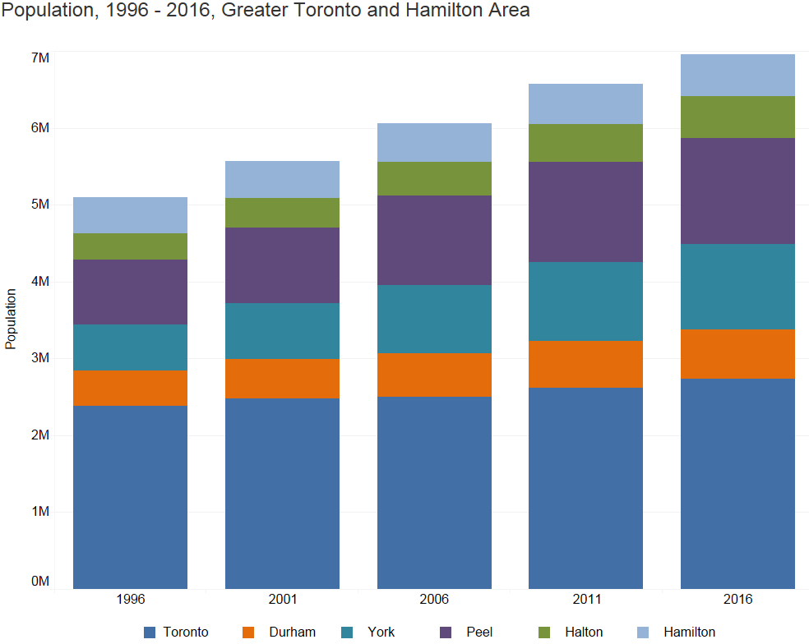

2016 Population by Municipality,
Greater Toronto and Hamilton Area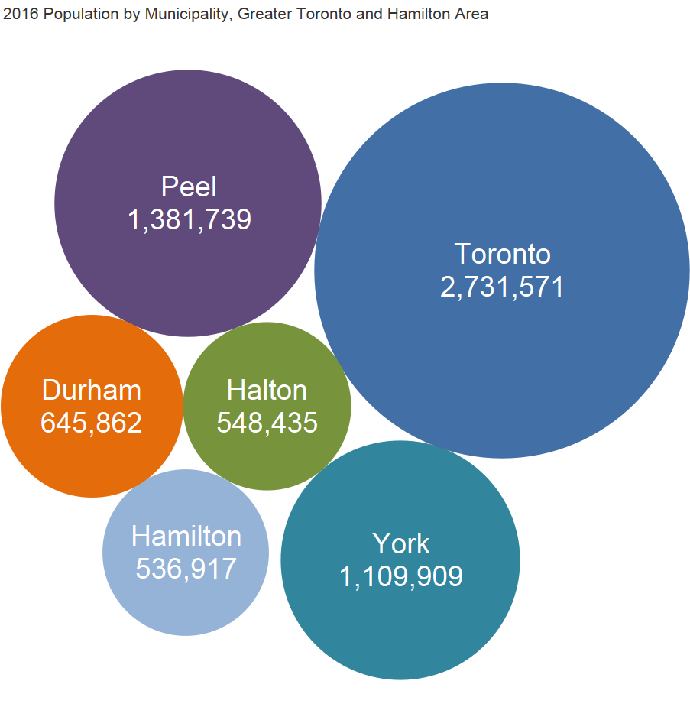

Population Change by Municipality, 1996-2016,
Greater Toronto and Hamilton Area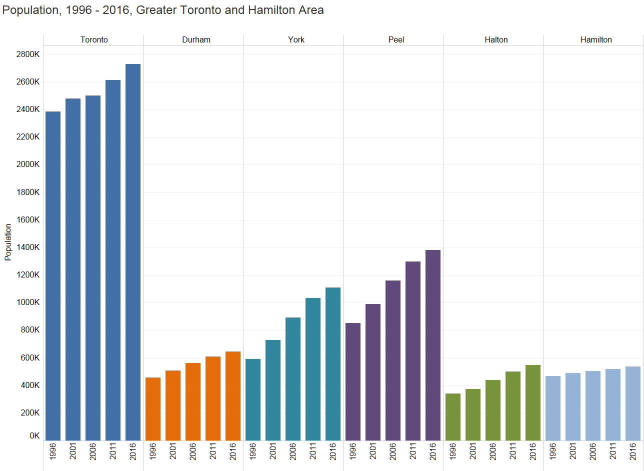

Population Growth Rates, 1996-2016, Greater Toronto and Hamilton Area

 | Percent Change |  |  |  |  |  |  |  |  | Annualized Compound Growth Rate
 |  | 1996-2001 |  | 2001-2006 |  | 2006-2011 |  | 2011-2016 |  | 2011-2016 |  | 2006-2016
GTHA |  | 9.3 |  | 8.8 |  | 8.5 |  | 5.8 |  | 1.13 |  | 1.39
Toronto |  | 4.0 |  | 0.9 |  | 4.5 |  | 4.5 |  | 0.88 |  | 0.88
Rest of the GTHA |  | 14.0 |  | 15.1 |  | 11.3 |  | 6.7 |  | 1.30 |  | 1.73
Durham |  | 10.5 |  | 10.7 |  | 8.4 |  | 6.2 |  | 1.21 |  | 1.41
York |  | 23.1 |  | 22.4 |  | 15.7 |  | 7.5 |  | 1.46 |  | 2.20
Peel |  | 16.0 |  | 17.2 |  | 11.9 |  | 6.5 |  | 1.28 |  | 1.77
Halton |  | 10.4 |  | 17.1 |  | 14.2 |  | 9.3 |  | 1.80 |  | 2.24
Hamilton |  | 4.8 |  | 2.9 |  | 3.1 |  | 3.3 |  | 0.64 |  | 0.62
Source: Statistics Canada, Censuses, 1996-2016

Dwelling Units, 1996-2016, Greater Toronto and Hamilton Area
 |  |  |  |  |  | Change
 | 1996 | 2001 | 2006 | 2011 | 2016 | 1996-2001 | 2001-  2006 | 2006-  2011 | 2011-2016
GTHA | 1,796,620 | 1,967,360 | 2,160,109 | 2,370,924 | 2,532,672 | 170,740 | 192,749 | 210,815 | 161,748
Toronto | 903,580 | 943,080 | 979,330 | 1,047,877 | 1,112,929 | 39,500 | 36,250 | 68,547 | 65,052
Rest of the GTHA | 893,040 | 1,024,280 | 1,180,779 | 1,323,047 | 1,419,743 | 131,240 | 156,499 | 142,268 | 96,696
Durham | 154,100 | 171,715 | 194,672 | 213,746 | 227,906 | 17,615 | 22,957 | 19,074 | 14,160
York | 177,575 | 223,170 | 275,673 | 323,543 | 357,084 | 45,595 | 52,503 | 47,870 | 33,541
Peel | 265,935 | 308,845 | 359,042 | 402,939 | 430,180 | 42,910 | 50,197 | 43,897 | 27,241
Halton | 118,155 | 133,665 | 156,947 | 179,013 | 192,977 | 15,510 | 23,282 | 22,066 | 13,964
Hamilton | 177,275 | 186,885 | 194,445 | 203,806 | 211,596 | 9,610 | 7,560 | 9,361 | 7,790
Toronto % of GTHA | 50.3 | 47.9 | 45.3 | 44.2 | 43.9 | 23.1 | 18.8 | 32.5 | 40.2
Source: Statistics Canada, 1996-2016 Censuses
Dwelling unit counts refer to units occupied by usual residents.

Dwelling Units, 1996-2016, Greater Toronto and Hamilton Area
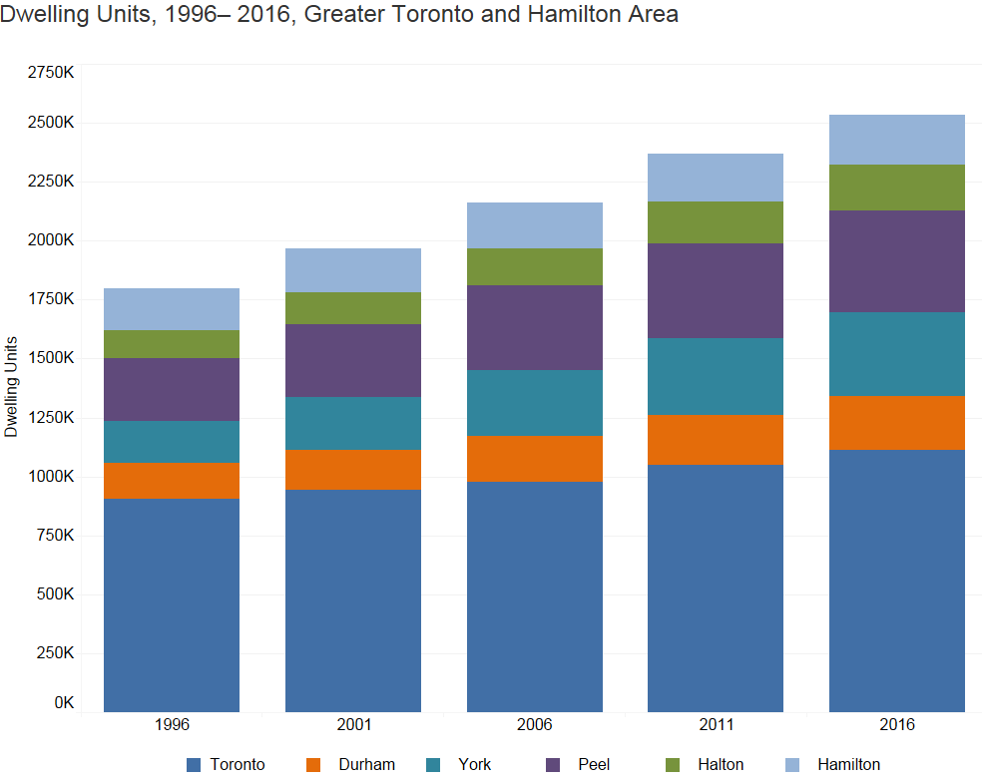

2016 Dwelling Units by Municipality,
Greater Toronto and Hamilton Area

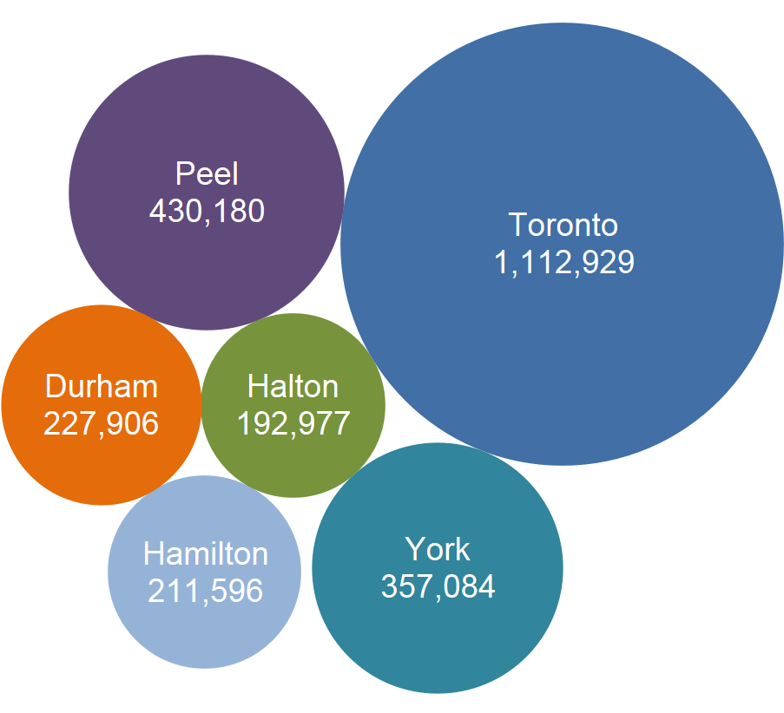

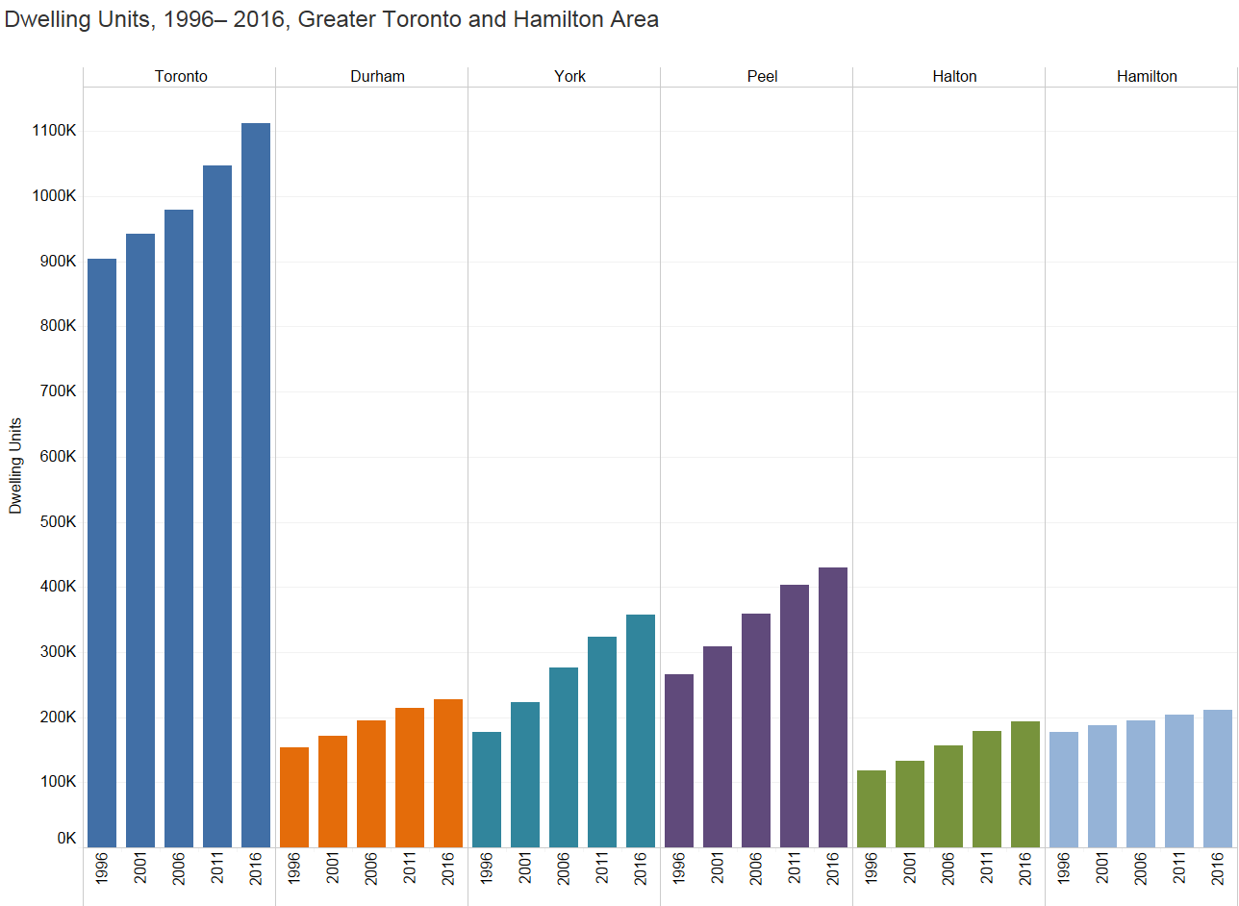
Dwelling Unit Change by Municipality, 1996-2016,
Greater Toronto and Hamilton Area

Percent Change in Dwelling Units, 1996-2016,
Greater Toronto and Hamilton Area

 | 1996-2001 | 2001-2006 | 2006-2011 |  | 2011-2016
GTHA | 9.5 | 9.8 | 9.8 |  | 6.8
Toronto | 4.4 | 3.8 | 7.0 |  | 6.2
Rest of the GTHA | 14.7 | 15.3 | 12.0 |  | 7.3
Durham | 11.4 | 13.4 | 9.8 |  | 6.6
York | 25.7 | 23.5 | 17.4 |  | 10.4
Peel | 16.1 | 16.3 | 12.2 |  | 6.8
Halton | 13.1 | 17.4 | 14.1 |  | 7.8
Hamilton | 5.4 | 4.0 | 4.8 |  | 3.8
Source: Statistics Canada, 1996-2016 Censuses
Dwelling unit counts refer to units occupied by usual residents.

Greater Toronto and Hamilton Area (GTHA)
Population and Percent Change by Municipality, 1996-2016

 |  |  |  |  |  | Percent Change
Municipality | 1996 | 2001 | 2006* | 2011* | 2016* | 1996-2001 | 2001-2006 | 2006-2011 | 2011-2016 | 1996-2016
Toronto | 2,385,421 | 2,481,494 | 2,503,281 | 2,615,060 | 2,731,571 | 4.0 | 0.9 | 4.5 | 4.5 | 14.5
Durham | 458,616 | 506,901 | 561,186 | 608,031 | 645,731 | 10.5 | 10.7 | 8.3 | 6.2 | 40.8
Ajax | 64,430 | 73,753 | 90,167 | 109,600 | 119,677 | 14.5 | 22.3 | 21.6 | 9.2 | 85.7
Brock | 11,705 | 12,110 | 11,979 | 11,341 | 11,642 | 3.5 | -1.1 | -5.3 | 2.7 | -0.5
Clarington | 60,615 | 69,834 | 77,820 | 84,548 | 92,013 | 15.2 | 11.4 | 8.6 | 8.8 | 51.8
Oshawa | 134,364 | 139,051 | 141,590 | 149,607 | 159,458 | 3.5 | 1.8 | 5.7 | 6.6 | 18.7
Pickering | 78,989 | 87,139 | 87,838 | 88,721 | 91,771 | 10.3 | 0.8 | 1.0 | 3.4 | 16.2
Scugog | 18,837 | 20,224 | 21,439 | 21,569 | 21,617 | 7.4 | 6.0 | 0.6 | 0.2 | 14.8
Uxbridge | 15,882 | 17,377 | 19,169 | 20,623 | 21,176 | 9.4 | 10.3 | 7.6 | 2.7 | 33.3
Whitby | 73,794 | 87,413 | 111,184 | 122,022 | 128,377 | 18.5 | 27.2 | 9.7 | 5.2 | 74.0
York | 592,445 | 729,254 | 892,359 | 1,032,249 | 1,109,648 | 23.1 | 22.4 | 15.7 | 7.5 | 87.3
Aurora | 34,857 | 40,167 | 47,629 | 53,203 | 55,445 | 15.2 | 18.6 | 11.7 | 4.2 | 59.1
East Gwillimbury | 19,770 | 20,555 | 21,069 | 22,473 | 23,991 | 4.0 | 2.5 | 6.7 | 6.8 | 21.4
Georgina | 34,978 | 39,536 | 42,346 | 43,517 | 45,418 | 13.0 | 7.1 | 2.8 | 4.4 | 29.8
King | 18,223 | 18,533 | 19,487 | 19,899 | 24,512 | 1.7 | 5.1 | 2.1 | 23.2 | 34.5
Markham | 173,383 | 208,615 | 261,573 | 301,709 | 328,966 | 20.3 | 25.4 | 15.3 | 9.0 | 89.7
Newmarket | 57,125 | 65,788 | 74,295 | 79,978 | 84,224 | 15.2 | 12.9 | 7.6 | 5.3 | 47.4
Richmond Hill | 101,725 | 132,030 | 162,704 | 185,541 | 195,022 | 29.8 | 23.2 | 14.0 | 5.1 | 91.7
Vaughan | 132,549 | 182,022 | 238,866 | 288,301 | 306,233 | 37.3 | 31.2 | 20.7 | 6.2 | 131.0
Whitchurch-Stouffville | 19,835 | 22,008 | 24,390 | 37,628 | 45,837 | 11.0 | 10.8 | 54.3 | 21.8 | 131.1
Peel | 852,526 | 988,948 | 1,159,405 | 1,296,814 | 1,381,739 | 16.0 | 17.2 | 11.9 | 6.5 | 62.1
Brampton | 268,251 | 325,428 | 433,806 | 523,911 | 593,638 | 21.3 | 33.3 | 20.8 | 13.3 | 121.3
Caledon | 39,893 | 50,595 | 57,050 | 59,460 | 66,502 | 26.8 | 12.8 | 4.2 | 11.8 | 66.7
Mississauga | 544,382 | 612,925 | 668,549 | 713,443 | 721,599 | 12.6 | 9.1 | 6.7 | 1.1 | 32.6
Halton | 339,875 | 375,229 | 439,256 | 501,669 | 548,435 | 10.4 | 17.1 | 14.2 | 9.3 | 61.4
Burlington | 136,976 | 150,836 | 164,415 | 175,779 | 183,314 | 10.1 | 9.0 | 6.9 | 4.3 | 33.8
Halton Hills | 42,390 | 48,184 | 55,289 | 59,008 | 61,161 | 13.7 | 14.7 | 6.7 | 3.6 | 44.3
Milton | 32,104 | 31,471 | 53,939 | 84,362 | 110,128 | -2.0 | 71.4 | 56.4 | 30.5 | 243.0
Oakville | 128,405 | 144,738 | 165,613 | 182,520 | 193,832 | 12.7 | 14.4 | 10.2 | 6.2 | 51.0
Hamilton | 467,799 | 490,268 | 504,559 | 519,949 | 536,917 | 4.8 | 2.9 | 3.1 | 3.3 | 14.8
GTHA | 5,096,682 | 5,572,094 | 6,060,046 | 6,573,772 | 6,954,041 | 9.3 | 8.8 | 8.5 | 5.8 | 36.4
Notes:
The numbers in this table may differ slightly due to rounding.
For some municipalities large percentage increases are due to small population counts.
* 2016, 2011 and 2006 counts do not include First Nations Reserves:
Durham Region: | Mississaugas of Scugog Island (Pop 2016 = 131, Pop 2011 = 93, Pop 2006 = 72)
York Region: | Chippewas of Georgina Island First Nation (Pop 2016 = 261, Pop 2011 = 275, Pop 2006 = 353)
Source: Statistics Canada, Censuses 1996, 2001, 2006, 2011, 2016

Greater Toronto and Hamilton Area (GTHA)
Occupied Private Dwellings and Percent Change by Municipality, 2006-2016

 |  |  |  | Percent Change |  |  | Average Number of Persons in all Occupied Dwellings
Municipality | 2006* | 2011* | 2016* | 2006-2011 | 2011-2016 | 2006-2016 | 2011 | 2016
Toronto | 979,330 | 1,047,877 | 1,112,929 | 7.0 | 6.2 | 13.6 | 2.50 | 2.45
Durham | 194,639 | 213,706 | 227,854 | 9.8 | 6.6 | 17.1 | 2.85 | 2.83
Ajax | 28,616 | 35,038 | 37,549 | 22.4 | 7.2 | 31.2 | 3.13 | 3.19
Brock | 4,422 | 4,336 | 4,543 | -1.9 | 4.8 | 2.7 | 2.62 | 2.56
Clarington | 26,865 | 29,880 | 32,838 | 11.2 | 9.9 | 22.2 | 2.83 | 2.80
Oshawa | 54,923 | 58,797 | 62,595 | 7.1 | 6.5 | 14.0 | 2.54 | 2.55
Pickering | 28,210 | 29,330 | 30,919 | 4.0 | 5.4 | 9.6 | 3.02 | 2.97
Scugog | 7,705 | 7,959 | 8,218 | 3.3 | 3.3 | 6.7 | 2.71 | 2.63
Uxbridge | 6,658 | 7,345 | 7,663 | 10.3 | 4.3 | 15.1 | 2.81 | 2.76
Whitby | 37,240 | 41,021 | 43,529 | 10.2 | 6.1 | 16.9 | 2.97 | 2.95
York | 275,544 | 323,429 | 356,966 | 17.4 | 10.4 | 29.5 | 3.19 | 3.11
Aurora | 15,656 | 17,691 | 18,851 | 13.0 | 6.6 | 20.4 | 3.01 | 2.94
East Gwillimbury | 6,887 | 7,540 | 8,077 | 9.5 | 7.1 | 17.3 | 2.98 | 2.97
Georgina | 15,263 | 15,851 | 16,821 | 3.9 | 6.1 | 10.2 | 2.75 | 2.70
King | 6,398 | 6,645 | 8,144 | 3.9 | 22.6 | 27.3 | 2.99 | 3.01
Markham | 77,191 | 90,534 | 102,676 | 17.3 | 13.4 | 33.0 | 3.33 | 3.20
Newmarket | 25,087 | 27,409 | 28,673 | 9.3 | 4.6 | 14.3 | 2.92 | 2.94
Richmond Hill | 51,000 | 58,651 | 64,116 | 15.0 | 9.3 | 25.7 | 3.16 | 3.04
Vaughan | 69,536 | 86,063 | 94,253 | 23.8 | 9.5 | 35.5 | 3.35 | 3.25
Whitchurch-Stouffville | 8,526 | 13,045 | 15,355 | 53.0 | 17.7 | 80.1 | 2.88 | 2.99
Peel | 359,042 | 402,939 | 430,180 | 12.2 | 6.8 | 19.8 | 3.22 | 3.21
Brampton | 125,934 | 149,271 | 168,011 | 18.5 | 12.6 | 33.4 | 3.51 | 3.53
Caledon | 18,214 | 19,086 | 21,256 | 4.8 | 11.4 | 16.7 | 3.12 | 3.13
Mississauga | 214,894 | 234,582 | 240,913 | 9.2 | 2.7 | 12.1 | 3.04 | 3.00
Halton | 156,947 | 179,013 | 192,977 | 14.1 | 7.8 | 23.0 | 2.80 | 2.84
Burlington | 63,159 | 68,779 | 71,373 | 8.9 | 3.8 | 13.0 | 2.56 | 2.57
Halton Hills | 18,812 | 20,261 | 21,078 | 7.7 | 4.0 | 12.0 | 2.91 | 2.90
Milton | 18,448 | 27,561 | 34,257 | 49.4 | 24.3 | 85.7 | 3.06 | 3.21
Oakville | 56,528 | 62,412 | 66,269 | 10.4 | 6.2 | 17.2 | 2.92 | 2.92
Hamilton | 194,445 | 203,806 | 211,596 | 4.8 | 3.8 | 8.8 | 2.55 | 2.54
GTHA | 2,159,947 | 2,370,770 | 2,532,502 | 9.8 | 6.8 | 17.2 | 2.77 | 2.75
Notes:
Dwelling unit counts refer to units occupied by usual residents.
The numbers in this table may differ slightly due to rounding.
For some municipalities, large percentage increases are due to small dwelling counts.
* 2016, 2011 and 2006 counts do not include First Nations Reserves:
Durham Region: | Mississaugas of Scugog Island: Dwellings Occupied by Usual Residents 2016 = 52, 2011 = 40, 2006 = 33
York Region: | Chippewas of Georgina Island First Nation: Dwellings Occupied by Usual Residents 2016 = 118,  2011 = 114, 2006 = 129
Source: Statistics Canada, Censuses 2006, 2011, 2016

City of Toronto Neighbourhoods
Total Population and Population Change, 2011-2016
Top 10 and Bottom 10 by Percent Change
 |  | Population |  | Change 2011-2016
Neighbourhood | Number | 2011 | 2016 | Absolute | Percent
Waterfront Communities-The Island | 77 | 43,361 | 65,913 | 22,552 | 52.0%
Niagara | 82 | 21,274 | 31,180 | 9,906 | 46.6%
Henry Farm | 53 | 11,333 | 15,723 | 4,390 | 38.7%
Bay Street Corridor | 76 | 19,348 | 25,797 | 6,449 | 33.3%
Little Portugal | 84 | 12,050 | 15,559 | 3,509 | 29.1%
Mimico (includes Humber Bay Shores) | 17 | 26,541 | 33,964 | 7,423 | 28.0%
Moss Park | 73 | 16,306 | 20,506 | 4,200 | 25.8%
Pelmo Park-Humberlea | 23 | 8,710 | 10,722 | 2,012 | 23.1%
Bayview Village | 52 | 17,671 | 21,396 | 3,725 | 21.1%
Islington-City Centre West | 14 | 38,084 | 43,965 | 5,881 | 15.4%
West Humber-Clairville | 1 | 34,100 | 33,312 | -788 | -2.3%
Bayview Woods-Steeles | 49 | 13,530 | 13,154 | -376 | -2.8%
Glenfield-Jane Heights | 25 | 31,390 | 30,491 | -899 | -2.9%
Malvern | 132 | 45,086 | 43,794 | -1,292 | -2.9%
Kensington-Chinatown | 78 | 18,495 | 17,945 | -550 | -3.0%
Cabbagetown-South St. James Town | 71 | 12,053 | 11,669 | -384 | -3.2%
Agincourt North | 129 | 30,279 | 29,113 | -1,166 | -3.9%
Hillcrest Village | 48 | 17,656 | 16,934 | -722 | -4.1%
Highland Creek | 134 | 13,097 | 12,494 | -603 | -4.6%
Weston-Pelham Park | 91 | 12,010 | 11,098 | -912 | -7.6%
Notes:
Neighbourhood level data in this backgrounder is compiled from Census Tract-level totals. Final neighbourhood
population totals may be slightly different. This data will be available for all 140 neighbourhoods on the City of
Toronto's Wellbeing mapping application and the City's Open Data site.
www.toronto.ca/wellbeing
www.toronto.ca/open

