September 14, 2017
2016 Census: Income
The 2016 Census Day was May 10, 2016. On September 13, 2017, Statistics Canada released data on the topic of income. For the first time, the Census of Population gathered income data solely from administrative sources, rather than asking Census participants to self-report their income levels. The income data for the 2016 Census covers the full year prior to the Census, so the reference period for this data is the year 2015.
Key Points

Median income levels
- In 2015, the median total household income in Toronto was $65,829. This is the lowest of all regions in the Greater Toronto Hamilton Area (GTHA). The highest was in Halton at $103,009. The median household total income was $70,366 for Canada and $74,287 for Ontario (see Figure 1 and Map 1). This is explained, at least in part, by the greater proportion of single person households in Toronto.
- Within Toronto, the highest median incomes are found in the centre of the city, roughly bounded by Bloor Street, Leslie Avenue, Wilson Avenue and Bathurst Street, as well as in the Royal York Road and Bloor Street West area. Although there are small pockets of lower median income within this area, reflected by clusters of high density private market rental buildings and the typically smaller households. The pattern of lower median household incomes forms a U shape reaching from north west Etobicoke, through the downtown core, and up through East York and central Scarborough (see Map 2).
- In 2015, the median economic family income in Toronto was $82,859. This is the lowest of all regions in the GTHA. The highest was in Halton at $119,370. The median household total income was $88,306 for Canada and $91,089 for Ontario. Toronto families are also the smallest among GTHA regions, with 3.1 individuals being the average family size. Peel and York regions have notably larger family sizes, at 3.6 and 3.4 people per family respectively.
- In 2015, the median total income of individuals age 15 and older in Toronto was $30,089. This is the lowest of all regions in the GTHA. The highest was in Halton at $42,577. The median individual income was $34,204 for Canada and $33,539 for Ontario.
- In Toronto, males had a median total individual income of $33,456 and females had a median total individual income of $27,576. The gap between these figures is $5,880. This gap is much smaller than the median gap in Ontario, where males had median income of $39,889 and females had a median individual income of $28,676, for a difference of $11,213.
- Lone parent families in Toronto had a median income of $51,040. That amount is more than $10,000 lower than any other GTHA region except Hamilton, which had comparable figures to Toronto. It is also about half of the median family income for couple families with children in Toronto, at $102,273.

Income sources
- Toronto residents earn a greater share of their income from market sources other than employment income (e.g. investment income, private retirement income) compared to other Canadians. 74.4% of Toronto residents' total income came from employment income. For Canada 72.0% of income came from employment income, and for Ontario the percentage was 72.9%.
- Torontonians' income relied significantly less on government transfers than across the province and nation. In Toronto, 9.4% of total income came from government transfers. Toronto was in the middle of the pack in the GTHA (i.e. third of six regions). For all Canada, 11.7% of total income came from government transfers, and for Ontario the percentage was 11.1% (see Figure 2).

Prevalence of low income
- In 2015, there were 543,390 persons or 20.2% of the population in Toronto with an income below Statistics Canada's Low Income Measure After Tax (LIM-AT). LIM-AT is a relative measure of low income, meaning that it does not reflect differences in the cost of living.
- Toronto continues to have a higher rate of low income than the rest of Canada (14.2%), Ontario (14.4%) and the rest of the regions in the GTHA (11.9%) (see Figure 4 and Map 3).
- Within Toronto, areas with the highest prevalence of low income can be found in numerous locations across the city. Areas with the lowest rates of low income can be found in south west Etobicoke, central Toronto, and north east Scarborough (see Map 4).
- In Toronto, the prevalence of low-income for young adults (18 to 24 years) (27.0%) and children (under 18 years) (26.3%) is significantly higher than for older age groups (see Figures 4 & 5).
- The threshold for LIM-AT in 2015 is $22,133 for a one person household, $31,301 for a two person household, and $44,266 for a four person household. (See glossary for more information about low income measures).

Income distribution
- Of Toronto residents who were employed in 2015, 35.1% had annual employment income under $20,000. This includes persons working part-time and/or for only part of the year.
- Toronto had a greater proportion of residents that earned over $100,000 (10.5%) a year in 2015 compared to the rest of the country (8.7%). Toronto also saw a higher proportion of residents who earned less than $40,000 and less than $20,000 (31.5%) in 2015 (see Figure 6).

GLOSSARY
Statistics Canada maintains a Census Dictionary for the Census of Population, 2016, available online at: http://www12.statcan.gc.ca/census-recensement/2016/ref/dict/
index-eng.cfm. Many more terms associated with the Census can be found there.

- Census Metropolitan Area (CMA): one or more adjacent municipalities centred on a core population centre. To be included in a CMA, the adjacent municipalities must have a high degree of integration with the core. Integration is measured by commuting flows.
- Census Tract (CT): a small, geographic area, typically with a population smaller than 10,000 persons. Their geography is relatively stable over time to allow for comparison of changes from Census to Census.
- Centre: is as defined in the City of Toronto Official Plan. Centres play an important role in how the City manages growth. The Scarborough, North York, Etobicoke and Yonge-Eglinton Centres are places with excellent transit accessibility where jobs, housing and services will be concentrated in dynamic mixed use settings with different levels of activity and intensity. More information can be found in the Toronto Official Plan.
- Economic family: a broader definition of family than the census family concept, meaning a group of two or more persons who live in the same dwelling and are related to each other by blood, marriage, common-law union, adoption or a foster relationship. A couple may be of opposite or same sex. This measure of family is used in Census reporting about family income.
- GTHA refers to the Greater Toronto and Hamilton Area. This area is comprised of the single-tier municipalities of Toronto and Hamilton, the regional municipalities of York, Durham, Peel, and Halton, and the cities and towns within the GTHA regional municipalities. This report refers to these single and upper tier municipalities as "regions". This is not the same geography as the Toronto Census Metropolitan Area as defined by Statistics Canada.
- Household refers to a person or group of persons who occupy the same dwelling and do not have a usual place of residence elsewhere in Canada or abroad. The dwelling may be either a collective dwelling or a private dwelling. The household may consist of a family group such as a census family, of two or more families sharing a dwelling, of a group of unrelated persons or of a person living alone. Household members who are temporarily absent on reference day are considered part of their usual household.
- Income: refers to income from a variety of sources. The total income of an individual, household, or family is comprised of market income (employment income, investment income, private retirement income, etc.) and government transfers (all cash benefits received from federal, provincial, territorial or municipal governments). More information about how Statistics Canada defines income can be found in the Census Dictionary.
- Low Income: refers to whether an individual, family, or household had an income below a specific low-income line. The low income line referenced throughout this backgrounder in the Low Income Measure After Tax (LIM-AT), as it is the statistic used most frequently and as a key indicator by Statistics Canada. The threshold of income varies based on the size of a household. For 2015, the LIM-AT threshold is $22,133 for a one person household, $31,301 for a two person household, and $44,266 for a four person household. See the Census Dictionary for the full range of LIM-AT thresholds: http://www12.statcan.gc.ca/census-recensement/2016/ref/dict/tab/t4_2-eng.cfm.
- Median: A statistic which is a form of average. Median refers to the mid-point of a distribution. For income distribution, the median income would be the income for which exactly one half of the population has a higher income and the other half has a lower income.
- Neighbourhood: The City of Toronto identifies 140 social planning neighbourhoods to help government and community agencies with their local planning. These neighbourhoods allow the provision of socio-economic data at a meaningful geographic area. Not all people define neighbourhoods the same way, but for the purposes of statistical reporting these neighbourhoods were defined based on Statistics Canada census tracts. More information about City of Toronto neighbourhoods can be found on the City's website.
- Undercoverage: is the number of persons excluded by the Census who should have been counted, as determined by Statistics Canada. Although Statistics Canada makes a great effort to count every person, in each Census a notable number of people are left out for a variety of reasons. For example, people may be traveling, some dwellings are hard to find, and some people simply refuse to participate. Overcoverage can also occur, when people are counted more than once or should not have been counted in a given population. Undercoverage is generally more common than overcoverage. The total impact of the coverage errors is the net undercoverage.
NOTES
All data in this backgrounder are from Statistics Canada, 2016 Census of Population.
Statistics Canada. 2017. Various geographies. Census Profile. 2016 Census. Statistics Canada Catalogue no. 98-316-X2016001. Ottawa. Released September 13, 2017.

All data in this backgrounder are based on geographic boundaries available at time of writing. In the event of any future boundary revisions, some data totals may change. This is especially the case for small area units such as Census Tracts.

The information previously collected by the long-form Census questionnaire was collected in 2011 as part of the voluntary National Household Survey. In 2016, Statistics Canada restored the mandatory long-form Census questionnaire in an effort to improve data collection. For the 2016 Census, income data for the Census of Population was gathered exclusively from administrative sources. This was the first time all income data was gathered in this manner.

In 2016, the income data represents a 100% sample and uses actual tax data, while the last long-form Census, in 2006, collected data from a 20% sample, and used mostly self-reported income data. It is not clear how directly comparable these two sets of income data are. Statistics Canada has not released any time series comparison data for geographies smaller than a Census Metropolitan Area, so this backgrounder does include any income data from earlier Censuses.

FUTURE CENSUS RELEASES
The City of Toronto will be releasing more backgrounders coinciding with each Census release, except for the Census of Agriculture. The Census release schedule is available from Statistics Canada, online at: https://www12.statcan.gc.ca/census-recensement/
index-eng.cfm. The City of Toronto will be preparing backgrounders for the following releases:

October 25, 2017 | Immigration and ethnocultural diversity  Housing  Aboriginal peoples
November 29, 2017 | Education  Labour  Journey to work  Language of work  Mobility and migration

REFERENCES

Prepared by staff from:
- Social Development, Finance and Administration
- Children's Services
- Economic Development and Culture
- Employment & Social Services
- Environment & Energy
- Long Term Care Homes and Services
- Toronto Public Health

Media contact: Bruce Hawkins, Strategic Communications, 416-392-3496, bruce.hawkins@toronto.ca
Staff contact: Harvey Low, Social Development, Finance & Administration, 416-392-8660, harvey.low@toronto.ca

Charts and maps

Figure 1: Median total household income by Census Division for the Greater Toronto and Hamilton Area and for Ontario and Canada 6
Figure 2: Government transfers as proportion of total income by Census Division for the Greater Toronto and Hamilton Area and for Ontario and Canada 7
Figure 3: Prevalence of low income (LIM-AT) by Census Division for the Greater Toronto and Hamilton Area and for Ontario and Canada 7
Figure 4: Prevalence of low income (LIM-AT) by age group, City of Toronto 8
Figure 5: Prevalence of low income (LIM-AT) by age group, Greater Toronto and Hamilton Area Census Divisions 8
Figure 6: Proportion of individuals with employment income by selected income brackets, Census Division for Toronto, the Greater Toronto and Hamilton Area, Ontario and Canada 9

Map 1: Median Household Income by Census Subdivision in the GTHA, 2015 10
Map 2: Prevalence of Low Income (LIM-AT) by Census Subdivision in the GTHA, 2015 12

Figure 1: Median total household income by Census Division for the Greater Toronto and Hamilton Area and for Ontario and Canada
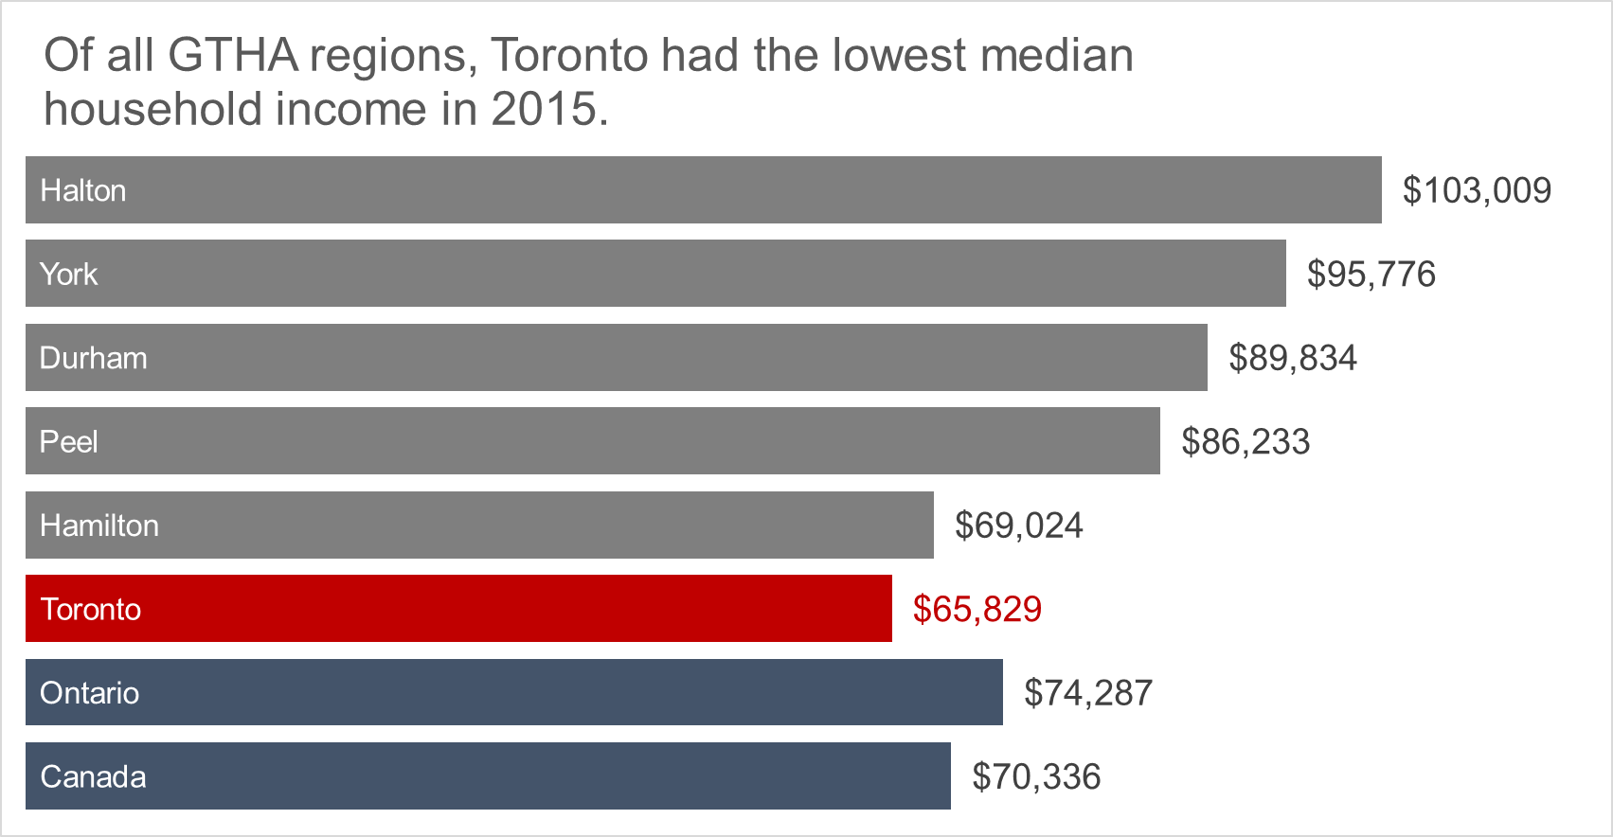

Figure 2: Government transfers as proportion of total income by Census Division for the Greater Toronto and Hamilton Area and for Ontario and Canada
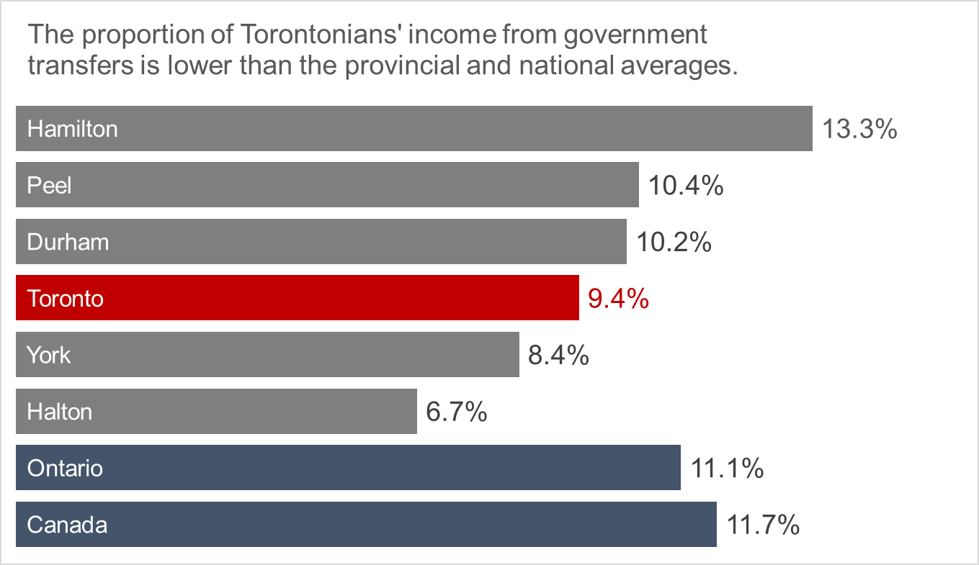

Figure 3: Prevalence of low income (LIM-AT) by Census Division for the Greater Toronto and Hamilton Area and for Ontario and Canada
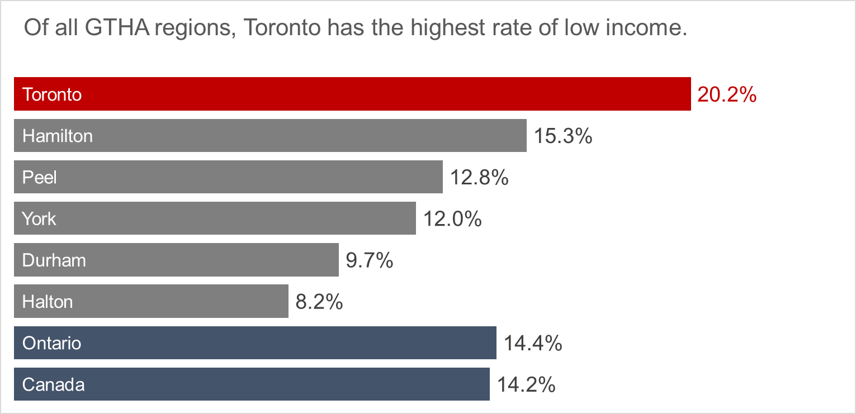

Figure 4: Prevalence of low income (LIM-AT) by age group, City of Toronto
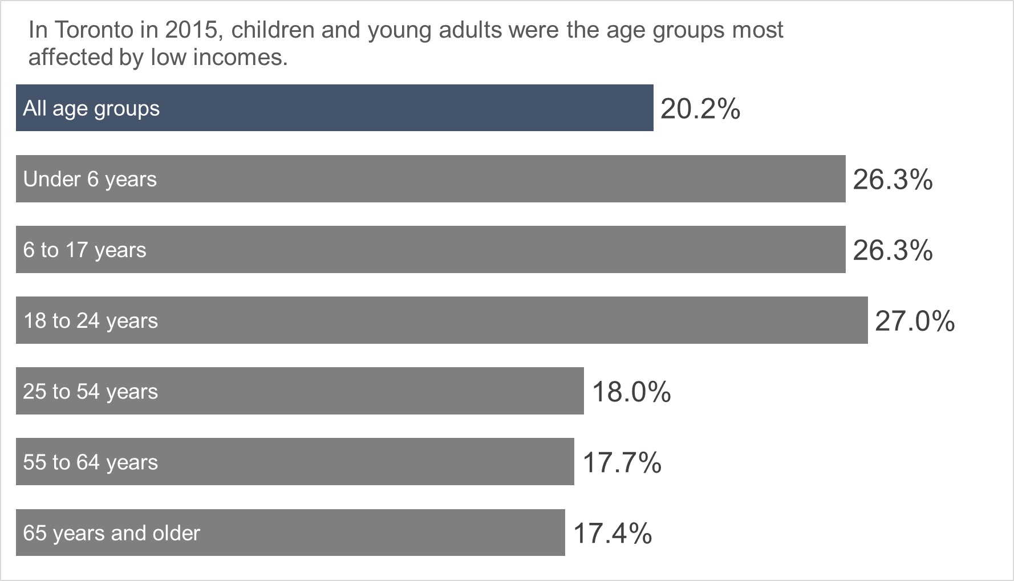

Figure 5: Prevalence of low income (LIM-AT) by age group, Greater Toronto and Hamilton Area Census Divisions
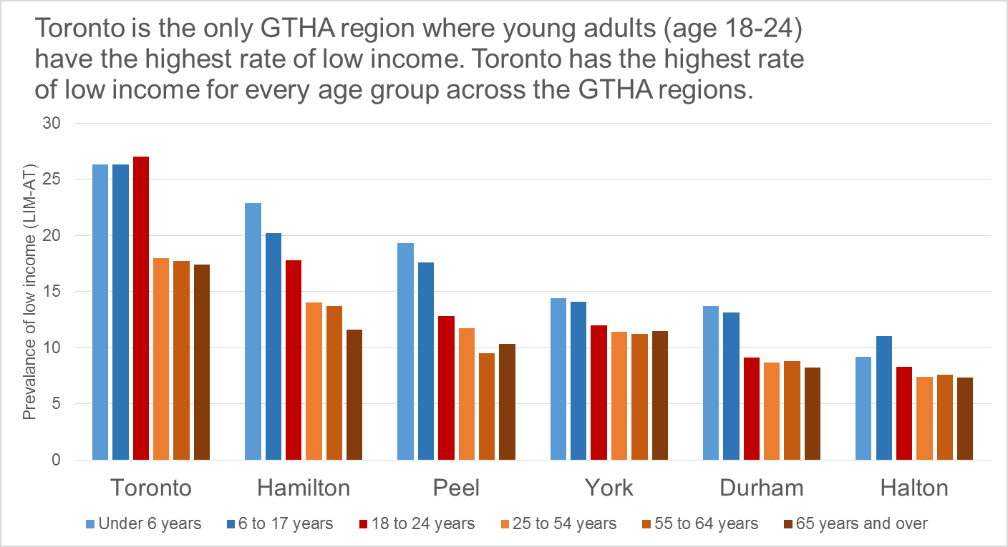

Figure 6: Proportion of individuals with employment income by selected income brackets, Census Division for Toronto, the Greater Toronto and Hamilton Area, Ontario and Canada
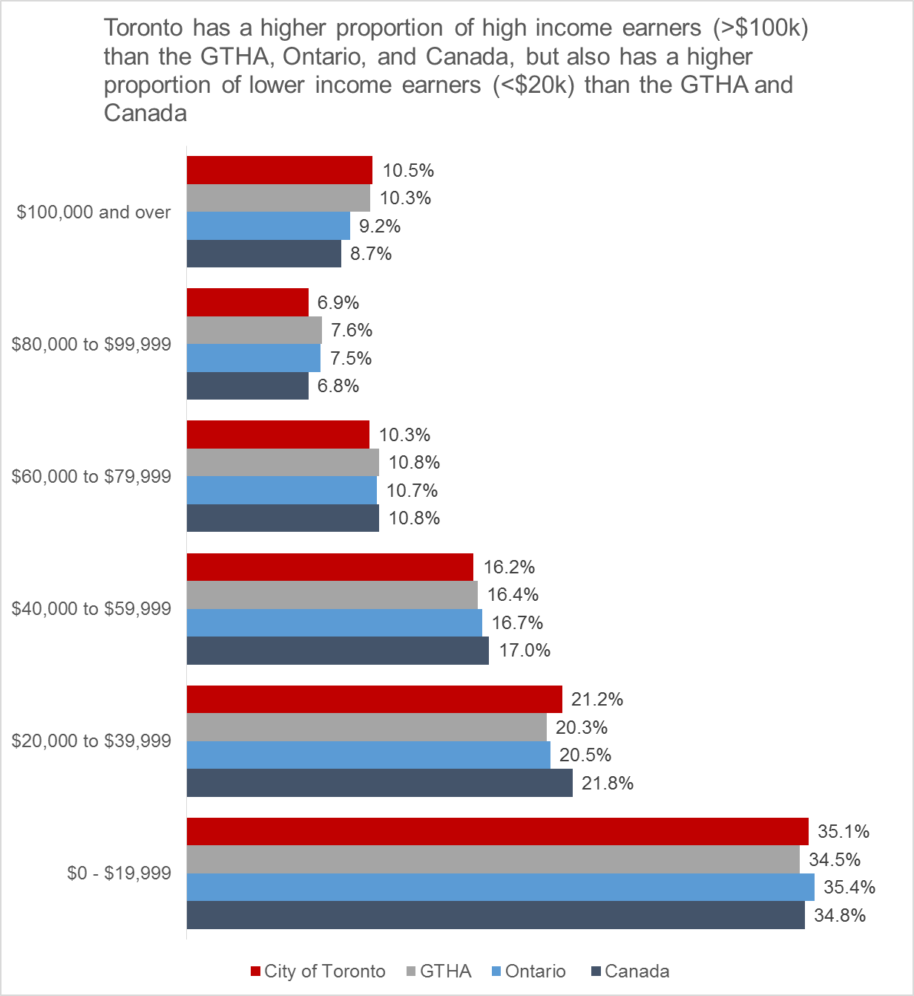

Map 1: Median Household Income by Census Subdivision in the GTHA, 2015
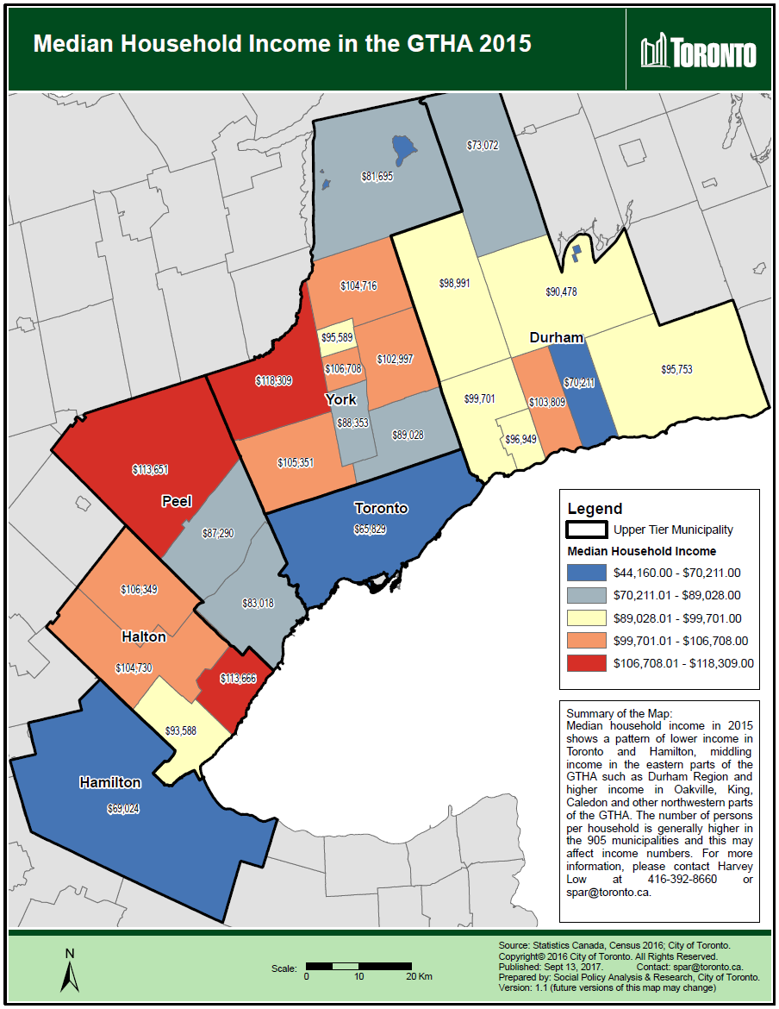
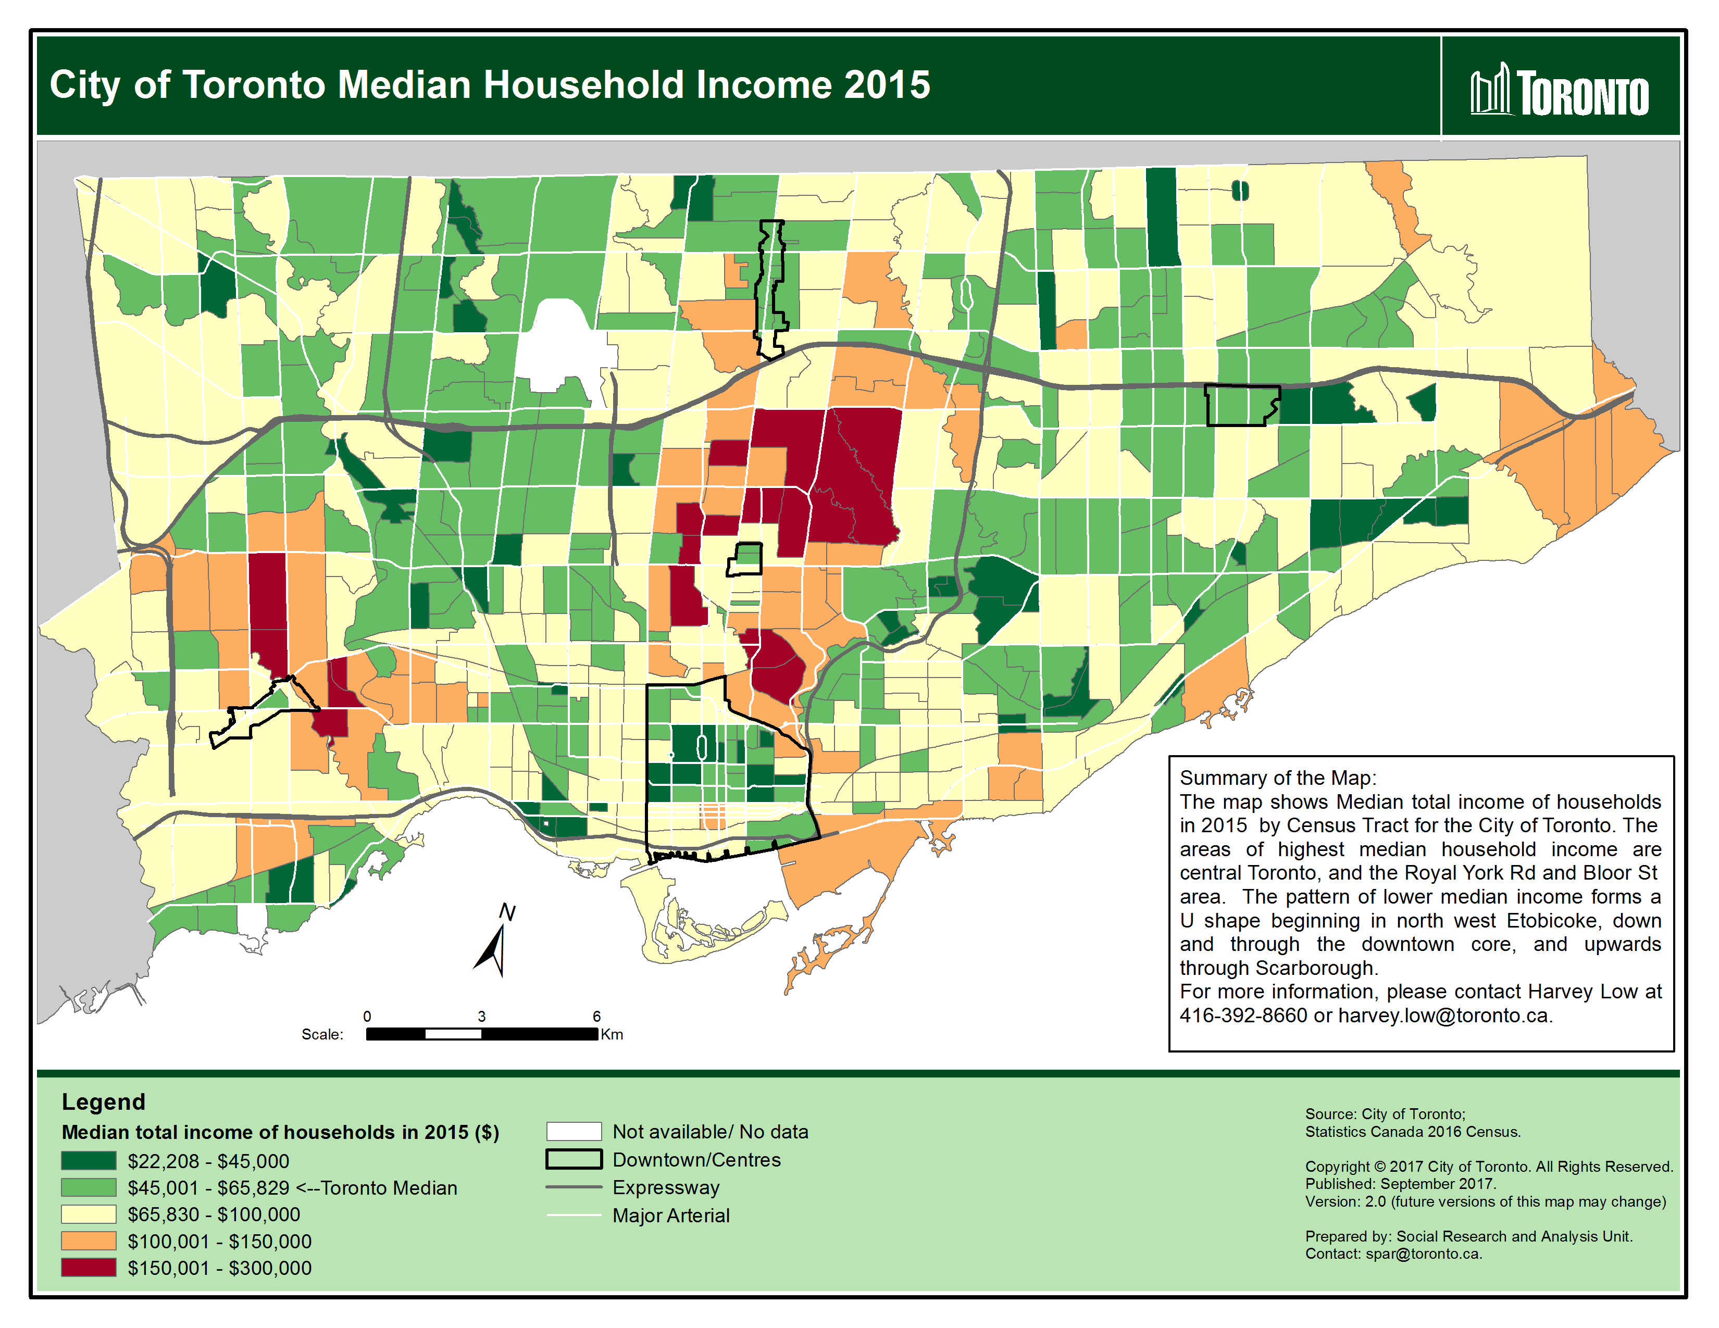
Map 2: Median Household Income by Census Tract in the City of Toronto, 2015
Map 3: Prevalence of Low Income (LIM-AT) by Census Subdivision in the GTHA, 2015
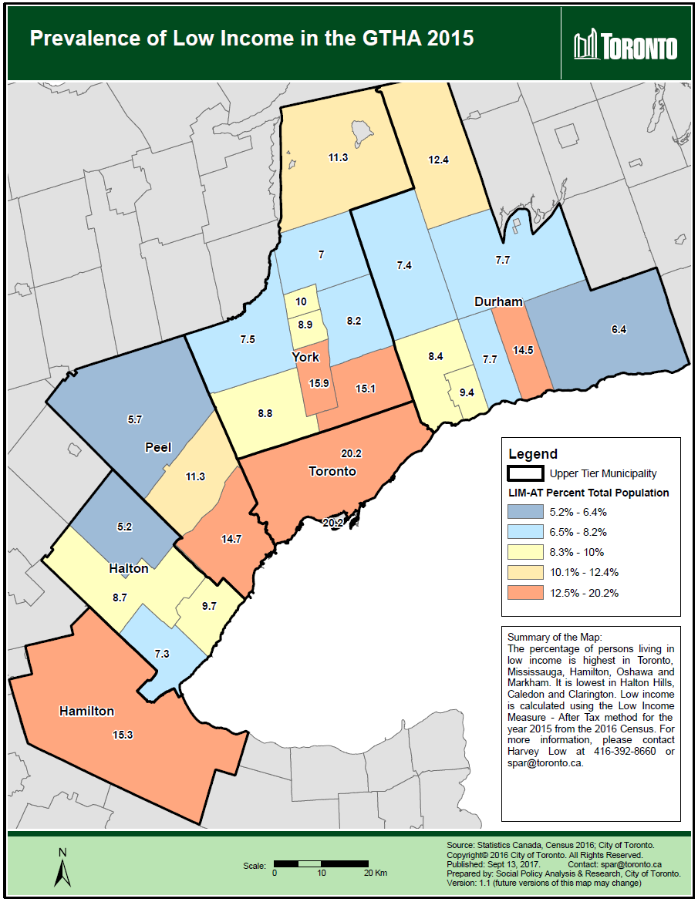
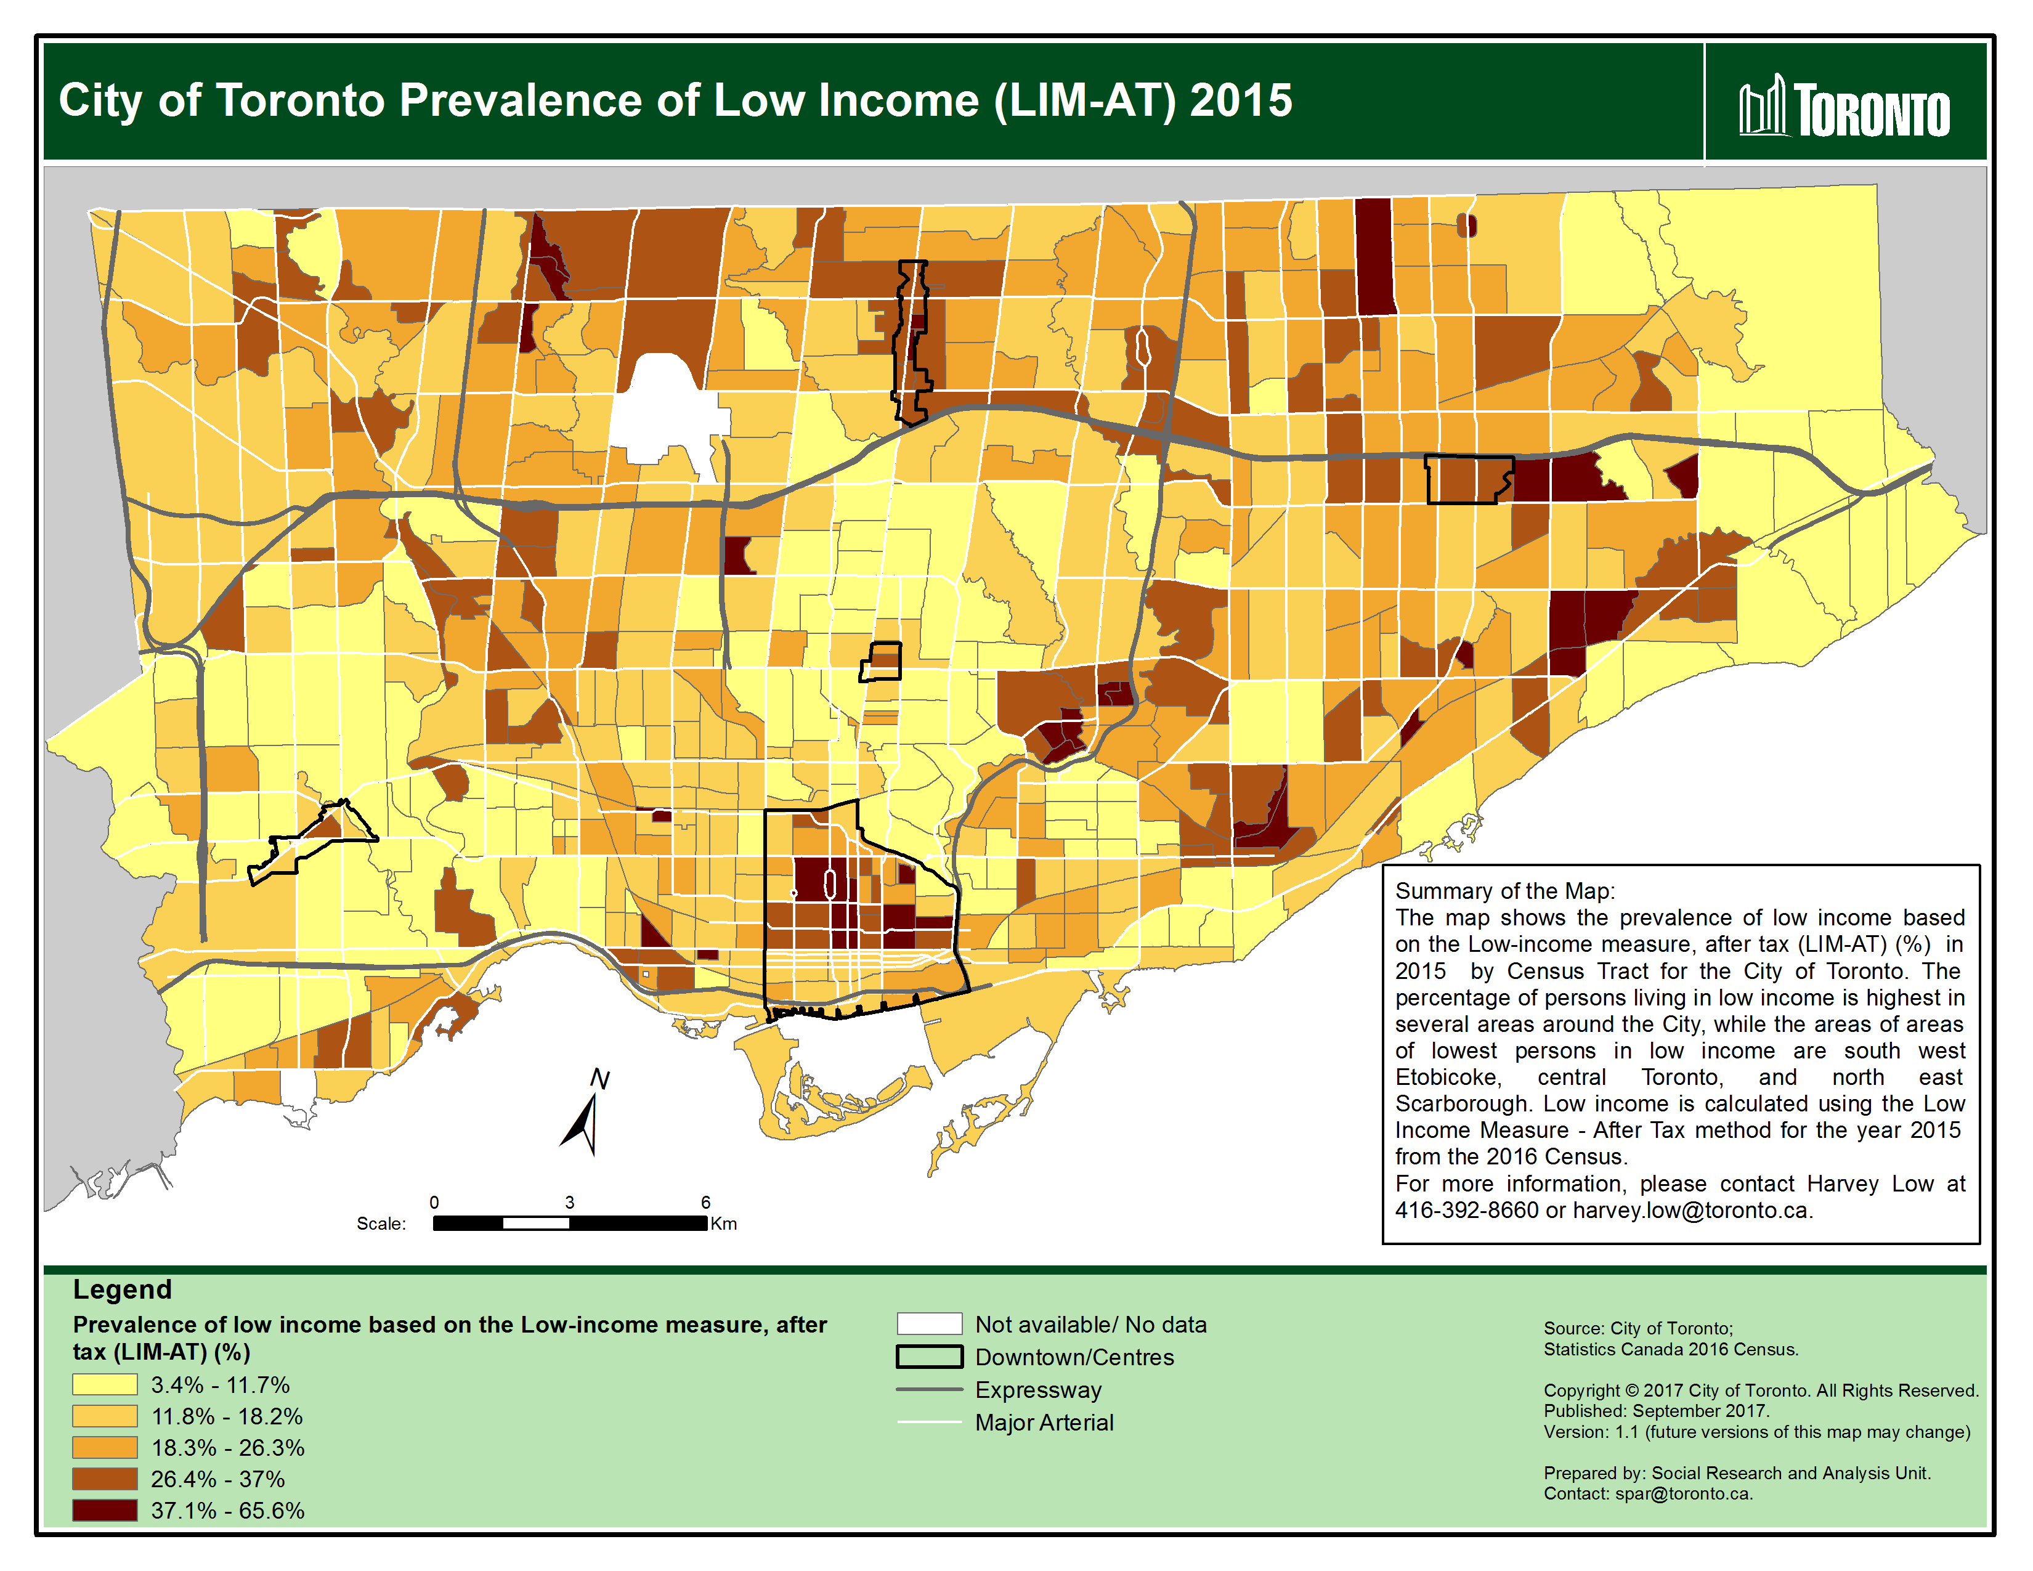
Map 4: Prevalence of Low Income (LIM-AT) by Census Tract in the City of Toronto, 2015

