DID YOU KNOW …

- Misspelled names can be corrected at Intake or Admission?

- Incorrect Date of Birth (DOB) (or Gender) can be corrected at Intake?

You complete a smart search for a client and notice that the client’s name is misspelled:

Step 1: Select the Client File
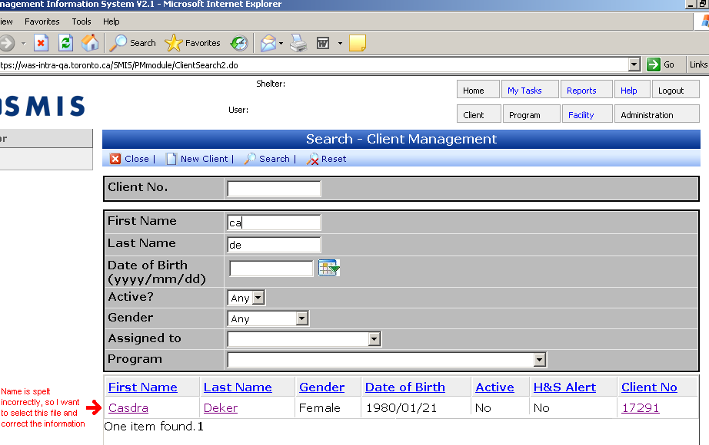

Step 2: Select Intake in the Navigator
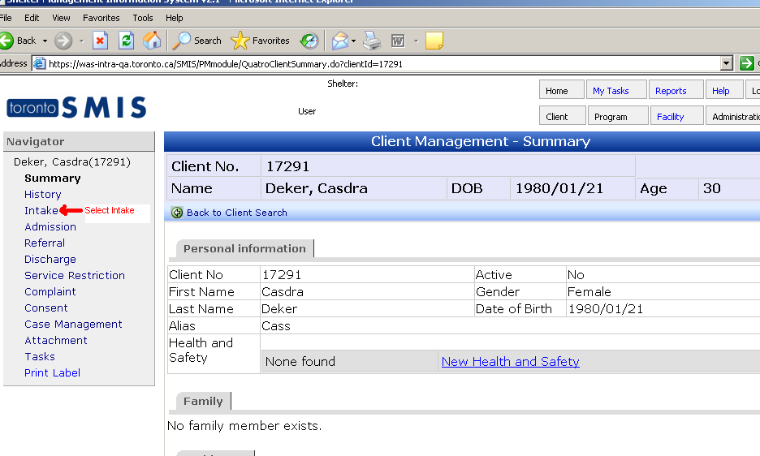

- If an Active Intake (updatable intake) already exists then Select Update.
- If there are no Active Intakes then Select New Intake
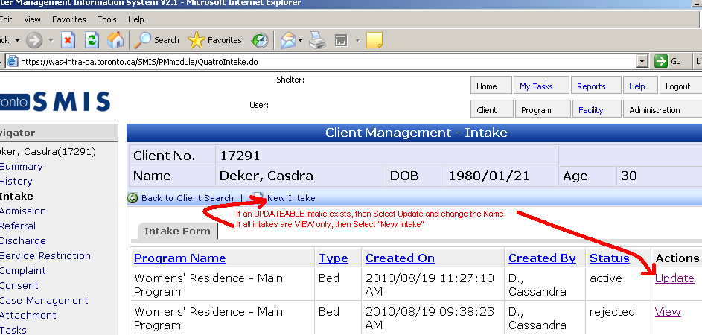

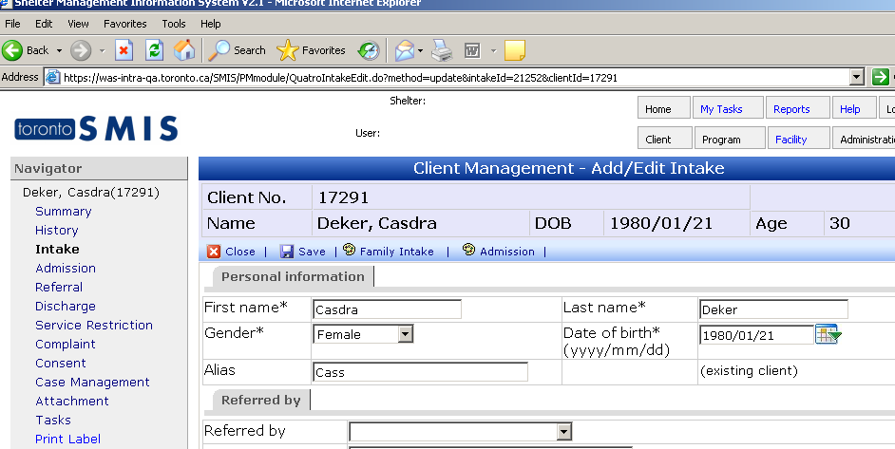

Step 3: Correct the spelling of the Client’s Name and Save
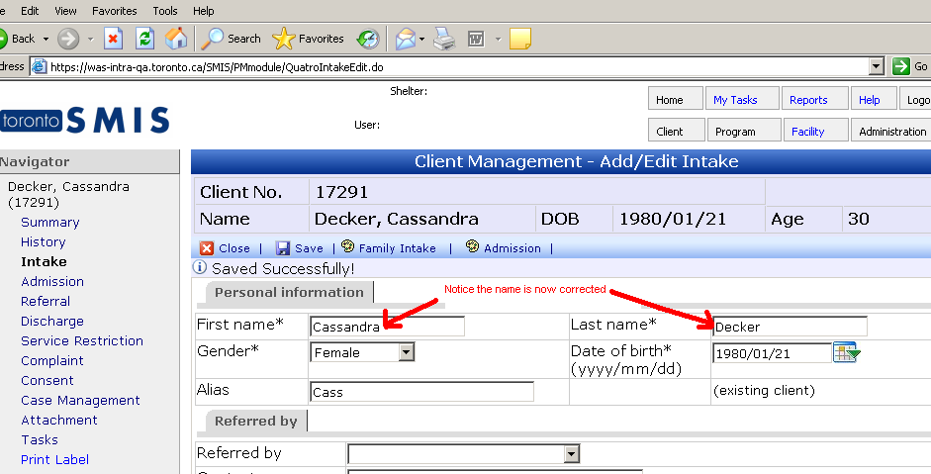

Client Search now shows the Correct Spelling of the Client Name.
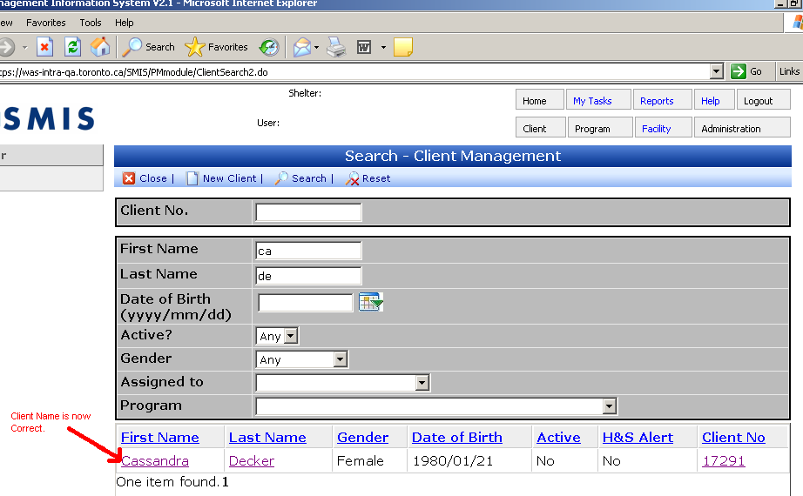

Date of Birth_ (or Gender) ______________________________________

An incorrect Date Of Birth (DOB) (or Gender) can be corrected before Admission when completing a New Intake or Updating an existing one, as long as the Client is not admitted into the Shelter Program.

If the Client has an incorrect DOB (or Gender) and is admitted into the Shelter, then you would have to discharge the client, re-intake the client changing the DOB/Gender and then re-admit.

Step 1: Select the Client File
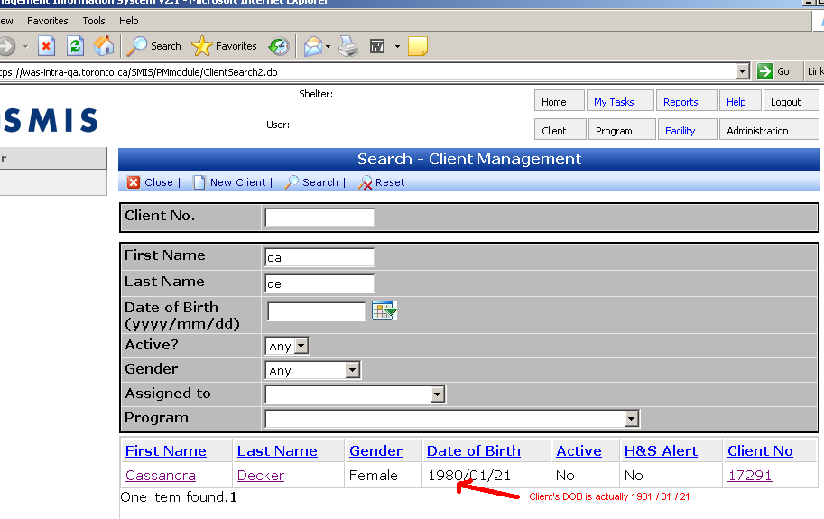

Step 2: Select Intake in the Navigator
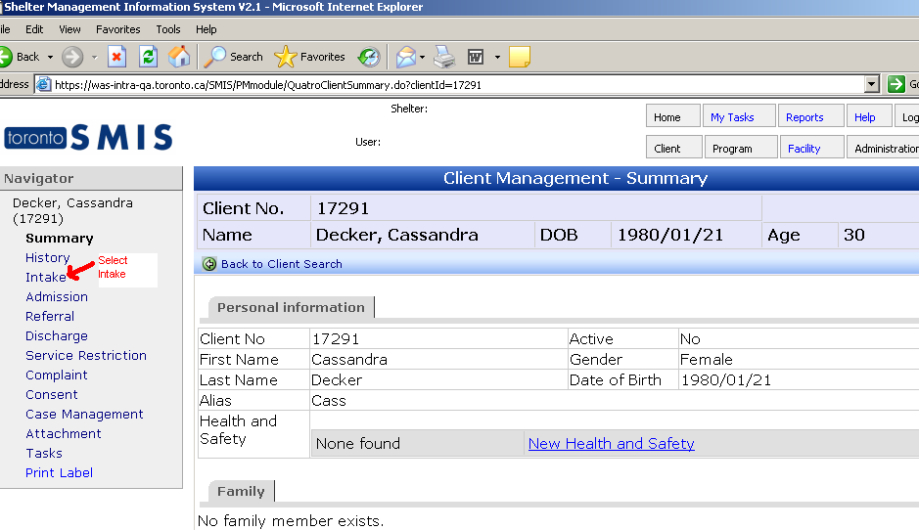

- If an Active Intake (updatable intake) already exists then Select Update.
- If there are no Active Intakes then Select New Intake
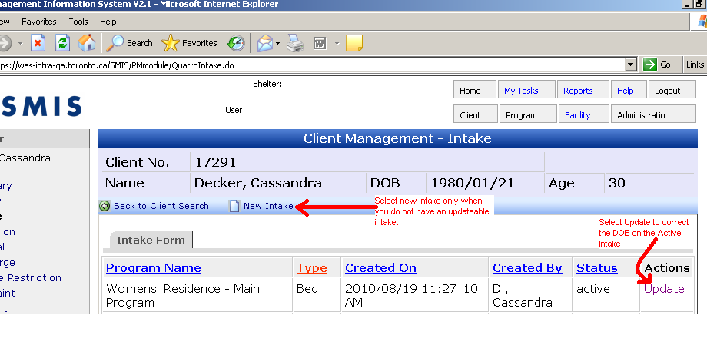
Step 3: Correct the DOB (or Gender) and Save
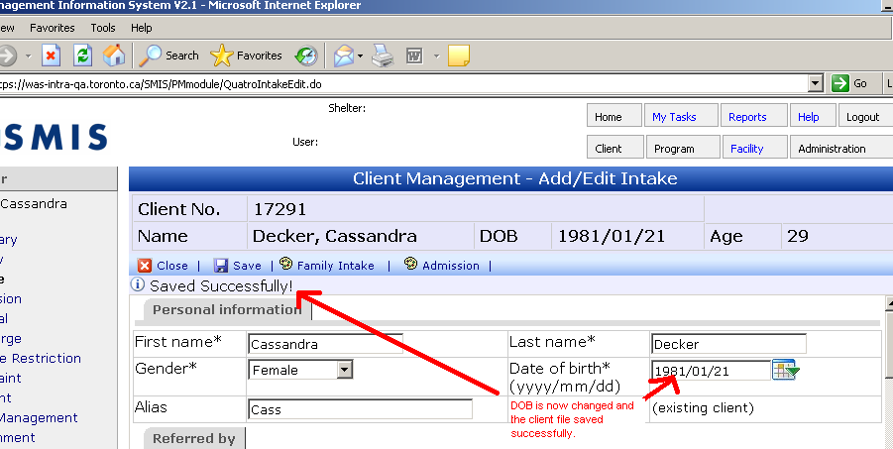

Client Search now shows the Correct DOB of the Client 