**StART Support Mural Program**

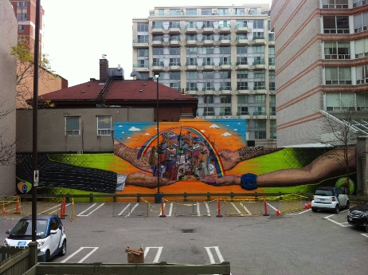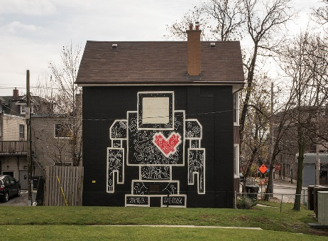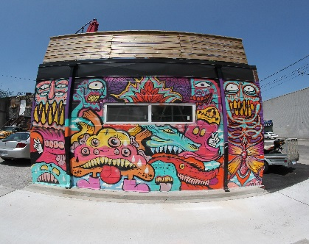

The City of Toronto will provide materials for the creation of graffiti art and art murals on properties with a history of repeated graffiti vandalism on walls exposed to city streets.

City of Toronto property owners who have received a Notice of Violation for Graffiti from Municipal Licensing & Standards or can otherwise prove they are experiencing issues with graffiti vandalism (i.e. photos or a Google streetview image) are eligible to receive up to $2,000 of direct material purchases, which can include:

* Artistic quality spray paint, available in a variety of colours;
* Assorted spray paint caps producing various effects;
* Exterior paint in a full colour spectrum; and
* A limited supply of application materials, including paint rollers, brushes and paint trays.

Materials required for the project will be purchased by City of Toronto staff through consultation with the artist(s) selected to complete the work and will be based on factors including the conceptual sketch for the design and the size of the mural proposed. Designs and artwork are subject to final approval by the City of Toronto.

The City has the sole discretion to approve or reject an application and to determine what materials will be provided if an application is approved.

Property owners must hire an artist of their choosing independently, and pay them directly for services rendered or equipment rentals as required. You may wish to visit the StreetARToronto Artist Directory online.

Property owners will be responsible for maintaining the artwork on their building in good repair, for a period of 1 year from the completion date of the project.

Email [graffiti@toronto.ca](mailto:graffiti@toronto.ca) or call 416-338-2951 for more details and to determine if you are eligible. Consultation with City staff is required before commencing any work. Please complete the attached application and submit it to [graffiti@toronto.ca](mailto:graffiti@toronto.ca).

**StART Support Mural Program Application**

Property Owner/Applicant Name (First, Last) _______________________________________

Address of Proposed Mural Location _____________________________________________

Mailing Address __________________________________ Postal Code ________________­

Telephone Number_________________ Email: ____________________________________

Artist Name (may use Artist Alias if desired) _______________________________________­

Artist Telephone Number__________________ Artist Email: __________________________

Area of the proposed wall (square feet): ________________________________________­­­­­___

Confirm that the proposed wall is visible from city streets (Y/N) ________________________

**Your application must include a digital photo of the wall**. The wall must be visible from the street.

Upon receipt, City of Toronto staff will contact you for further details about your proposed project The following items will be required to complete the application process and release materials:

1. Conceptual sketch of the proposed artwork, signed by the property owner and artist as evidence of their agreement on the design. Designs and artwork are subject to final approval by the City.

2. A list of required materials (form to be provided). Allocation of materials are conditional upon the submission of the wall size and conceptual sketch, along with consultation with City staff.

3. A signed Terms and Conditions agreement by the property owner to be provided by the City of Toronto.

4. A completed Declaration of Compliance with Anti-Harassment/Discrimination Legislation and City Policy which can be downloaded on the website.

Please submit this application to [graffiti@toronto.ca](mailto:graffiti@toronto.ca) or call 416-338-2951 for more information.

Transportation Services collects personal information on this form under the authority of the City of Toronto Act, S.O. 2006, Chapter 11, Schedule A, s. 136(c), City of Toronto Municipal Code, Chapter 485, Graffiti, and City of Toronto By-Law No. 894-2011 and No. 1218-2011.  The information collected will be used to administer the application process, determine eligibility for the StART Support Mural Program and follow up purposes.  Questions about this collection can be directed to the Project Manager, City Hall, 23rd Floor, East Tower, 100 Queen Street West, Toronto, Ontario, M5N 2H2 or by telephone at 416-338-2951.

Terms and Conditions

**StART Support Mural Program**

____________________________________________ (Name of Applicant/Property Owner) has the authority to make decisions on behalf of the property located at:

__________________________________________________________________________

The Property Owner agrees that by signing and submitting this document, they are bound by the terms and conditions contained in Appendix 1, attached.

The Property Owner agrees that they will be responsible for the maintenance of the completed project for 1 year.

The Property Owner agrees that by signing and submitting this application that they have not received mural installation funding from the StreetARToronto Program or the Economic Development Business Improvement Area Mural Program, and confirm that they will not apply for this funding in the future for this project.

The Property Owner will ensure that the project will be carried out in accordance with the *Building Code Act, 1992*, City of Toronto By-laws, the *Occupational Health and Safety Act, 1990* and all other applicable law, all as amended.

The Property Owner acknowledges that the completed project is subject to inspection by the City of Toronto (the "City").

____________________________________________________________________________

______________________________________________

Property Owner

______________________________________________

Signature

______________________________________________

**Appendix 1**

**StART Support Mural Program**

*Terms and Conditions of Material Provision:*

By signing and submitting the **StART Support Mural Program** (the "StART Support") application (the "Application"), the applicant acknowledges and agrees to the following terms and conditions:

**1.0 Use and Purpose of Material Funding**

1.1 The materials provided by the City (the "Materials") must be used only for the purposes of the StART Support Mural Program as detailed in the application and conceptual sketch.

1.2 Designs and artwork are subject to final approval by the City.

1.3 The Property Owner (the "Property Owner") must notify City staff, as identified in Section 9.0, of any proposed changes affecting material requirements to the project from what is contained in the application. The materials can be used for such changes only with the prior written consent of City staff.

1.4 The Property Owner must not transfer or assign the materials or any part of it to another individual or corporation, without the prior written consent of City staff.

1.5 The Property Owner is wholly responsible for the selection and management of the artist(s) performing the artwork installation, including any arrangements or agreements that must be made with the Artist for the design, installation and maintenance of the mural.

1.6 The Property Owner is wholly responsible for any additional costs arising from the project, including but not limited to, picking up required materials from vendors, equipment rentals, any required permits and insurance, substrate cleaning, artist payments, etc.

1.7 The Property Owner agrees to have the mural posted on the City of Toronto website, and that it may be used in any City of Toronto promotional materials as required. The artist will be credited for their work. The Property Owner shall ensure that the artist is aware of and agrees to the posting of the mural on the City of Toronto website and use of images in promotional materials.

1.8 The artwork shall not promote violence, hatred or contempt against any identifiable person or group distinguished on the basis of colour, race, ancestry, religion, ethnic origin, sexual orientation, politics, age, language or disability.

1.9 The artwork shall not comprise an advertisement and must comply with City of Toronto Municipal Code Chapter 694, Signs, General. Application for a variance to the Sign Bylaw is the sole responsibility of the property owner. Material funding will not be provided for signs. The approval and provision of Materials by the City as a part of the StART Support Mural Program does not absolve the Property Owner from compliance with applicable law.

2.0 Ownership and Disclosure of Application Documentation

The do­cu­men­ta­tion comprising any Application, al­ong with all correspondence, documentation and information provided to the City by any applicant in connection with, or arising out of this StART Support project, once re­ceiv­ed by the Ci­ty:

1. shall become the property of the City and may be appended to the Application from the suc­cess­ful Property Owners;
2. shall be­come subject to the *Municipal Freedom of Information and Protection of Privacy Act* ("*MFIPPA*"), and may be released, pursuant to that Act.

Because of *MFIPPA*, prospective Property Owners are advised to identify in their Application any scientific, technical, commercial, proprietary or similar confidential information, the disclosure of which could cause them injury.

**3.0 Project Completion Time**

3.1 The StART Support project must be completed no later than October 31 of the year the application is received (the "Final Completion Date") unless City staff have provided prior written approval of an extension.

3.2 In the event that any portion of the StART Support project is incomplete or unsatisfactorily completed, as determined by the City, on the Final Completion Date, or the extension thereof, the Property Owner shall upon request by the City, immediately repay the value of the materials received, or return unused materials, in whole or in part, plus interest as determined by the City.

3.3 A minimum of one digital photo depicting the completed project in it's entirety, with a minimum resolution of 300 dpi, must be submitted to the City at the completion of the project.

**4.0 Properties Designated Under Either Part IV or Part V of the Ontario Heritage Act**

4.1 Properties listed and designated on the City of Toronto's Inventory of Heritage Properties will have limited approval for a StART Support mural. Owners of heritage properties are solely responsible for receiving the necessary project review and approvals from the City of Toronto's Heritage Preservation Services unit at 416-392-1975 or [heritagepreservation@toronto.ca](mailto:heritagepreservation@toronto.ca).

**5.0 Limitation of Liability and Indemnification**

5.1 The City will not be liable for any damages, injury or any loss of use or profit of the Property Owner arising out of, or in any way related to the Funding or to the Property Owner’s operations.

5.2 The Property Owner shall indemnify the City, its officers, employees and agents, against all costs, damages and expenses incurred as a result of a claim or proceeding related to the Funding or to the Property Owner’s operations, including but not limited to allegations or claims of copyright infringement, unless such costs, damages or expenses arise from the negligence or wilful act of an officer, employee or agent of the City.

5.3 The Property Owner agrees that there is no intention to form an employer/employee or agency relationship between the City and the Property Owner. Neither is there any intention to create a partnership, joint venture or joint enterprise between the Property Owner and the City.

5.4 The Property Owner agrees that the City shall not be responsible for any damages, injury or loss arising from the arrangements between the Property Owner and the Artist. The Property Owner understands that the City is not a party to the arrangements made between the Property Owner and the Artist. In addition, the provision of Materials shall not be construed as an endorsement of an Artist or the Artist’s works. The Property Owner understands and agrees that it is the Property Owner’s sole responsibility to review and scrutinize the Artist’s abilities, qualifications and background.

6.0 **Anti-Racism, Access and Equity Guidelines**

6.1 The Property Owner must complete and file a Declaration of Compliance with Anti-Harassment/Discrimination Legislation and City Policy that indicates that the Property Owner has adopted and upholds a policy of access and non-discrimination. The Property Owner will work actively to integrate anti-racism, access and equity, throughout their operations, in accordance with the City’s approved Anti-Racism, Access and Equity Policy as it relates to all funding Property Owners.

7.0 **Maintenance Obligations**

7.1 If vandalism to the artwork occurs, graffiti must be removed within three (3) working days of notification. Where Hate/Racist, Gang-related and/or offensive graffiti is identified, graffiti must be removed within twenty four (24) hours of being notified.

7.2 It is the responsibility of the property owner to maintain the street art in good repair, including the removal of any graffiti vandalism, for a period of 1 year from the Final Completion Date.

7.3 It is the responsibility of the property owner to remove graffiti vandalism on their property following the 1 year term of the maintenance agreement in accordance with City of Toronto Municipal Code Chapter 485, Graffiti.

**8.0 Permission to Repair or Change Mural**

8.1 The Property Owner agrees to extend permission for the artist or the City to enter onto the property for repairs or changes to the mural, as required, for a period of 1 year from the completion date of the mural.

**9.0 Notifications and Communications**

9.1 Any requests, notifications and materials must be submitted in writing to the attention of Graffiti Management Plan staff by email or hard copy to:

[graffiti@toronto.ca](mailto:graffiti@toronto.ca)

or

Public Realm Section, Transportation Services

City of Toronto

23rd Floor, East Tower

Toronto City Hall

100 Queen Street West

Toronto, Ontario M5H 2N2

Attention: Jodi Callan, Project Manager



### Declaration of Compliance with Anti-Harassment/Discrimination Legislation & City Policy

Group/ Vendor/ Individual Name: Date:

Organizations/individuals in Ontario, including the City of Toronto, have obligations under the Ontario Human Rights Code, the Occupational Health and Safety Act, the Employment Standards Act, the Accessibility for Ontarians with Disabilities Act, the Criminal Code of Canada and the Charter of Rights and Freedoms. In addition, the City of Toronto also has policies that prohibit discrimination on the additional grounds of political affiliation or level of literacy, subject to the requirements of the Charter. Organizations are required to have and post policies, programs, information, instruction, plans and/or other supports, and an appropriate internal process available to their employees and service recipients to prevent, address and remedy discrimination, racism, harassment, hate and inaccessibility complaints under the applicable legislation and including the additional grounds of discrimination prohibited under City policy. Individuals are obliged to refrain from harassment/hate activity.

For Office Use Only

**DECLARATION OF COMPLIANCE WITH ANTI-HARASSMENT/ DISCRIMINATION LEGISLATION & CITY POLICY**

The City of Toronto requires all organizations and individuals that contract with the City to sign the following Declaration of Compliance with Anti-Harassment/Discrimination Legislation & City Policy. This Declaration must be signed by your organization and submitted with the contract or Letter of Understanding. The name of your organization and the fact that you have signed this declaration may be included in a public report to City Council.

**Declaration: I/we uphold our obligations under the above provincial and federal legislation. In addition, I/we uphold our obligations under City policies which prohibit harassment/discrimination on a number of grounds including political affiliation and level of literacy.**

**WHERE LEGALLY MANDATED I/we have in place the necessary policies, programs, information, instruction, plans and/or other supports that are consistent with our obligations, and I/we have an internal process available to my/our employees and service recipients to prevent, address and remedy discrimination, racism, harassment, hate and inaccessibility complaints. I/we agree that I/we shall, upon the request of the City, provide evidence of the policies, programs, information, instruction, plans and other supports and an appropriate internal complaint resolution process required under this Declaration which is sufficient to allow the City to determine compliance. I/We acknowledge that failure to demonstrate compliance with this declaration to the satisfaction of the operating Division, in consultation with the City Solicitor, may result in the termination of the contract.**

**Name of Vendor or Name of Grant Applicant** (Organization or Individual)**:**

Complete Address:

Email __________________

Tel. No._________________

Postal Code: Fax No.

Name of Signing Officer or Name of Applicant (Name – *please print*): Position:

Signature: Date:

*Authorised Signing Officer or Individual*



Multilingual Services: 311 and TTY 416-338-0889