 |  | DELEGATED APPROVAL FORM  DIRECTOR, REAL ESTATE SERVICES  MANAGER, REAL ESTATE SERVICES |  |  | TRACKING NO.: 2018-031
Approved pursuant to the Delegated Authority contained in Executive Committee Item EX27.12, as adopted by City Council on October 2, 3 and 4, 2017 or, where applicable, in Executive Committee Item EX28.8, as adopted by City Council on November 7, 8 and 9, 2017.
Prepared By: | Jack Harvey |  | Division: | Real Estate Services
Date Prepared: | February 02, 2018 |  | Phone No.: | (416) 397-7704
Purpose | To obtain authority to enter into a lease amending agreement (the "Agreement") between the City of Toronto (the "City") and Carrot Common Corporation (the "Tenant") to abate the monthly basic rent for four months in consideration of the City's early termination of the lease to facilitate Chester Subway Station upgrades.
Property | 4,825 square feet of City-owned land at the rear of 22 Chester Avenue, designated as Part 6, 7, 8, 9 10. 11 and 12 on Plan R-3874 (the "Leased Area"), as outlined in heavy red on the site plan on page 5.
Actions | - Authority be granted to enter into the Agreement with the Tenant, substantially on terms and conditions outlined below, and on any such other or amended terms and conditions as may be satisfactory to the Director of Real Estate Services or his designate, and in a form acceptable to the City Solicitor;  - The Director of Real Estate Services or his designate, shall administer and manage the Agreement including the provision of any consents, approvals, amendments, waivers, notices and notice of termination provided that the Director of Real Estates Services may, at any time, refer consideration of such matters to City Council for its determination and direction; and  - The appropriate City Officials be authorized and directed to take the necessary action to give effect thereto.
Financial Impact | Approval will reduce the basic rent revenue for the City each month for the remaining four months of the term for a total revenue reduction of $1,666.64 ($416.66 per month for four months).  The Acting Chief Financial Officer has reviewed this DAF and agrees with the financial impact information.
Comments | By adoption of Clause No. 8, Report No. 13 of the Parks, Recreation and Property Committee, the Metropolitan Council on November 10, 1987, approval was granted to enter into a lease agreement with the Tenant to use the Leased Area for parking purposes commencing on December 1, 1987 and expiring on November 30, 1992. By adoption of Clause No. 9, Report No. 32 of the Management Committee, the Metropolitan Council on October 14, 1992 approved a lease renewal commencing December 1, 1992 and expiring on November 30, 1997. By adoption of Clause No. 64, Report No. 23 of the Corporate Administration Committee, the Metropolitan Council on October 8 and 9, 1997 approved a lease renewal commencing December 1, 1997 and expiring on November 30, 2002. As authorized by DAF No. 2002-167, the lease was renewed for five years effective December 1, 2002, expiring on November 30, 2007 and the Tenant was in overholding until November 30, 2013. As authorized by DAF No. 2014-273 the lease was renewed for a further term of five years commencing December 1, 2013 and ending November 30, 2018.  The Leased Area is under the operational management of the Toronto Transit Commission ("TTC"). In early 2017 Real Estate Service was advised the property was required by TTC for construction at the rear of Chester Station. Due to various reasons, the construction has been delayed. As a result of the delays, the lease termination date has been changed on three occasions enabling the Tenant to continue to lease the Leased Area. The most recent termination date was scheduled for December 31, 2017 and the Tenant removed their parking meter machine to ensure the property could be vacated by the termination date. Subsequent to the Tenant's equipment removal TTC advised the construction project was further delayed and the property is not required until March 31, 2018. A revised termination notice was issued. In consideration of the fact that the Tenant is unable to collect parking fees from its customers, and continuing the tenancy for an additional four months benefits both parties, Real Estate staff consider the new rental rate to be fair and reasonable and at current market rates.  In accordance with general condition "cc" noted on Page 3, the concurrence of Tim Park, Manager, Real Estate Services has been obtained.
Terms | Basic Rent: From December 1, 2017 until the end of the Term $2,000.00 per month ($24,000.00 per annum)  All other terms and conditions remain unchanged.
Property Details
  Ward: | 29 – Toronto-Danforth
  Assessment Roll No.: | Part of 1904-08-4-570-08500
  Approximate Size: | 17.5 m x 26.5 m ± (57.4 ft x 86.9 ft ±)
  Approximate Area: | 448.24 m² ± (4,825 ft² ±)
  Other Information: | N/A
_{Revised: December 22, 2017}

A. | Manager, Real Estate Services  has approval authority for: |  |  | Director, Real Estate Services  has approval authority for:
1. Acquisitions: |  |  | Where total compensation does not exceed  $50,000. |  |  | Where total compensation does not exceed  $1 Million.
2. Expropriations: |  |  | Statutory offers, agreements and settlements where total compensation does not cumulatively exceed $50,000. |  |  | Statutory offers, agreements and settlements where total compensation does not cumulatively exceed $1 Million.
3. Issuance of RFPs/REOIs: |  | Delegated to a more senior position. |  |  |  | Issuance of RFPs/REOIs.
4. Permanent Highway Closures: |  | Delegated to a more senior position. |  |  |  | Initiate process & authorize GM, Transportation Services to give notice of proposed by-law.
5. Transfer of Operational Management to Divisions and Agencies: |  | Delegated to a more senior position. |  |  | Delegated to a more senior position.
6. Limiting Distance Agreements: |  |  | Where total compensation does not exceed  $50,000. |  |  | Where total compensation does not exceed  $1 Million.
7. Disposals (including Leases of 21 years or more): |  |  | Where total compensation does not exceed  $50,000. |  |  | Where total compensation does not exceed  $1 Million.
8. Exchange of land in Green Space System & Parks & Open Space Areas of Official Plan: N/A |  | Delegated to a more senior position. |  |  |  | Exchange of land in Green Space System and Parks and Open Space Areas of Official Plan.
9. Leases/Licences (City as Landlord/Licensor): |  | X | (a) Where total compensation (including options/ renewals) does not exceed $50,000. |  |  | (a) Where total compensation (including options/ renewals) does not exceed $1 Million.
9. Leases/Licences (City as Landlord/Licensor): |  |  | (b) Where compensation is less than market value, for periods not exceeding three (3) months, including licences for environmental assessments and/or testing, etc. |  |  | (b) Where compensation is less than market value, for periods not exceeding six (6) months, including licences for environmental assessments and/or testing, etc.
 |  | Leases pursuant to the Community Space Tenancy Policy delegated to a more senior position. |  |  | Leases pursuant to the Community Space Tenancy Policy delegated to a more senior position.
10. Leases/Licences (City as Tenant/Licensee): |  |  | Where total compensation (including options/ renewals) does not exceed $50,000. |  |  | Where total compensation (including options/ renewals) does not exceed $1 Million.
11. Easements (City as Grantor): |  |  | Where total compensation does not exceed $50,000. |  |  | (a) Where total compensation does not exceed $1 Million.
 |  | Delegated to a more senior position. |  |  |  | (b) When closing roads, easements to pre-existing utilities for nominal consideration.
12. Easements (City as Grantee): |  |  | Where total compensation does not exceed  $50,000. |  |  | Where total compensation does not exceed  $1 Million.
13. Revisions to Council Decisions in Real Estate Matters: |  | Delegated to a more senior position. |  |  |  | Amendment must not be materially inconsistent with original decision (and subject to General Condition (u)).
14. Miscellaneous: |  | Delegated to a more senior position. |  |  |  | (a) Approvals, Consents, Notices and Assignments under all Leases/Licences
 |  |  |  |  |  | (b) Releases/Discharges
 |  |  |  |  |  | (c) Surrenders/Abandonments
 |  |  |  |  |  | (d) Enforcements/Terminations
 |  |  |  |  |  | (e) Consents/Non-Disturbance Agreements/ Acknowledgements/Estoppels/Certificates
 |  |  |  |  |  | (f) Objections/Waivers/Caution
 |  |  |  |  |  | (g) Notices of Lease and Sublease
 |  |  |  |  |  | (h) Consent to regulatory applications by City, as owner
 |  |  |  |  |  | (i) Consent to assignment of Agreement of Purchase/Sale; Direction re Title
 |  |  |  |  |  | (j) Documentation relating to Land Titles applications
 |  |  |  |  |  | (k) Correcting/Quit Claim Transfer/Deeds
B. Director, Real Estate Services and Manager, Real Estate Services each has signing authority on behalf of the City for:
- Documents required to implement matters for which he or she also has delegated approval authority.
- Expropriation Applications and Notices following Council approval of expropriation (Manager, Acquisitions & Expropriations is only Manager with
such signing authority).
Director, Real Estate Services also has signing authority on behalf of the City for:
- Agreements of Purchase and Sale and all implementing documentation for purchases, sales and land exchanges not delegated to staff for approval.
- Community Space Tenancy Leases approved by delegated authority by Deputy City Manager, Internal Corporal Services and any related documents.

Consultation with Councillor(s)
Councillor: |  |  | Mary Fragedakis |  |  |  |  |  |  |  |  | Councillor:
Contact Name: |  |  | Daryl Finlayson |  |  |  |  |  |  |  |  | Contact Name:
Contacted by: |  |  |  | Phone |  | X | E-Mail |  | Memo |  | Other | Contacted by: |  | Phone |  | E-mail |  | Memo |  | Other
Comments: |  |  | advised |  |  |  |  |  |  |  |  | Comments:
Consultation with Divisions and/or Agencies
Division: |  |  | TTC |  |  |  |  |  |  |  |  | Division: | Financial Planning
Contact Name: |  |  | Graham Tulett |  |  |  |  |  |  |  |  | Contact Name: | Patricia Libardo
Comments: |  |  | Approved |  |  |  |  |  |  |  |  | Comments: | Approved
Legal Division Contact
Contact Name: |  |  | Dale Mellor
DAF Tracking No.: 2018-031 |  |  |  |  |  |  |  |  |  |  |  | Date | Signature
Recommended by:
 | X | Recommended by: |  |  | Manager, Real Estate Services  Tim Park  Daran Somas, Acting Mgr. LSM |  |  |  |  |  |  |  | X  X
 | X | Approved by:
 |  | Approved by: |  |  | Director, Real Estate Services  David Jollimore |  |  |  |  |  |  |  | X
General Conditions (“GC”)
- The local Councillor (or local Councillors if the subject property is located on a ward boundary or if the transaction involves an exchange of properties in more than one ward), will be consulted prior to the exercise of delegated Approving Authority by staff for all Acquisitions, Disposals, Land Exchanges and Leases. In the event of a vacancy in the Ward in which the subject property is located, the Mayor's office shall be consulted in the alternative.
- Where approving power has been delegated to staff, the Deputy City Manager, Internal Corporate Services, in consultation with any other applicable Deputy City Manager or the City Manager, may determine that such matter is of such special interest that same should be returned to the relevant Committee and Council for consideration and determination.
- Exercise of delegated authority is subject to all applicable Council policies, statutes or other applicable law.
- Authority to approve financial commitments/expenditures is subject to all amounts being available in an approved budget, or funding being available from third party sources, except for "Strategic Property Acquisitions" as set out in EX44.22 adopted by Council August 25, 26, 27 and 28, 2014, which identifies alternative funding mechanisms subject to additional approval requirements.
- Property interests are to be based on appraised value, and no interest shall be granted at less than market value unless otherwise specifically authorized.
- Authority to approve transactions at less than market value is subject to statutory anti-bonusing provisions.
- Total compensation means the aggregate of all types of payments, including land value, estimated clean-up costs, potential arbitration awards, loss claims, etc., but exclusive of any applicable taxes and registration costs.
- Authority to acquire property is conditional upon provision being made to bring the property into compliance with applicable MOE or other requirements such that it will be fit for its intended municipal purpose, except for property acquisitions of 50M² or less for transit shelter purposes.
- Authority to initiate the permanent road closure process in A.4 is conditional upon confirmation by the GM of Transportation Services that it is feasible to permanently close the highway.
- Disposal authorities in A.7 are subject to the property having been declared surplus, and the disposal policy complied with.
- Land exchanges, except for those in A.8, may be authorized based on the delegated Approving Authority for disposals in A.7.
- Approving Authority with respect to land located in the Designated Waterfront Area as defined in the Toronto Waterfront Revitalization Corporation Act, 2002 is conditional upon the approval of the Director, Waterfront Secretariat.
- Authority to approve an exchange of land in A.8 is conditional upon confirmation by the Chief Planner and Executive Director of City Planning, and the GM of Parks, Forestry & Recreation, that the land being exchanged is (i) nearby land of equivalent or larger area, and (ii) of comparable or superior green space utility.
- Approving Authority in A.9 Leases (City as Landlord) but not Licences (City as Licensor) is limited to periods (including options/renewals) of less than twenty-one (21) years, as leases of 21 years or more may be authorized based on the delegated Approving Authority for disposals in A.7.
- Total compensation in leasing matters where the City is landlord (A.9) includes the value of tenant improvements if factored into tenant’s rental payments.
- Total compensation in leasing matters where the City is the tenant (A.10) includes the value of any tenant improvements to be paid by the City.
- Where options/renewals are included in leases, if the renewal rent is to be determined at a date later than the original approval date, total compensation is to be calculated as though all options are exercised, estimating the renewal rent based on the highest rent payable in the first term of the lease.
- Total compensation in leasing matters where the City is landlord (A.9) or tenant (A.10) is to be calculated from the date of approval pursuant to this delegation (ie. first allowing for the expiry of any prior approvals, whether by Council or a delegated authority).
- Approving Authority in leasing matters includes authority to approve renewals/extensions within the parameters of the delegated Approving Authority.
- Approving Authority includes authority for amendments within the parameters of the delegated Approving Authority, the cumulative total of which may not exceed the delegated financial limit.
- Where proposed additional amounts in A.13 exceed 10 per cent of the original decision, even if otherwise in compliance with all other conditions, then Approving Authority is transferred upwards to the next more senior level of Approving Authority having the relevant overall financial limit.
- Approving Authority includes authority for all documents necessary to implement the authority, including ancillary agreements, on terms and conditions satisfactory to the Approving Authority, in consultation with the relevant operating Division(s).
- Staff positions referred to in this delegation include successors from time to time.
- Documents are to be in a form satisfactory to the City Solicitor (including indemnity and insurance provisions).
- Delegated signing authorities in B are conditional upon the documents having received the City Solicitor’s prior “Approval as to Form”.
- Authority to use land acquired by the City for parking purposes by the Toronto Parking Authority is conditional upon Council enacting a by-law designating such use.
- All residential leasing documents shall adhere to the Residential Tenancies Act, 2006 and any successor legislation.
- Despite GC(n), Approving Authority in residential leasing matters is not limited to periods of less than twenty-one (21) years and total compensation in residential leasing matters where the City is landlord is to be calculated based on an assumed term of ten years unless the lease term expressly identified therein is longer.
- Where Approving Authority has been delegated to the Manager level, such authority shall be conditional upon the Manager first having secured the written concurrence of a second Manager within the Real Estate Services Division.

Location Map
22 Chester Avenue

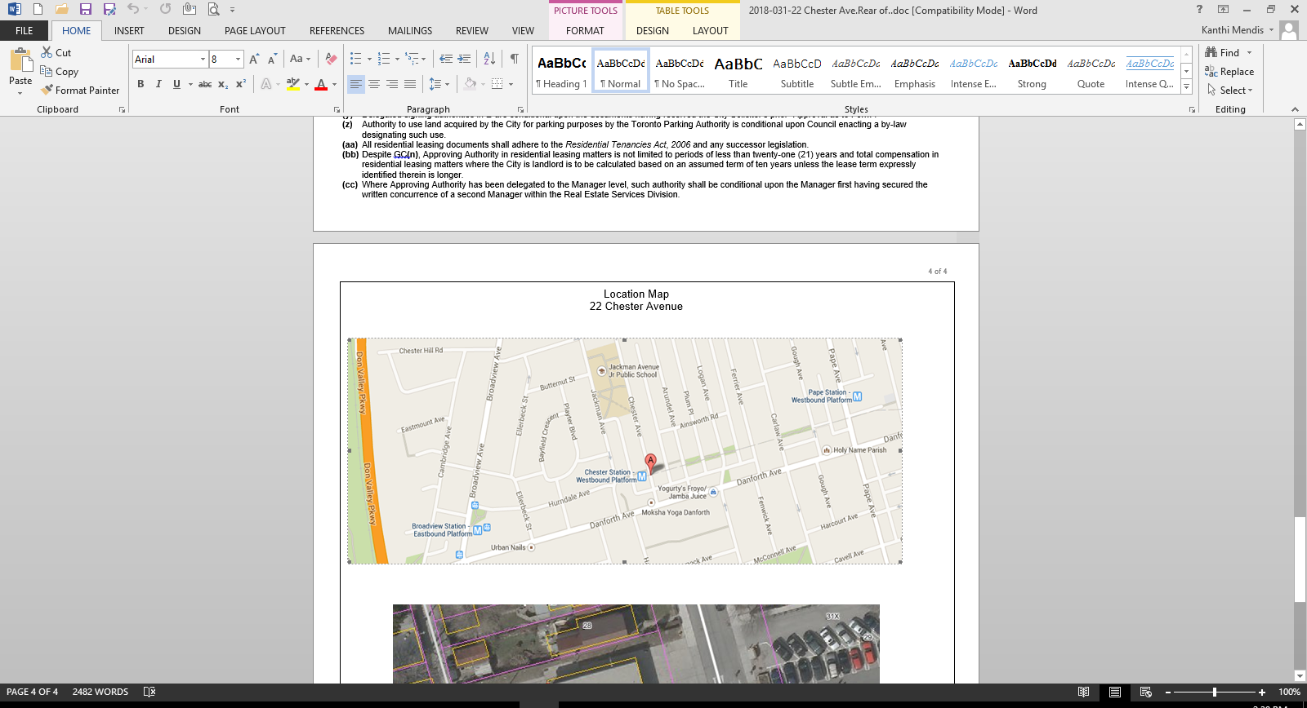

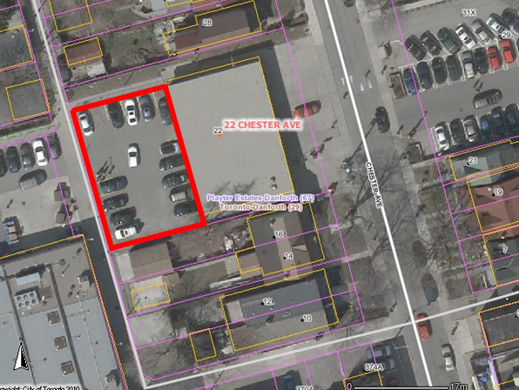
Revised Dec. 22, 2017

