Election 2018 Program

JSON Unofficial Result Files

Version history:
Version | Date of change | Author | Change description
0.1 | 07/06/2018 | Raymond Lin | Initial release
0.2 | 07/09/2018 | Tharshan S | Added Examples
0.3 | 08/03/2018 | Raymond Lin | Add municipal ward name
0.4 | 09/18/2018 | Tharshan S | Sample data change.

Table Of Contents

Introduction 3
Unofficial All Office 4
Top Level Properties 4
Office Structure 5
Ward Structure 6
Candidate Structure 6
Unofficial Mayoral Ward By Ward 7
Top Level Properties 7
Office Property 7
Candidate Structure 8
Ward Structure 8

Introduction
The unofficial reports of election 2018 will be published in JSON format. This document describes the JSON formats of the unofficial reports.
The following unofficial reports will be published to AWS:
Report | File name
Unofficial All Office | unofficialresult.json
Unofficial Mayoral Ward By Ward | unofficialresult-wardbyward.json

Unofficial All Office
This is the regular results in JSON format.

Top Level Properties
This report file has following top level properties:
Property Name | Description
electionDesc | Short description such as the election name.
office | List of offices in this election. Each office is an instance of the Office Structure  There are six(6) offices; Mayor, Councillor, Toronto District School Board, Toronto Catholic District School Board, Conseil scolaire Viamonde, and Conseil scolaire de district catholique Centre-Sud.
seq | A value derived from the timestamp when this file is generated. Different seq values indicate JSON files were generated at different times, but the report contents may be the same.
Example : | {  "electionDesc" : "2014 Test Municipal Election",  "office" : [ … ],  "seq" : "1537281351713"  }

Office Structure
The office is structured to have following properties:
Property Name | Description
id | Office id
name | Office name
Ward | List of wards in this office. Each ward is an instance of the Ward Structure
Example 1 | {  "id" : 1,  "name" : "Mayor",  "ward" : [ … ]  },
Explorer view of all offices:
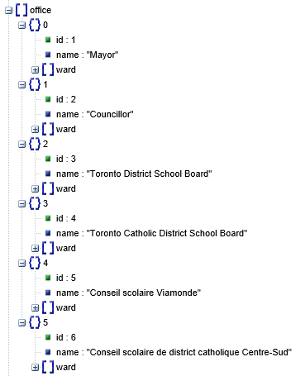

Ward Structure
The ward is structured to have following properties:
Property Name | Description
name | Ward name, if one is available. There is no name for schoolboard wards.
num | Ward number.
polls | Total number of subdivisions in this ward.
pollsReceived | Total number of subdivisions received in this ward.
totalVoters | Total number of voters in this ward.
votesReceived | Total number of votes received in this ward.
candidate | List of candidates in this ward. Each candidate is an instance of the Candidate Structure
Example | {  "name" :"Etobicoke North",  "num" : "1",  "polls" : "39",  "pollsReceived" : "34",  "totalVoters" : "30064",  "votesReceived" : "16039",  "candidate" : [ …]  },

Candidate Structure
The candidate is structured to have following properties:
Property Name | Description
name | Candidate name.
votesReceived | Total number of votes received for this candidate in this ward.
percentage | Percentage of the votes received against the total votes received in this ward.
Example | {  "name" : "Oweka-Arac Ongwen",  "votesReceived" : "56",  "percentage" : "0.01"  },

Unofficial Mayoral Ward By Ward
This is the mayoral ward by ward report in JSON format.

Top Level Properties
This report file has following top level properties:
Property Name | Description
electionDesc | Short description such as the election name.
office | Detailed report section. See Office Property for details.
seq | A value derived from the timestamp when this file is generated. Different seq values indicate JSON files were generated at different times, but the report contents may be the same.
Example: | {  "electionDesc" : "2014 Test Municipal Election",  "office" : { … },  "seq" : "1537281351660"  }

Office Property
The office property contains the detailed report. It has following properties:
Property Name | Description
name | Office name "Mayor".
polls | Total number of subdivisions in this office.
pollsReceived | Total number of subdivisions received in this office.
totalVoters | Total number of voters in this office.
votesReceived | Total number of votes received in this office.
candidate | List of mayoral candidates. Each candidare is an instance of the Candidate Structure.
Example: | {  "name" : "Mayor",  "polls" : "1988",  "pollsReceived" : "1767",  "totalVoters" : "1602483",  "votesReceived" : "981054",  "candidate" : [ ... ]  },

Candidate Structure
The candidate is structured to have following properties:
Property Name | Description
name | Candidate name.
votesReceived | Total number of votes received of this candidate.
ward | List of wards that contains votes for this candidate. Each ward is an instance of the Ward Structure.
Example: | {  "name" : "Oweka-Arac Ongwen",  "votesReceived" : "56",  "ward" : […]  },

Ward Structure
The ward is structured to have following properties:
Property Name | Description
name | Ward name.
num | Ward number.
polls | Total number of subdivisions in this ward.
pollsReceived | Total number of subdivisions received in this ward.
totalVoters | Total number of voters in this ward.
votesCounted | Total number of votes counted in this ward.
votesReceived | Total number of votes received for this candidate in this ward.
Example: | {  "name" : "Etobicoke North",  "num" : "1",  "polls" : "39",  "pollsReceived" : "34",  "totalVoters" : "30064",  "votesCounted" : "16537",  "votesReceived" : "0"  }

