Election Day

Accessibility Officer

and

Information Officer

Manual

Contact Information

Contact | Phone
Election Information Contact Centre  The public and Candidates can call for election information | 3-1-1
Accessibility Contact Centre  Voters can call if they have a concern or complaint about accessibility. | 416-338-1111, press 6

Table of Contents

1 Introduction 1
1.1 Welcome 1
1.2 An Important Message 1
1.3 Expectations 1
2 The Role of an Accessibility Officer 3
3 The Role of an Information Officer 4
4 General Election Information 6
4.1 Voters and Voting 6
4.2 Identification Requirements 6
4.3 Scrutineers & Candidates 6
4.4 Electronic Devices in the Voting Place 7
4.5 Different Voting Situations 7
5 Customer Service and Accessibility 8
5.1 Creating a Positive Voting Experience 8
5.2 Serving People with Disabilities 8
5.3 Inclusive Voting Places 8
5.4 Accommodations and Special Services 9
6 Before Election Day Checklist 11
7 Opening the Voting Place Checklist 12
8 Closing the Voting Place Checklist 13
9 Additional Information 14

- Introduction

  - Welcome

Thank you for joining the election team!

As an Election Official you play an important part in delivering this election for Toronto.

This manual outlines your duties and is for your use:
    - Make notes in it
    - Use the checklists included
    - Read the entire manual before election day

It is not necessary to memorize everything. Just be familiar with the manual so you can find the information you need when you need it.

  - An Important Message

You have been assigned as either an Accessibility Officer or an Information Officer.

Both are customer service positions and receive the same rate of pay.

Depending on the need at the voting place, the voting place manager may have you act in either position.

For this reason, you are trained to fill either role.

  - Expectations

As an Election Official and a representative of the City of Toronto you are expected to:
    - Be professional (helpful, courteous and patient)
    - Maintain secrecy
    - Act with integrity (be fair, impartial and unbiased)
    - Follow policies and procedures
    - Work together with the voting place team
    - Treat all co-workers and the public with respect
    - Refrain from engaging in harassment and/or discrimination
    - Provide people with disabilities full and equal access to the election process

This election must be conducted according to the principles of democratic elections:
    - The secrecy and confidentiality of an individual's vote is paramount
    - The election is fair and must not favour one Candidate over another
    - The election is accessible to all voters
    - The integrity of the process is maintained throughout the election
    - Voters and Candidates are treated fairly
    - There should be certainty that the results of the election reflect the votes cast
    - The proper majority vote governs by ensuring that valid votes are counted and invalid votes are rejected, so far as reasonably possible

- The Role of an Accessibility Officer

Your Role

Accessibility Officers fill a critical election role.

If there is something which could prevent voters from accessing a voting place, an Accessibility Officer is assigned.

As an Accessibility Officer, it is up to you to make sure the voting place is accessible to all voters, including people with disabilities.

By ensuring voters can access the voting place, you help them exercise their right to vote.

Your Team

If you are working in a small voting place (apartment, condominium or nursing home), your team will include:
    - A DRO who is the voting place manager
    - A Ballot Officer who issues ballots to voters
    - A Supervisor who provides mobile support to a number of voting places

If you are working in a large voting place (community centre, school or place of worship), your team will include:
    - An MDRO who is the voting place manager
    - Ballot Officers who issue ballots to voters
    - Revising Officers who add voters to the voters' list and make changes to the list
    - A Tabulator Officer who accepts ballots from voters and feeds the ballots into a vote tabulator
    - A Supervisor who provides mobile support to a number of voting places

You may also be working with:
    - A VAT Officer who assists voters using a VAT
- The VAT is a ballot marking machine which allows voters with disabilities to mark their ballot privately and independently

Your Duties

Depending on the barrier at the voting place, you may be assigned to:
    - Open a door where there is no "push button"
    - Operate an elevator
    - Direct voters to the accessible entrance
    - Ensure voters proceed directly to and from the voting room.

The voting place manager (MDRO or DRO) will advise you of your specific duties on election day.
- The Role of an Information Officer

Your Role

Information Officers are responsible for the flow of voters in the voting place.

Your role is to greet voters in the voting room and direct them to the appropriate Election Official.

You will also circulate secrecy folders from the Tabulator to the Ballot Officers.

Your Team

You will be working with:
    - An MDRO who manages the voting place
    - Ballot Officers who issue ballots to voters on the voters' list
    - Revising Officers who add voters to the voters' list and make corrections to the list
    - A Tabulator Officer who accepts ballots from voters and feeds the ballots into a vote tabulator
    - A Supervisor who provides mobile support to a number of voting places

You may also be working with:
    - An Accessibility Officer who ensures all voters can access the voting place
    - A VAT Officer who assists voters using a VAT
- The VAT is a ballot marking machine which allows voters with disabilities to mark their ballot privately and independently

This is the typical layout of a voting place showing the Election Officials in the voting room.

Your Duties

You determine which Election Official to direct the voter to by asking:
    - If the voter has a Voter Information Card
    - If the information on the Voter Information Card is correct

If the Voter has a Voter Information Card and the Information is Correct, you:
    - Ask the voter to have their identification ready
    - Direct the voter to the appropriate Ballot Officer for the voter's name

If the Voter does not have a Voter Information Card, you:
    - Ask the voter to have their identification ready
    - Direct the voter to the Revising Officer

If the Voter has a Voter Information Card but the information on the Card is Incorrect you:
    - Ask the voter to have their identification ready
    - Direct the voter to the Revising Officer

Sample Voter Information Card

A Voter Information Card:
    - Is sent to each voter whose name appears on the voters' list
    - Tells the voter where and when they may vote
    - Can make it easier to find a voter on the voters' list, but it is not mandatory for a voter to show their card
    - Is not accepted as identification

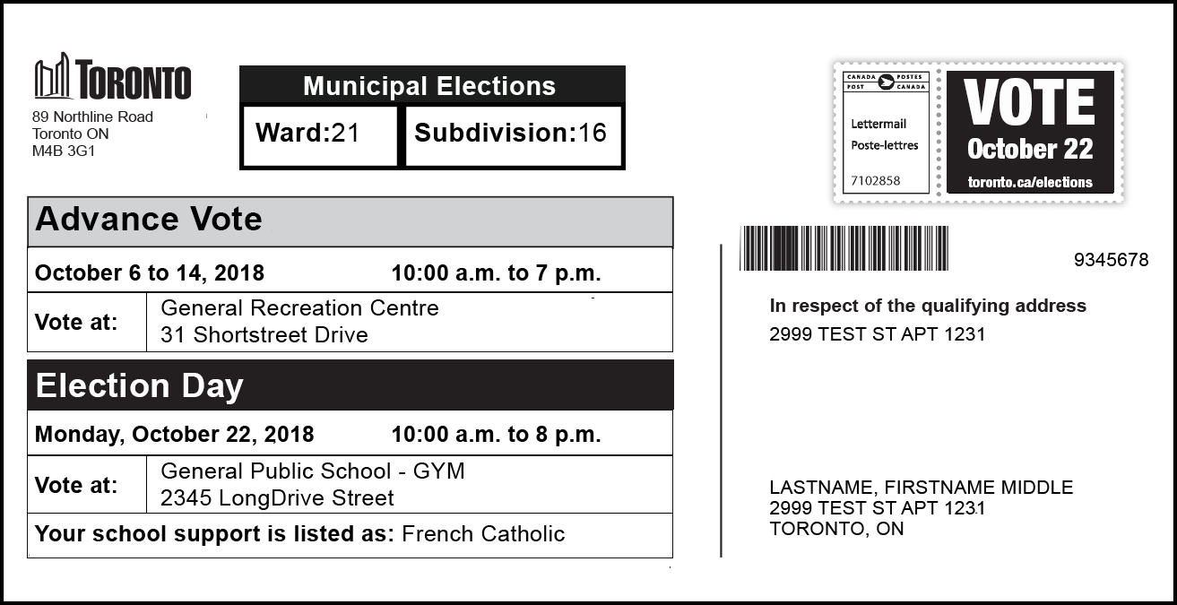

- General Election Information

  - Voters and Voting

Every person is entitled to vote who, on voting day:
    - Is a Canadian citizen and
    - Is at least 18 years of age and
    - Lives in the city of Toronto or
- Owns or rents property in Toronto or
- Is the spouse of a person who owns or rents property in Toronto
    - And is not prohibited from voting under any law

Important to know:
    - A person may only vote once in this election
    - If a person lives in Toronto and owns or rents another property in Toronto, they must vote in the ward in which they live

Voters will be voting for one Candidates for each of these offices:
    - Mayor
    - Councillor
    - Trustee
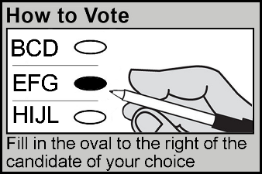
Voters will:
    - Receive a ballot in a secrecy folder
    - Mark their ballot by filling in the oval to the right of the Candidate of their choice

  - Identification Requirements

Each voter must be show identification when being served by a Ballot Officer or Revising Officer.

Identification must show the voter's name and Toronto address.

Acceptable identification is listed on the back cover of this manual.

If a voter has a complaint about the identification requirements, notify the MDRO or DRO.

  - Scrutineers & Candidates

A Candidate may appoint Scrutineers to represent them in the voting place.

Scrutineers and Candidates must sign in with the MDRO or DRO when they arrive at the voting place.

  - Electronic Devices in the Voting Place

To maintain the secrecy of the vote, the use of electronic communication and photographic devices in a voting place by voters, Scrutineers and Candidates is prohibited, except when used to show acceptable identification or a Voter Information Card.

Electronic communication and photographic devices include, but are not limited to, mobile phones, tablets and laptops.

Election Officials may use electronic communication and photographic devices for election purposes only when necessary and after receiving approval from the DRO or MDRO. When possible, staff should leave the voting place to use these devices

  - Different Voting Situations

Voter Cannot Enter the Voting Place

If requested, a voter may be served outside the voting room, in the parking lot or at the curb.

Notify the MDRO or DRO immediately if there is a request for this service.

Voter Has a Ballot Transfer Notice

If a voter presents a Ballot Transfer Notice, direct the voter to the MDRO or DRO.

Voter Has a Proxy Appointment

If a person presents a Proxy Appointment, direct the voter to the appropriate Ballot Officer.

- Customer Service and Accessibility

  - Creating a Positive Voting Experience

It is important that you and your team create a positive voting experience for all voters:
    - Make eye contact
    - Smile
    - Greet voters as they arrive
    - Use a welcoming tone
    - Listen
    - Be polite and respectful
    - Focus on problem solving

  - Serving People with Disabilities

It's important that people with disabilities have full and equal access to elections and can vote in the same place and in similar ways as others. Sometimes, this may require an approach that is flexible and responsive to the individual needs of the voter.

Remember to TALK!:
- Take a moment to ask "May I help you?"
- Ask, don't assume. Never assist unless asked to.
- Listen and speak directly to the person.
- Know the accommodations and special services available.

Important to do:
    - Be welcoming and treat the voter with respect
    - Do not single out a voter if you believe they may have a disability
    - Do not discuss a voter's needs or disability in front of others
    - When assisting a voter, keep the voter's privacy and independence in mind

  - Inclusive Voting Places

Everyone in the voting place has the right to be treated respectfully.

During the day, you will be interacting with many different people and the words you use can be important.

Follow these tips to ensure your words are respectful and your voting place is inclusive for all voters.

Don't Assume

Don't assume someone is a man or a woman. You can't tell someone's gender identity by just looking at them.

Avoid Using Gendered Language

Avoid using words that are based on gender, such as:
    - Mr. / Sir
    - Miss / Mrs. / Ms / Madam / Ma'am
    - He / him / his / gentleman / man
    - She / her / hers / woman / lady

Even though we use titles like Mr. or Ms. to be respectful, this may end up having the opposite effect and it might impact someone negatively.

Use words which are gender neutral, such as:
    - You
    - They
    - The voter
    - This person
    - The Election Official

Another option is to identify the person by what they are wearing:
    - "Excuse me, the person in the blue shirt"
    - "Can you help the person in the blue shirt?"

If at any time a person tells you how they would like to be addressed or corrects you – tell them thank you for the information and move forward using that language.

As always, a warm smile and a wave can go a long way in creating a welcoming space!

  - Accommodations and Special Services

To meet the needs of voters, including voters with disabilities and voters whose first language is not English, these accommodations and special services are available:

Accessible Voting Equipment
    - A Voter Assist Terminal (VAT) is located in one voting place in each ward on election day. The VAT is a ballot-marking machine that allows voters with disabilities to vote privately and independently

Assistance to Voters
    - If a voter needs assistance inside the voting place, they may bring a friend along or ask an Election Official for assistance
    - Accessibility Officers are placed at sites with physical barriers to provide assistance to voters when required
    - All Election Officials receive customer service training and an Accessible Customer Service Handbook

Ballot Transfers
    - If a voter is unable to vote at their designated voting place, they can transfer their ballot to an alternate voting place within the same ward. This is done through Election Services

Curbside Voting
    - If a voter is able to travel to a voting place but is physically unable to go inside, they can ask to have their ballot brought to their vehicle, outside of the building or to another area within the voting place

Proxy Voting
    - If a voter is unable to attend a voting place to cast their ballot, they may appoint a proxy to vote on their behalf. This is done through Election Services

Translated Materials and Language Services
    - Election information is available in other languages on the Elections website (www.toronto.ca/elections)
    - If a voter needs help in a language that is not on the website, they can call 3-1-1 for over-the-phone interpretation in more than 180 languages
    - A voter may ask anyone who is not a Candidate or a Scrutineer to act as an interpreter for them
    - 'How to Vote' booklets are available in multiple languages and Braille at each voting place

Other Items in the Voting Place
    - Magnifying sheets to assist voters with low vision
    - Pads of paper to communicate with voters who are deaf, deafened or hard-of-hearing
    - How to Vote Sample Pads for Election Officials to show voters how to mark the ballot
    - Multilingual posters in the voting place letting voters know there is a How to Vote Booklet with voting instructions
- Before Election Day Checklist

- Plan your travel route
    - To arrive at your voting place at 9:00 a.m. on election day

- Expect a phone call from your MDRO or DRO asking if you intend to work

- Take the online election training available:
    - Visit https://electionstaffingmyjob.toronto.ca
    - Log in to your account
    - Under Outstanding Training Requirements, click on "Go to Online Training"

- Read your Accessible Customer Service Handbook

- Plan your needs for election day:
    - Refreshments: Bring enough food and drinks for the day
    - Dress: Indoor temperatures vary; dress in layers
    - Medication: Bring any medication you will need to take during the day

- Opening the Voting Place Checklist

Work with your team to complete these tasks and open the voting place at
10:00 a.m.

- Arrive at the voting place at 9:00 a.m. sharp!

- Set up tables and chairs in the voting room

- Assemble voting screens:
    - Tie a piece of string found in the MDRO's or DRO's supply bag to each marking pen cap
    - Attach a marking pen to each voting screen by threading the string through the hole in the side of the screen and knotting the string

- At about 5 feet above the ground or floor so they can be easily seen, post:
    - Vote Here sign in an area near the main entrance to the building, where it can be seen from the street
    - Directional Arrow signs on doors and walls leading to the voting room
    - Accessible Entrance sign at the accessible entrance noted on the Final List of Voting Places in your supply bag
    - Accessible Entrance Directional Arrow signs directing voters to the accessible entrance at all other entrances
    - Multilingual posters in a highly visible area (front entrance of building, entrance to voting room, near Information Officer)
    - No Cell Phones/Cameras signs in the voting room
    - Ward Map, where space permits
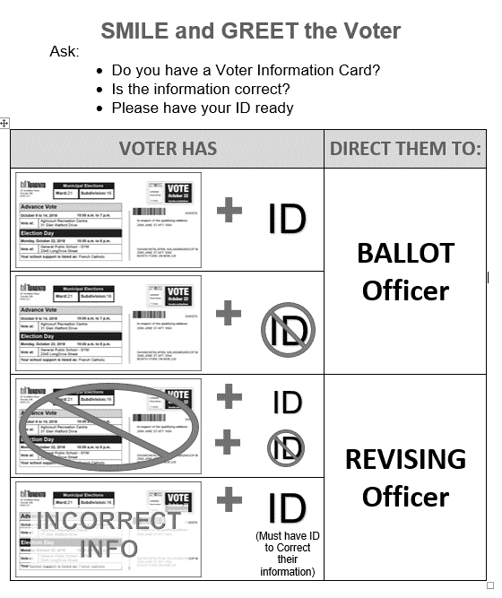
- If you are an Information Officer, the MDRO will provide you with:
    - A clipboard with a "greet sheet" (voter scenarios and list of acceptable identification)

- Open the voting place at 10:00 a.m. sharp!

- Closing the Voting Place Checklist

The MDRO or DRO will close the voting place at 8:00 p.m. sharp!
    - Any voters in line at 8:00 p.m. will be allowed to complete voting
    - If there is a line-up of voters at 8:00 p.m. voting place staff must ensure no other person joins the line

- Sign the first copy of the election results tape when directed by the MDRO or DRO

- Break down the tabulator stand and used voting screens:
    - Leave them at the voting place for recycling, if agreed to by the on-site contact

- Take down all election signs posted in the voting place and place in the supply bag

- Return the voting room to its original state:
    - Tidy up
    - Reposition furniture, if possible

- Assist the MDRO or DRO with any other tasks

- Assist the MDRO or DRO with loading equipment and supplies into their vehicles

Important to Do:
Make sure the voting place doors do not lock automatically, leaving you outside and the rest of the supplies inside.

- Leave when the MDRO or DRO says you are free to leave

- Additional Information

Occupational Health and Safety Act & Regulations

    - Voting places and voting place staff are governed by the Occupational Health and Safety Act (OHSA) and its Regulations
    - An OHSA Regulation requires that every worker participate in health and safety awareness training
    - Training is provided by Ontario's Ministry of Labour, which has developed an online Health and Safety Awareness program that focuses on the health and safety rights and responsibilities of workers, supervisors and employers. It also provides a general introduction to workplace health and safety.
    - To access the course, visit: http://www.labour.gov.on.ca/english/hs/elearn/worker/index.php

City of Toronto Responsibilities

    - Ensuring the safety of the voting place
- This includes making you aware of any existing or potential hazards in the voting place, and in the duties you perform. A hazard is anything in the voting place that could hurt you or other voting place staff
    - Informing you about the safe work practices you should follow for your own protection.

Your Responsibilities

    - Following the law and the relevant health and safety policies
    - Following the voting place policies and procedures
    - Working and acting in a way that will not hurt you or any other voting place staff
    - Reporting any hazards you find in the voting place to the DRO, MDRO or Supervisor

Potential Hazards in the Voting Place

Hazards that could arise in the voting place may include:
    - Slips, trips and falls due to wet floors, food or other spills
    - Damaged tables or chairs
    - Electrical hazards (frayed or damaged extension cords, damaged plugs, damaged wall sockets)
    - Fires and fire alarms
    - Workplace violence or harassment

Fire Alarms

In the event of a fire alarm:
    - Notify your MDRO, DRO or Supervisor immediately
    - Instruct voters to leave the building and advise they can return once it is safe to do so
    - Notify the on-site contact and call 9-1-1
    - Together with the voting place staff, lock the voting room and secure the voting place
If you cannot lock the room assist the MDRO or DRO with removing the tabulator and ballots from the voting place and securing them in their vehicle

Workplace Violence and Harassment

    - Voting places and voting place staff are governed by the City of Toronto's Workplace Violence and Workplace Harassment policies. Voters and other people who enter the voting place are also governed by these policies
    - The City of Toronto will not tolerate acts of violence and will take all reasonable and practical measures to prevent violence and to protect employees from acts of violence. Appropriate remedial, disciplinary and/or legal action will be taken according to the circumstances
    - Workplace violence is the use or attempted use of physical force against a voting place staff that causes or could cause physical injury. Workplace violence may also be a statement or behaviour that could be reasonably interpreted as a threat to use physical force, and that could cause physical injury
    - In case of workplace violence:
- Try to put distance between yourself and the situation
- Do not attempt to physically intervene in a violent situation between individuals
- Call 9-1-1 or instruct a person close to the exit to seek help
- Notify the MDRO, DRO or Supervisor immediately

Voter Identification Must Show Name and Qualifying (Toronto) Address

Acceptable Identification:
- Ontario issued photo card, driver’s license or motor vehicle permit (vehicle portion)
- Cancelled personalized cheque, credit card or bank account statement
- Utility bill for hydro, telephone or cable TV, water, gas or a bill from a public utilities commission
- Cheque stub, T4 statement or pay receipt issued by an employer
- Statement of direct deposit for Ontario Works or Ontario Disability Support Program
- Property tax assessment, income tax assessment notice, Child Tax Benefit statement
- Mortgage statement, lease or rental agreement
- Transcript or report card from a post-secondary school
- Document showing campus residence, issued by the office or officials responsible for student residence at a post-secondary institution
- Any other document from the government of Canada, Ontario or a municipality in Ontario or a document issued or certified by a court in Ontario
- Any document from a Band Council in Ontario established under the Indian Act (Canada)
- Insurance policy or insurance statement
- Loan agreement or other financial agreement with a financial institution
- Statement of Employment Insurance Benefits Paid T4E
- Statement of Old Age Security T4A (OAS), Canada Pension Plan Benefits T4A (P), Canada Pension Plan Statement of Contributions
- Workplace Safety and Insurance Board Statement of Benefits T5007
- CNIB card or a card from another registered charitable organization that provides services to persons with disabilities
- Document showing residence at a long-term care home under the Long-Term Care Homes Act, 2007, issued by the Administrator for the home
- Hospital card or record

Electronic Identification:
- Identification is accepted in whichever format it was first issued
- With documents issued electronically (such as e-statements or e-invoices) a hard copy or online version shown on a mobile device is acceptable
- Photocopies or scanned versions of documents that were not issued electronically are not acceptable (such as a passport)

Note: A Voter Information Card cannot be used as identification

