` Election Day

Revising Officer

Manual

Contact Information

Contact | Phone
Election Information Contact Centre  The public and candidates can call for election information | 3-1-1
Accessibility Contact Centre  Voters can call if they have a concern or complaint about accessibility. | 416-338-1111, press 6

Table of Contents

1 Introduction 1
1.1 Welcome 1
1.2 Expectations 1
2 People in the Voting Place 2
2.1 Your Role 2
2.2 Your Team 2
2.3 Voters and Voting 4
2.4 Scrutineers and Candidates 5
3 Before Election Day Checklist 7
4 Opening the Voting Place Checklist 8
5 Common Voting Scenarios 10
6 Exceptions to Common Voting Scenarios 11
6.1 Electronic Devices in the Voting Place 11
6.2 French-language Forms 11
6.3 Language or Communication Challenges 11
6.4 Removal of a Deceased Person's Name 12
6.5 School Support Information 13
6.6 Voter Already Marked Voted 14
6.7 Voter Cannot Enter the Voting Place 14
6.8 Voter Complaints 14
6.9 Voter Has a Ballot Transfer Notice 15
6.10 Voter Has a Proxy Appointment 15
6.11 Voter Is Homeless 16
6.12 Voter Is In the Wrong Voting Place 17
6.13 Voter Needs Help of an Interpreter 17
7 Customer Service and Accessibility 18
7.1 Creating a Positive Voting Experience 18
7.2 Serving People with Disabilities 18
7.3 Inclusive Voting Places 18
7.4 Accommodations and Special Services 20
8 Closing the Voting Place Checklist 22
9 Additional Information 23
10 Sample Forms and Training Materials 25

- Introduction

  - Welcome

Thank you for joining the election team!

As an Election Official you play an important part in delivering this election for Toronto.

This manual outlines your duties and is for your use:
    - Make notes in it
    - Use the checklists included
    - Read the entire manual before election day

It is not necessary to memorize everything. Just be familiar with the manual so you can find the information you need when you need it.

  - Expectations

As an Election Official and a representative of the City of Toronto you are expected to:
    - Be professional (helpful, courteous and patient)
    - Maintain secrecy
    - Act with integrity (be fair, impartial and unbiased)
    - Follow policies and procedures
    - Work together with the voting place team
    - Treat all co-workers and the public with respect
    - Refrain from engaging in harassment and/or discrimination
    - Provide people with disabilities full and equal access to the election process

This election must be conducted according to the principles of democratic elections:
- The secrecy and confidentiality of an individual's vote is paramount
- The election is fair and must not favour one candidate over another
- The election is accessible to all voters
- The integrity of the process is maintained throughout the election
- Voters and candidates are treated fairly
- There should be certainty that the results of the election reflect the votes cast
- The proper majority vote governs by ensuring that valid votes are counted and invalid votes are rejected, so far as reasonably possible

- People in the Voting Place

  - Your Role

Revising Officer

As a Revising Officer, it is your role to:
    - Assist with opening and closing the voting place
    - Serve voters who do not have a Voter Information Card or who require an amendment to the voters' list
    - Complete all necessary paperwork

  - Your Team

These are the roles of the Election Officials on your team.

MDRO

It is the role of the MDRO to:
    - Manage the voting place, supplies and ballots
    - Ensure policies and procedures are followed
    - Sign in Scrutineers and Candidates and monitor their activity
    - Complete all necessary paperwork

Ballot Officers

It is the role of Ballot Officers to:
    - Assist with opening and closing the voting place
    - Serve voters who are on the voters' list, administer declarations and issue ballots
    - Complete all necessary paperwork

Tabulator Officer

It is the role of the Tabulator Officer to:
    - Assist with opening and closing the voting place
    - Receive ballots from voters and feed them into the vote tabulator
    - Produce and phone in results at the close of voting

Information Officer

It is the role of the Information Officer to:
    - Control the flow of voters in the voting place
    - Ask voters to have their identification ready
    - Direct voters with a Voter Information Card to a Ballot Officer
    - Direct voters without a Voter Information Card to a Revising Officer
    - Circulate secrecy folders from the Tabulator Officer to the Ballot Officer

Accessibility Officer

If an Accessibility Officer is assigned to your voting place, it is their role to:
    - Ensure access to the voting place for all voters which may include:
- Opening doors where there is no "push button"
- Operating an elevator
- Directing voters to the accessible entrance
- Ensuring voters proceed directly to and from the voting room

VAT Officer

If a VAT Officer is assigned to your voting place, it is their role to:
    - Set up and operate the VAT (Voter Assist Terminal)
- The VAT is a ballot marking machine that allows voters with disabilities to mark their ballot privately and independently
    - Assist voters using the VAT

Supervisor

A Supervisor provides mobile support to a number of voting places and it is their role to:
    - Deliver and set up the vote tabulator
    - Provide support and problem-solve
    - Ensure staff follow policies and procedures
    - Provide additional ballots and supplies if needed
    - Assist with Scrutineer and Candidate issues
    - Record attendance of voting place staff and evaluate staff performance
- Performance evaluations are used to determine future election employment and promotions

  - Voters and Voting

Qualifications

Every person is entitled to vote who, on voting day:
    - Is a Canadian citizen and
    - Is at least 18 years of age and
    - Lives in the city of Toronto or
- Owns or rents property in Toronto or
- Is the spouse of a person who owns or rents property in Toronto
    - And is not prohibited from voting under any law

Important to Know:
    - A person may only vote once in this election
    - If a person lives in Toronto and owns or rents another property in Toronto, they must vote in the ward in which they live

Identification Requirements

Each voter must be asked for identification.

Identification must show the voter's name and Toronto address.

Acceptable identification is listed on the back cover of this manual.

If a voter wishes to complain about the identification requirements they may contact Election Services at 416-338-1111.
Voting
Voters may vote for one candidate for each of these offices:
    - Mayor
    - Councillor
    - Trustee

Important to Know:
A non-resident owner or tenant of commercial or industrial property is not eligible to vote for Trustee. They receive a Non-resident ballot which does not include the office of Trustee.

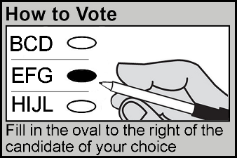
Voters will:
    - Receive a ballot in a secrecy folder
    - Mark their ballot by filling in the oval to the right of the candidate of their choice

  - Scrutineers and Candidates

Their Role

A Candidate may appoint Scrutineers to represent them in the voting place.

Each Candidate may station one Scrutineer at each Ballot Officer and one at the tabulator.

A Candidate may act as a Scrutineer.

Signing In

When a Scrutineer arrives at your voting place, they must sign in with the MDRO or DRO.

Scrutineer Activities

Scrutineers and Candidates can:
    - Enter the voting place 15 minutes before it opens and to inspect the vote tabulator stand, the ballots and all other election documents but not so as to delay the opening of the voting place
    - Object to a voter voting (objection to be decided by the Election Official)
    - Sign the statement of the results of the election (results tape)
    - Place their seal on the ballot box after the close of voting on election day

Scrutineers and Candidates cannot:
    - Attempt, directly or indirectly, to interfere with how a voter votes or with a voter who is marking a ballot
    - Display a Candidate's election material (such as buttons, ribbons, pins) in the voting place
    - Compromise the secrecy of voting
    - Obtain or attempt to obtain, in the voting place, any information about how a voter intended to vote or has voted

    - Communicate any information obtained at a voting place about how a voter intends to vote or has voted
    - Speak to or provide assistance to any voters
    - Act as an interpreter (a voter must make their own arrangements)
    - Use a cell phone in the voting place

Election Officials have the right to remove from the voting place any individual who is causing a disturbance. Candidates and Scrutineers forfeit their right to be present if they disrupt the voting place or interfere with the voting process.
Important to Know:
If a Scrutineer is not following the rules, notify the MDRO of the situation.

- Before Election Day Checklist

- Plan your travel route:
    - To arrive at your voting place at 8:30 a.m. on election day

- Expect a phone call from the MDRO asking if you intend to work

- Take the online election training available:
    - Visit https://electionstaffingmyjob.toronto.ca
    - Log in to your account
    - Under Outstanding Training Requirements, click on "Go to Online Training"

- Read your Accessible Customer Service Handbook

- Plan your needs for election day:
    - Refreshments: Bring enough food and drinks for the day
    - Dress: Indoor temperatures vary; dress in layers
    - Medication: Bring any medication you will need to take during the day

- Opening the Voting Place Checklist

Work with your team to complete these tasks and open the voting place at
10:00 a.m.

- Arrive at the voting place at 8:30 a.m. sharp!

- Set up tables and chairs, ensuring the voting place layout provides:
    - For a good flow of people in, through and out of the voting room
    - Adequate lighting
    - A working electrical outlet for the tabulator
    - Separate entrance and exit doors for voters, if possible
    - Extra chairs for voters who require them, if possible
    - Enough space to ensure voter privacy at the voting screens
    - Enough space to allow for voters using wheelchairs or scooters

Recommended Layout

- Look for any windows and security cameras in the voting room:
    - Ensure voting screens are set up in an area that protects the secrecy of the vote
    - Notify the MDRO if there are security cameras present

- Assemble voting screens:
    - Tie a piece of string to each marking pen cap
    - Attach a marking pen to each screen by threading the string through the hole in the side of the screen and knotting the string

- At about 5 feet above the ground or floor so they can be easily seen, post:
    - Vote Here sign in an area near the main entrance to the building, where it can be seen from the street
    - Directional Arrow signs on doors and walls leading to the voting room
    - Accessible Entrance sign at the accessible entrance noted on the Final List of Voting Places in your supply bag
    - Accessible Entrance Directional Arrow signs directing voters to the accessible entrance at all other entrances
    - Multilingual posters in a highly visible area (front entrance of building, entrance to voting room, near Information Officer)
    - No Cell Phones/Cameras signs in the voting room
    - Ward Map, where space permits

- Set up your workstation with these items:
    - Pens
    - Ruler
    - Revising the Voters' List Placemat
    - Voters' List Amendment Applications
    - Pad of paper to communicate with voters who are deaf, deafened or hard of hearing
    - Voters' List for DROs, MDROs and Revising Officers

- Open the voting place at 10:00 a.m. sharp!
- Common Voting Scenarios

The Information Officer greets the voter and determines which voting scenario applies by asking:
    - If the voter has a Voter Information Card
    - If the information on the Voter Information Card is correct

Voter Does Not Have a Voter Information Card or the Information on the Card is Incorrect

The Information Officer:
    - Asks the voter to have their identification ready
    - Directs the voter to a Revising Officer

You, as the Revising Officer, search for the voter on the voters' list.

    - If the voter is ON the list and the information is correct:
- Direct the voter to a Ballot Officer who will issue a ballot

    - If the voter is ON the list and the information is incorrect:
- Complete a Voters' List Amendment Application with the voter
- Direct the voter to a Ballot Officer who will issue a ballot

    - If the voter is not on the list and has identification:
- Complete a Voters' List Amendment Application with the voter
- Direct the voter to a Ballot Officer who will add the voter to the list and issue a ballot

    - If the voter is not on the list and does not have identification:
- Advise the voter if they return with identification they can be added to the list and receive a ballot

A voter who is issued a ballot:
    - Marks their ballot at the voting screens
    - Gives the marked ballot to the Tabulator Officer

The Tabulator Officer:
    - Asks the voter to wait
    - Feeds the ballot into the vote tabulator
    - Thanks the voter for voting

- Exceptions to Common Voting Scenarios

  - Electronic Devices in the Voting Place

To maintain the secrecy of the vote, the use of electronic communication and photographic devices in a voting place by voters, Scrutineers and Candidates is prohibited, except when used to show acceptable identification or a Voter Information Card.

Electronic communication and photographic devices include, but are not limited to, mobile phones, tablets and laptops.

Election Officials may use electronic communication and photographic devices for election purposes only when necessary and after receiving approval from the MDRO. When possible, staff should leave the voting place to use these devices.

  - French-language Forms

If a person requests to complete a French-language form:
    - French-language versions of the Voters' List Amendment Application are in the MDROs supply bag

  - Language or Communication Challenges

For some voters, the voting process can pose language or communication challenges.

By being aware of the options available to deal with these challenges, Election Officials can ensure voters are able to exercise their right to vote.

Options

    - An Election Official who speaks the same language as a voter can serve the voter in that language
- No declaration is needed

    - A voter can have a person act as an interpreter
- A Scrutineer or Candidate cannot act as an interpreter
- An interpreter can assist more than one person but must take a declaration each time
- A child may act as an interpreter if they are 6 years of age or older and the Ballot Officer is satisfied they are competent to act as an interpreter on behalf of a voter
- A Personal Support Worker can act as an interpreter to facilitate communication between an Election Official and a voter with a disability

    - 3-1-1 can provide over-the-phone interpretation in more than 180 languages

    - Each voting place has a How to Vote Booklet with voting instructions in English and 26 languages
- This can be useful for voters whose first language is not English and for voters who are deaf, deafened or hard-of-hearing

    - Each voting place has a Braille How to Vote Booklet with voting instructions
- This can be useful for voters who are blind or partially-sighted

    - Multilingual posters in the voting place let voters know there is a How to Vote Booklet with voting instructions

    - Each voting place has pads of paper communicate with voters who are deaf, deafened or hard-of-hearing

    - Ballot Officers have How to Vote Demo Pads for Election Officials to show voters how to mark the ballot

    - If a mobile phone is available, Google Translate can be useful

  - Removal of a Deceased Person's Name

If a person requests to have a deceased person's name removed from the voters' list, follow the steps on the Revising the Voters' List Placemat.

The applicant must show one of these documents as proof of death:
    - A burial or death certificate
    - A Medical Certificate of Death
    - A document /receipt issued by a cemetery/crematorium in Ontario that proves burial or cremation
    - A statement from a medical doctor, coroner or funeral director
    - A Registration of Death
    - A notarial copy of Letters of Probate
    - A Life or Group Insurance claim along with a statement signed by a medical doctor
    - An official notification from the Public Trustee
    - A Memorandum of Notification of Death issued by the Chief of Defence Staff of National Defence
    - A Statement of Verification of Death from the Department of Veterans Affairs
    - A program from a funeral ceremony
    - An obituary from a newspaper

If a person does not have proof of death with them, advise them:
    - The change cannot be made in the voting place
    - The change can be made by contacting the Municipal Property Assessment Corporation (MPAC) at 1-866-296-6722

  - School Support Information

English Public School Board

A voter is entitled to vote for the English Public school board (Toronto District School Board) if they are:
    - Not qualified to be a voter for the French Public or French Catholic school boards, and
    - Are not an English Catholic School Board supporter

English Catholic School Board

A voter is entitled to vote for the English Catholic school board (Toronto Catholic District School Board) if they are:
    - Roman Catholic, and/or
    - An English Catholic School Board supporter, and
    - Not qualified to be a voter for the French Public or French Catholic school boards

French Public School Board

A voter is entitled to vote for the French Public school board (Conseil scolaire Viamonde) if they:
    - First learned and still understand French, or
    - Received their elementary school instruction in Canada in French, or
    - Has children who received, or are now receiving, elementary or secondary school instruction in Canada in French
(Does not include French immersion or French as a second language)

French Catholic School Board

A voter is entitled to vote for the French Catholic school board (Conseil scolaire catholique MonAvenir) if they:
    - Meet the qualifications listed for French Public school board, and
    - Are Roman Catholic

  - Voter Already Marked Voted

    - Call the MDRO to your table and explain the situation

The MDRO will escort the voter to the Ballot Officer and resolve the situation.

  - Voter Cannot Enter the Voting Place

If requested, a voter may be served outside the voting room, in the parking lot or at the curb.

Notify the MDRO if there is a request for this service.

  - Voter Complaints

Handle voter complaints professionally:
    - Attempt to solve the problem
    - Be professional and remain calm
    - Be aware of your body language
    - Provide options, where possible
    - Speak clearly and politely
    - Advise the person of the next steps
    - If needed, contact your MDRO for assistance

Complaint About Accessibility at the Voting Place

    - Advise the MDRO of any issues or complaints about accessibility immediately
    - If a voter wishes to file a complaint they can do so by email, verbally and in writing to Election Services:
email: AccessibleElections@toronto.ca
Phone: 416-338-1111, then press 6
Fax: 416-395-1300
Mail: Election Services
89 Northline Road, Toronto ON M4B 3G1
TTY: 416-338-OTTY

Complaint About Identification Requirements

    - Explain to the voter the Municipal Elections Act requires that a voter provide identification to verify identity and residence
    - Advise if they wish, a formal complaint may be made by contacting Election Services at 416-338-1111

Complaint About the Voters' List

    - Explain to the voter:
- The voters' list is provided to Election Services by the Municipal Property Assessment Corporation (MPAC)
- Errors and omissions do occur
- The information on the Voters' List Amendment Application will be given to MPAC for correction
    - Advise if they wish, a formal complaint may be made by contacting MPAC at 1-866-296-6722

  - Voter Has a Ballot Transfer Notice

If a voter has a Ballot Transfer Notice, direct them to the appropriate Ballot Officer.

  - Voter Has a Proxy Appointment

If a voter has a Proxy Appointment, direct them to the appropriate Ballot Officer.

  - Voter Is Homeless

Important to know:
A voter who is homeless:
    - Has the right to vote
    - Does not have to show identification
    - Can complete a Voters' List Amendment Application to be added to the voters' list and receive a ballot

If a voter tells you they are homeless:
    - Be welcoming and treat the voter with respect
    - Use quiet conversation to ensure the voter's privacy
    - Let the voter know they can:
- Complete an Application with the Revising Officer to be added to the list
- Give the completed Application to the Ballot Officer and receive a ballot
    - Follow the steps on the Revising the Voters' List Placemat to add the voter to the voters' list

Voter's Address on the Voters' List Amendment Application

    - Should be the most common place they have returned to eat or sleep during the last 5 weeks

    - Can be recorded as:
- An intersection (corner of "street name" and "street name")
- A park
- A shelter or drop-in centre

    - If the exact street address is known, check the street index to determine if the property is in your sub

    - If the exact address is not known, discreetly explain the situation to the MDRO and together use the ward map to determine if the property is in your sub

    - If you cannot determine if the property is in your sub, the MDRO can phone the Ward Centre for direction

  - Voter Is In the Wrong Voting Place

If a voter's address does not appear in the street index of your voters' list, they are in the wrong voting place.

If a voter is in the wrong voting place:
    - With the MDRO, use the ward map and list of voting places to determine where the voter should vote
    - If you cannot determine where the voter should vote, advise the voter to call 3-1-1 to find out where they may vote
    - If there is urgency or you are uncertain how to address the voter's situation, advise the MDRO as they can phone the Ward Centre for direction

  - Voter Needs Help of an Interpreter

If a voter needs the help of an interpreter the Ballot Officer will follow the steps on the Ballot Issuing Placemat.

Important to Know:
    - A Scrutineer or Candidate cannot act as an interpreter
    - An interpreter can assist more than one person but must take a declaration each time
    - An Election Official acting as an interpreter can assist more than one person and does not have to take a declaration
    - A child may act as an interpreter if they are 6 years of age or older and the Ballot Officer is satisfied that they are competent to act as an interpreter on behalf of a voter

- Customer Service and Accessibility

  - Creating a Positive Voting Experience

It is important that you and your team create a positive voting experience for all voters:
    - Make eye contact
    - Smile
    - Greet voters as they arrive
    - Use a welcoming tone
    - Listen
    - Be polite and respectful
    - Focus on problem solving

  - Serving People with Disabilities

It's important that people with disabilities have full and equal access to elections and can vote in the same place and in similar ways as others. Sometimes, this may require an approach that is flexible and responsive to the individual needs of the voter.

Remember to TALK!:
- Take a moment to ask "May I help you?"
- Ask, don't assume. Never assist unless asked to.
- Listen and speak directly to the person.
- Know the accommodations and special services available.

Important to do:
    - Be welcoming and treat the voter with respect
    - Do not single out a voter if you believe they may have a disability
    - Do not discuss a voter's needs or disability in front of others
    - When assisting a voter, keep the voter's privacy and independence in mind

  - Inclusive Voting Places

Everyone in the voting place has the right to be treated respectfully.

During the day, you will be interacting with many different people and the words you use can be important.

Follow these tips to ensure your words are respectful and your voting place is inclusive for all voters.

Don't Assume

Don't assume someone is a man or a woman. You can't tell someone's gender identity by just looking at them.

Avoid Using Gendered Language

Avoid using words that are based on gender, such as:
    - Mr. / Sir
    - Miss / Mrs. / Ms / Madam / Ma'am
    - He / him / his / gentleman / man
    - She / her / hers / woman / lady

Even though we use titles like Mr. or Ms. to be respectful, this may end up having the opposite effect and it might impact someone negatively.

Use words which are gender neutral, such as:
    - You
    - They
    - The voter
    - This person
    - The Election Official

Another option is to identify the person by what they are wearing:
    - "Excuse me, the person in the blue shirt"
    - "Can you help the person in the blue shirt?"

If at any time a person tells you how they would like to be addressed or corrects you – tell them thank you for the information and move forward using that language.

As always, a warm smile and a wave can go a long way in creating a welcoming space!

What to Do If Someone’s ID Doesn’t “Match” Their Appearance

As you know, a voter must show identification with their name and Toronto address.

Photo identification is not required and at no time should you question someone's gender based on the identification they provide.

  - Accommodations and Special Services

To meet the needs of voters, including voters with disabilities and voters whose first language is not English, these accommodations and special services are available:

Accessible Voting Equipment
    - A Voter Assist Terminal (VAT) is located in one voting place in each ward on election day. The VAT is a ballot-marking machine that allows voters with disabilities to vote privately and independently
    - The MDRO has a Final List of Voting Places which lists where the VAT is located for your ward

Assistance to Voters
    - All Election Officials receive customer service training and an Accessible Customer Service Handbook
    - Accessibility Officers are placed at sites with physical barriers to provide assistance to voters when required
    - If a voter needs assistance inside the voting place, they may bring a friend along or ask an Election Official for assistance

Ballot Transfers
    - If a voter is unable to vote at their designated voting place, they can transfer their ballot to an alternate voting place within the same ward. This is done through Election Services
    - If a person arrives at the voting Place with a Ballot Transfer Notice, voting place staff follow the instructions on the Notice

Curbside Voting
    - If a voter is able to travel to a voting place but is physically unable to go inside, they can ask to have their ballot brought to their vehicle, outside of the building or to another area within the voting place

Proxy Voting
    - If a voter is unable to attend a voting place to cast their ballot, they may appoint a proxy to vote on their behalf. This is done through Election Services
    - If a person arrives at the voting place with a Proxy Appointment, voting place staff follow the steps on the Ballot Issuing Placemat

Translated Materials and Language Services
    - Election information is available in other languages on the Elections website (www.toronto.ca/elections)
    - If a voter needs assistance in a language that is not on the website, they can call 3-1-1 for over-the-phone interpretation in more than 180 languages
    - A voter may ask anyone who is not a Candidate or a Scrutineer to act as an interpreter for them
    - 'How to Vote' booklets are available in multiple languages and Braille at each voting place

Other Items in the Voting Place
    - Magnifying sheets to assist voters with low vision
    - Pads of paper to communicate with voters who are deaf, deafened or hard-of-hearing
    - How to Vote Demo Pads for Election Officials to show voters how to mark the ballot
    - Multilingual posters in the voting place letting voters know there is a How to Vote Booklet with voting instructions
- Closing the Voting Place Checklist

The MDRO will close the voting place at 8:00 p.m. sharp!

- Serve the remaining voters:
    - Allow any voters in line at 8:00 p.m. to complete voting
    - If there is a line-up of voters at 8:00 p.m. voting place staff must ensure no other person joins the line

- Give the MDRO:
    - Any white copies of completed Voters' List Amendment Applications
    - Your voters' list
    - All other supplies

- Sign the first copy of the elections results tape when directed by the MDRO

- Take down all election signs posted in the voting place and place in the supply bag

- Return the voting room to its original state:
    - Tidy up
    - Reposition furniture, if possible

- Assist the MDRO with any other tasks

Important to do:
Make sure the voting place doors do not lock automatically, leaving you outside and the rest of the supplies inside.

- Leave when the MDRO says you are free to leave
- Additional Information

Occupational Health and Safety Act and Regulations

    - Voting places and voting place staff are governed by the Occupational Health and Safety Act (OHSA) and its Regulations
    - An OHSA Regulation requires that every worker participate in health and safety awareness training
    - Training is provided by Ontario's Ministry of Labour, which has developed an online Health and Safety Awareness program that focuses on the health and safety rights and responsibilities of workers, supervisors and employers. It also provides a general introduction to workplace health and safety.
    - To access the course, visit:
http://www.labour.gov.on.ca/english/hs/elearn/worker/index.php

City of Toronto Responsibilities

    - Ensuring the safety of the voting place
- This includes making you aware of any existing or potential hazards in the voting place, and in the duties you perform. A hazard is anything in the voting place that could hurt you or other voting place staff.
    - Informing you about the safe work practices you should follow for your own protection

Your Responsibilities

    - Following the law and the relevant health and safety policies
    - Following the voting place policies and procedures
    - Working and acting in a way that will not hurt you or any other voting place staff
    - Reporting any hazards you find in the voting place to the MDRO or Supervisor

Potential Hazards in the Voting Place

Hazards that could arise in the voting place may include:
    - Slips, trips and falls due to wet floors, food or other spills
    - Damaged tables or chairs
    - Electrical hazards (frayed or damaged extension cords, damaged plugs, damaged wall sockets)
    - Fires and fire alarms
    - Workplace violence or harassment

Fire Alarms

In the event of a fire alarm:
    - Notify your Supervisor immediately
    - Instruct voters to leave the building and advise they can return once it is safe to do so
    - Notify the on-site contact and call 9-1-1
    - Together with the voting place staff, lock the voting room and secure the voting place
- If you cannot lock the room assist the MDRO with removing the tabulator and ballots from the voting place and securing them in their vehicle

Workplace Violence and Harassment

    - Voting places and voting place staff are governed by the City of Toronto's Workplace Violence and Workplace Harassment policies. Voters and other people who enter the voting place are also governed by these policies.
    - The City of Toronto will not tolerate acts of violence and will take all reasonable and practical measures to prevent violence and to protect employees from acts of violence. Appropriate remedial, disciplinary and/or legal action will be taken according to the circumstances.
    - Workplace violence is the use or attempted use of physical force against a voting place staff that causes or could cause physical injury. Workplace violence may also be a statement or behaviour that could be reasonably interpreted as a threat to use physical force, and that could cause physical injury.
    - In case of workplace violence:
- Try to put distance between yourself and the situation
- Do not attempt to physically intervene in a violent situation between individuals
- Call 9-1-1 or instruct a person close to the exit to seek help
- Notify the MDRO or Supervisor immediately
    - Workplace harassment can involve unwelcome words or actions that are, or should be known to be offensive, embarrassing, humiliating or demeaning. It can also include behaviour that intimidates, isolates or discriminates against voting place staff

Protection of Privacy
Voting place staff have access to the City of Toronto voters' list for the purpose of performing their election duties. The personal information contained in the voters' list may not be used for any other purposes
- Sample Forms and Training Materials

Item | Page
Voter Information Card | 26
Voters' List | 27
Voters' List Amendment Application | 30

VOTER INFORMATION CARD

A Voter Information Card:
- Is sent to each voter whose name appears on the voters' list
- Tells the voter where and when they may vote
- Can make it easier to find a voter on the voters' list, but it is not mandatory for a voter to show their card
- Is not accepted as identification

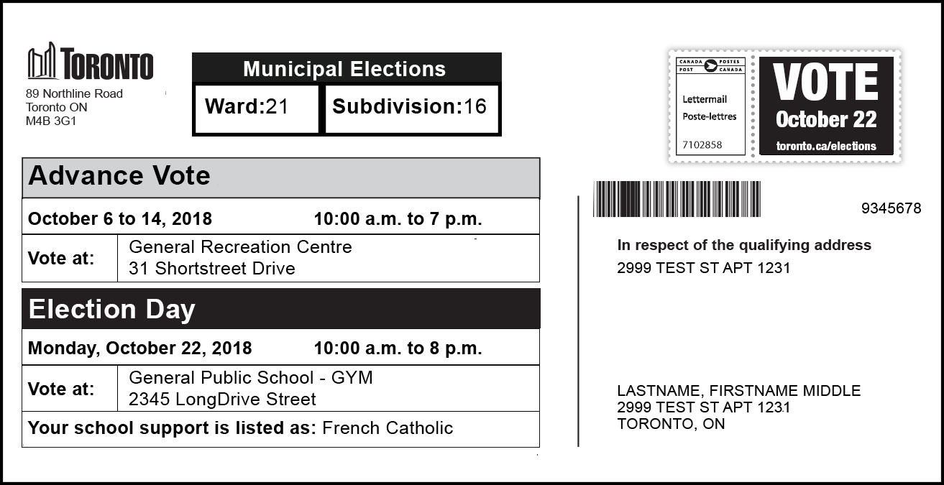

VOTERS' LIST

There are two types of voters' list:
- One for MDROs, DROs and Revising Officers, which is alphabetical by street
- One for Ballot Officers, which is alphabetical by voter's name

MDRO, DRO and Revising Officer Voters' List Cover

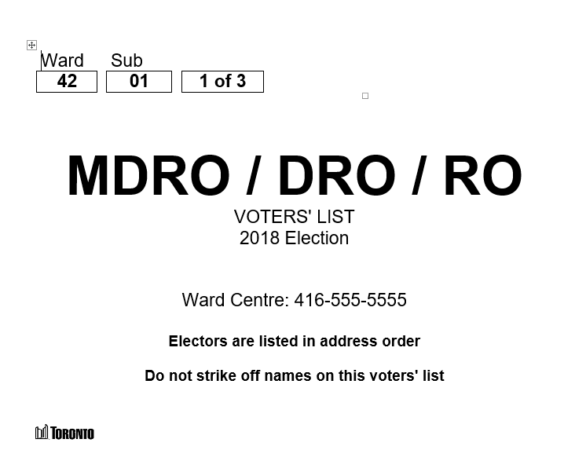

Placard showing name range
VOTERS' LIST

Street Index Page
The first page of the voters' list contains the Street Index which lists the street addresses located in your sub in alphabetical order.
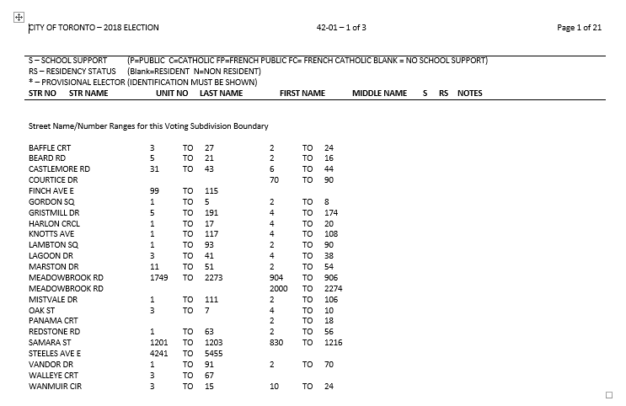
Streets
in the sub
Range of odd
street numbers in the sub
Range of even
street numbers in the sub

VOTERS' LIST

List of Voters Pages

Voters' are listed:
- Alphabetically by street, then
- Numerically by street number, then
- Alphabetically by last name

If a voter has added their name to the voters' list online, they are listed with a * beside their name and MUST SHOW ID is shown in the NOTES column:
- The voter must show identification
- They cannot complete a Declaration of Identity with the Ballot Officer if they do not have identification

A voter who voted during the advance vote is shown with their information crossed off and VOTED is shown in the NOTES column.
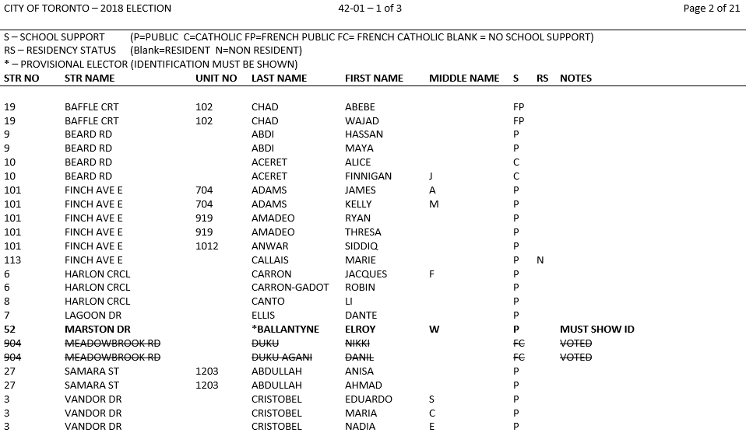
Last
Name
First
Name
Street
Name
Street
Number
School
Support/
Residency Status

Notes
Unit
Middle
Name

VOTERS' LIST AMENDMENT APPLICATION

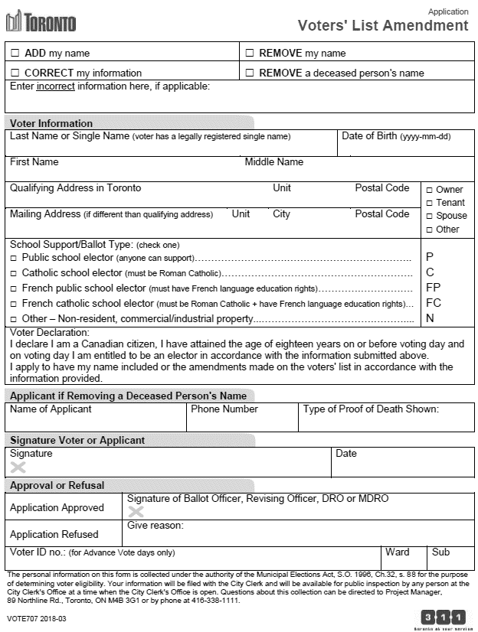
Name and address
is mandatory.
Date of Birth is not mandatory.
Must be completed
If applicable
One box must
be checked
If applicable
One box must
be checked
One box must
be checked

Voter Identification Must Show Name and Qualifying (Toronto) Address

Acceptable Identification:
- Ontario issued photo card, driver’s license or motor vehicle permit (vehicle portion)
- Cancelled personalized cheque, credit card or bank account statement
- Utility bill for hydro, telephone or cable TV, water, gas or a bill from a public utilities commission
- Cheque stub, T4 statement or pay receipt issued by an employer
- Statement of direct deposit for Ontario Works or Ontario Disability Support Program
- Property tax assessment, income tax assessment notice, Child Tax Benefit statement
- Mortgage statement, lease or rental agreement
- Transcript or report card from a post-secondary school
- Document showing campus residence, issued by the office or officials responsible for student residence at a post-secondary institution
- Any other document from the government of Canada, Ontario or a municipality in Ontario or a document issued or certified by a court in Ontario
- Any document from a Band Council in Ontario established under the Indian Act (Canada)
- Insurance policy or insurance statement
- Loan agreement or other financial agreement with a financial institution
- Statement of Employment Insurance Benefits Paid T4E
- Statement of Old Age Security T4A (OAS), Canada Pension Plan Benefits T4A (P), Canada Pension Plan Statement of Contributions
- Workplace Safety and Insurance Board Statement of Benefits T5007
- CNIB card or a card from another registered charitable organization that provides services to persons with disabilities
- Document showing residence at a long-term care home under the Long-Term Care Homes Act, 2007, issued by the Administrator for the home
- Hospital card or record

Electronic Identification:
- Identification is accepted in whichever format it was first issued
- With documents issued electronically (such as e-statements or e-invoices) a hard copy or online version shown on a mobile device is acceptable
- Photocopies or scanned versions of documents that were not issued electronically are not acceptable (such as a passport)

Note: A Voter Information Card cannot be used as identification

