Election Day

D R O

Manual

Table of Contents

1 Introduction 1
1.1 Welcome 1
1.2 Expectations 1
2 People in the Voting Place 2
2.1 Your Role 2
2.2 Your Team 2
2.3 Voters and Voting 3
2.4 Scrutineers and Candidates 4
3 Before Election Day Checklist 6
4 Opening the Voting Place Checklist 8
5 Election Day Reminders 12
6 Common Voting Scenarios 13
7 Exceptions to Common Voting Scenarios 15
7.1 Electronic Devices in the Voting Place 15
7.2 French-language Declarations 15
7.3 French-language Forms 16
7.4 Language or Communication Challenges 16
7.5 Nursing Homes 17
7.6 Removal of a Deceased Person's Name 19
7.7 School Support Information 20
7.8 Scrutineer Objects to a Voter 21
7.9 Voter Already Marked Voted 21
7.10 Voter Cannot Enter the Voting Place 21
7.11 Voter Complaints 24
7.12 Voter Declines to Accept a Ballot 25
7.13 Voter Has a Ballot Transfer Notice 25
7.14 Voter Has a Voting Proxy Appointment 25
7.15 Voter Is Homeless 26
7.16 Voter Is in the Wrong Voting Place 27
7.17 Voter Leaves the Voting Place with a Ballot 27
7.18 Voter Makes a Mistake on the Ballot 27
7.19 Voter Needs Help of an Election Official 27
7.20 Voter Needs Help of a Friend 28
7.21 Voter Needs Help of an Interpreter 28
8 Customer Service and Accessibility 29
8.1 Creating a Positive Voting Experience 29
8.2 Serving People with Disabilities 29
8.3 Inclusive Voting Places 29
8.4 Accommodations and Special Services 31
9 Closing the Voting Place Checklist 33
10 Vote Tabulator 37
11 Additional Information 39
12 Sample Forms and Training Materials 41

- Introduction

  - Welcome

Thank you for joining the election team!

As an Election Official you play an important part in delivering this election for Toronto.

This manual outlines your duties and is for your use:
    - Make notes in it
    - Use the checklists included
    - Read the entire manual before election day

It is not necessary to memorize everything. Just be familiar with the manual so you can find the information you need when you need it.

  - Expectations

As an Election Official and a representative of the City of Toronto you are expected to:
    - Be professional (helpful, courteous and patient)
    - Maintain secrecy
    - Act with integrity (be fair, impartial and unbiased)
    - Follow policies and procedures
    - Work together with the voting place team
    - Treat all co-workers and the public with respect
    - Refrain from engaging in harassment and/or discrimination
    - Provide people with disabilities full and equal access to the election process

This election must be conducted according to the principles of democratic elections:
- The secrecy and confidentiality of an individual's vote is paramount
- The election is fair and must not favour one Candidate over another
- The election is accessible to all voters
- The integrity of the process is maintained throughout the election
- Voters and Candidates are treated fairly
- There should be certainty that the results of the election reflect the votes cast
- The proper majority vote governs by ensuring that valid votes are counted and invalid votes are rejected, so far as reasonably possible

- People in the Voting Place

  - Your Role

As a DRO, it is your role to:
    - Arrive at 8:30 a.m.
    - Manage the voting place, supplies and ballots
    - Ensure policies and procedures are followed
    - Serve voters who do not have a Voter Information Card or who require an amendment to the voters' list
    - Receive ballots from voters and feed them into the vote tabulator
    - Sign in Scrutineers and Candidates and monitor their activity
    - Produce results at the close of voting
    - Complete all necessary paperwork
    - Return supplies

  - Your Team

Your confirmation notice lists the Election Officials on your team.

Ballot Officer

It is the role of Ballot Officer to:
    - Arrive at 8:30 a.m.
    - Assist with opening and closing the voting place
    - Serve voters who are on the voters' list, administer declarations and issue ballots
    - Complete all necessary paperwork
    - Phone in results at the close of voting

Accessibility Officer

If an Accessibility Officer is assigned to your voting place, it is their role to:
    - Arrive at 9:00 a.m.
    - Ensure access to the voting place for all voters which may include:
- Opening doors where there is no "push button"
- Operating an elevator
- Directing voters to the accessible entrance
- Ensuring voters proceed directly to and from the voting room

Important to Do:
Review the Final List of Voting Places in your supply bag if an Accessibility Officer is assigned to your voting place. It lists their specific duties and where they will be stationed at the voting place.

Supervisor

A Supervisor provides mobile support to a number of voting places and it is their role to:
    - Deliver and set up the vote tabulator
    - Provide support and problem-solve
    - Ensure staff follow policies and procedures
    - Provide additional ballots and supplies if needed
    - Assist with Scrutineer and Candidate issues
    - Record attendance of voting place staff and evaluate staff performance
- Performance evaluations are used to determine future election employment and promotions

  - Voters and Voting

Qualifications

Every person is entitled to vote who, on voting day:
    - Is a Canadian citizen and
    - Is at least 18 years of age and
    - Lives in the city of Toronto or
- Owns or rents property in Toronto or
- Is the spouse of a person who owns or rents property in Toronto
    - And is not prohibited from voting under any law

Important to Know:
    - A person may only vote once in this election
    - If a person lives in Toronto and owns or rents another property in Toronto, they must vote in the ward in which they live

Identification Requirements

Each voter must be asked for identification.

Identification must show the voter's name and Toronto address.

Acceptable identification is listed on the back cover of this manual.

Important to Know:
Voters who have added their names to the voters' list online are listed with a * beside their name and "MUST SHOW ID" in the NOTES column of the Voters' List. If these voters do not have identification they cannot complete a Declaration of Identity. They must show identification to be issued a ballot.

Voting

Voters may vote for one Candidate for each of these offices:
    - Mayor
    - Councillor
    - Trustee

Important to Know:
A non-resident owner or tenant of commercial or industrial property is not eligible to vote for Trustee. They receive a Non-resident ballot which does not include the office of Trustee.
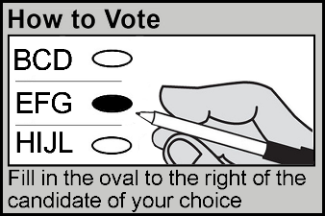
Voters will:
    - Receive a ballot in a secrecy folder
    - Mark their ballot by filling in the oval to the right of the Candidate of their choice

  - Scrutineers and Candidates

Their Role

A Candidate may appoint Scrutineers to represent them in the voting place.

Each Candidate may station one Scrutineer at each Ballot Officer and one at the vote tabulator.

A Candidate may act as a Scrutineer.

Signing In

When a Scrutineer arrives at your voting place, they must:
    - Show you their Scrutineer Appointment Notice and identification
- A Candidate only has to show their identification
    - Sign in and take the Declaration of Secrecy at the back of your voters' list
    - Wear a Scrutineer label which you will provide to them

Important to Know:
    - You must return the Appointment Notice and identification to the Scrutineer once they have signed in
    - A Scrutineer may leave the voting place and return. They do not have to sign in with you more than once

Scrutineer Activities

Scrutineers and Candidates can:
    - Enter the voting place 15 minutes before it opens and to inspect the vote tabulator stand, the ballots and all other election documents but not so as to delay the opening of the voting place
    - Object to a voter voting (objection to be decided by the Election Official)
    - Sign the statement of the results of the election (results tape)
    - Place their seal on the ballot box after the close of voting on election day

Scrutineers and Candidates cannot:
    - Attempt, directly or indirectly, to interfere with how a voter votes or with a voter who is marking a ballot
    - Display a Candidate's election material (such as buttons, ribbons, pins) in the voting place
    - Compromise the secrecy of voting
    - Obtain or attempt to obtain, in the voting place, any information about how a voter intended to vote or has voted
    - Communicate any information obtained at a voting place about how a voter intends to vote or has voted
    - Speak to or provide assistance to any voters
    - Act as an interpreter (a voter must make their own arrangements)
    - Use a cell phone in the voting place

Election Officials have the right to remove from the voting place any individual who is causing a disturbance. Candidates and Scrutineers forfeit their right to be present if they disrupt the voting place or interfere with the voting process.

Important to Know:
If a Scrutineer is not following the rules:
    - Politely explain the rules to them
    - Advise the rules are listed on their Scrutineer Appointment Notice
    - Let them know if the rules are not followed, they will be asked to leave the voting place
    - Notify the Supervisor or Ward Centre of the situation

- Before Election Day Checklist

- Plan your travel route
    - To arrive at your voting place at 8:30 a.m. on election day
    - From your voting place to the Receiving Centre
- A Receiving Centre Map / Windshield Sign is in your supply bag (see sample in this manual)

- Visit your voting place
    - Use the Final List of Voting Places in your supply bag to locate:
- The preferred entrance
- The accessible entrance, if different from the preferred entrance
- The voting room

- Phone the staff listed on your Confirmation Notice
    - Confirm they intend to work
    - Ask anyone who does not intend to work to call Election Services at
416-338-1111 (press 2)

- If an Accessibility Officer is assigned to your voting place, review the Final List of Voting Places in your supply bag. It lists their specific duties and where they are to be located at the voting place

- Expect a phone call from your Supervisor
    - Ask for their cell phone number and record the number on the inside front cover of this manual
    - If your voting place is a nursing home or long term care facility, ask the supervisor if they can provide you with the name of the on-site contact at the facility
- You will need to speak with the on-site contact on election day regarding any bed-to-bed voting required

- Use the Supply Checklist in your supply bag to confirm you received the correct supplies
    - Note any missing supplies as the Supervisor will be able to give them to you on election day

- Remove the Ballot Statement and packs of ballots from the Ballot Transfer Box (Unused Ballots) in your supply bag

- Follow the "Before Election Day" instructions on the Ballot Statement to:
    - Confirm you received the correct ballots for your ward
    - Confirm you received the correct number of ballots
    - Initial 50% of the ballots before election day

Important to Do:
Call 416-338-1111 immediately:
    - If you received the wrong ballots for your ward
    - There is a difference between the number of ballots shown on the Ballot Statement and the number of ballots you received

- Take the online election training available:
    - Visit https://electionstaffingmyjob.toronto.ca
    - Log in to your account
    - Under Outstanding Training Requirements, click on "Go to Online Training"

- Read your Accessible Customer Service Handbook

- Plan your needs for election day:
    - Refreshments: Bring enough food and drinks for the day
    - Dress: Indoor temperatures vary; dress in layers
    - Medication: Bring any medication you will need to take during the day

- Opening the Voting Place Checklist

Work with your team to complete these tasks and open the voting place
at 10:00 a.m.

- Arrive at the voting place at 8:30 a.m. sharp!

- Phone the Ward Centre if staff do not arrive:
    - By 9:00 a.m. for a Ballot Officer
    - By 9:30 a.m. for an Accessibility Officer

Important to Know:
The Supervisor will deliver and set up the vote tabulator between 8:30 a.m. and 9:30 a.m.

- Set up tables and chairs, ensuring the voting place layout provides:
    - For a good flow of people in, through and out of the voting room
    - Adequate lighting
    - A working electrical outlet for the tabulator
    - Separate entrance and exit doors for voters, if possible
    - Extra chairs for voters who require them, if possible
    - Enough space to ensure voter privacy at the voting screens
    - Enough space to allow for voters using wheelchairs or scooters

Recommended Layout
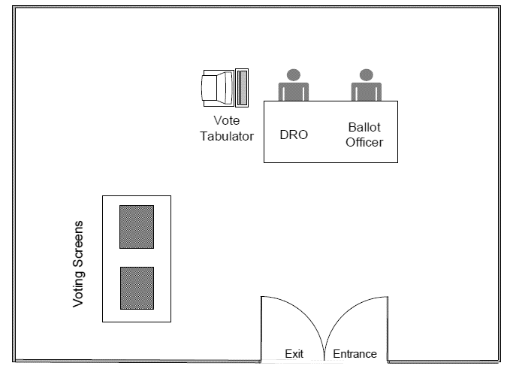

- Look for any windows and security cameras in the voting room:
    - Ensure voting screens are set up in an area that protects the secrecy of the vote
    - Notify the Supervisor if there are security cameras present

- Assemble voting screens:
    - Tie a piece of string found in your supply bag to each marking pen cap
    - Attach a marking pen to each voting screen by threading the string through the hole in the side of the screen and knotting the string

- At about 5 feet above the ground or floor so they can be easily seen, post:
    - Vote Here sign in an area near the main entrance to the building, where it can be seen from the street
    - Directional Arrow signs on doors and walls leading to the voting room
    - Accessible Entrance sign at the accessible entrance noted on the Final List of Voting Places in your supply bag
    - Accessible Entrance Directional Arrow signs directing voters to the accessible entrance at all other entrances
    - Multilingual posters in a highly visible area (front entrance of building, entrance to voting room
    - No Cell Phones/Cameras signs in the voting room
    - Ward Map, where space permits

- After signs are posted, walk from the accessible entrance to the voting room
    - Look for and resolve any accessibility issues present
    - Check that automatic door openers (push buttons) are working
    - Notify the Supervisor if there are any accessibility issues you cannot resolve

- When the Supervisor delivers and sets up the tabulator:
    - Check the zero tape for:
- The correct date
- The correct time, within 10 minutes
- The correct ward and sub for your voting place
- Zero votes besides each Candidate's name
    - Roll and paper-clip the zero tape to prevent it from being torn

Important to Do:
    - If the date is wrong OR the time is off by more than 10 minutes OR if the ward and sub are wrong OR there are votes beside any Candidate's name:
- DO NOT USE THE TABULATOR
- Notify the Supervisor and call the Tabulator/VAT Contact Centre immediately

- Give the Ballot Officer these items:
    - Ballot Issuing Placemat
    - Pens
    - Ruler
    - Secrecy folders
    - Declarations of Identity
    - Voter Information Envelope
    - How to Vote Booklet
    - How to Vote demo pad
    - Pad of paper to communicate with voters who are deaf, deafened or hard-of-hearing
    - Magnifying sheet
    - Supply of the 5 ballot types which have your initials
    - Voters' list for Ballot Officers along with the corresponding placard for their table

- Remind Ballot Officer to:
    - Initial a supply of ballots before the voting place opens
    - Use their Placemat (Look it up, don't make it up!)
    - Ask every voter for identification showing their name and Toronto address

- If an Accessibility Officer is assigned to your voting place:
    - Advise them of their duties which is listed on the Final List of Voting Places
    - Remind them to welcome all voters
    - Remind them to notify you if any voter requests to be served outside the voting room
    - Stress how important it is to provide access to all voters

- Set up your workstation with these items:
    - Revising the Voters' List Placemat
    - Vote Tabulator Placemat
    - Pens
    - Ruler
    - Critical Items Envelope
    - Forms File
    - Pad of paper to communicate with voters who are deaf, deafened or hard-of-hearing
    - Scrutineer labels
    - Voters' List for MDROs, DROs and Revising Officers
    - How to Vote Booklet

- If you have an envelope in your supply bag marked "Ballot Transfer From Your Voting Place" give the Notice in the envelope to the appropriate Ballot Officer and direct them to:
    - Cross the voter's name off the voters' list
    - Record "Ballot Transfer" in the Notes column to the right of the voters' name
    - Place the Notice in the Voter Information Envelope

- If your voting place is a nursing home or long term care facility, speak with the on-site contact to determine:
    - If bed-to-bed voting is needed for voters who cannot get to the voting room

- Open the voting place at 10:00 a.m. sharp!

- Election Day Reminders

As DRO, you are responsible for managing the operation of your voting place.

- Manage the voting place, supplies and ballots
- Ensure voting place staff are following procedures:
    - All voters are being asked for identification
    - Ballots are being handled in a manner that ensures secrecy
- Ensure that forms are being completed correctly and signed by staff:
    - If forms are missing signatures, have them signed and remind staff that signatures are important
- Sign in Scrutineers and Candidates as they arrive and monitor their activity
- Initial and distribute additional ballots to Ballot Officers
- Distribute additional forms if needed
- Place white copies of completed Voters' List Amendment Applications in the Critical Items Envelope
- Notify your Supervisor if you need any supplies
- Update the Ballot Statement if your Supervisor delivers additional ballots
- Place spoiled and declined ballots in the Forms File
- Check the voting screen area to ensure there is no campaign material and screens are not marked in any way
- Set up new or additional voting screens if necessary
- Phone the Ward Centre immediately if media arrive at the voting place

- Common Voting Scenarios

This section gives an overview of voting processes. Ballot Officers and DROs are provided with placemats that detail the steps on how to process voters.

Voter Has a Voter Information Card and the Information is Correct

The Ballot Officer:
    - Asks for identification
    - Asks for a Voter Information Card (not required but helpful)
    - Uses the voters' list:
    - Finds the voter's name and checks it against the identification
    - Crosses the name off the list
    - Selects the correct ballot for the voter
    - Places the initialed ballot in a secrecy folder and shows the voter how to mark the ballot
    - Gives the ballot to the voter and directs them to the voting screens and vote tabulator
    - Places the Voter Information Card in the Voter Information Envelope

The voter:
    - Marks their ballot at the voting screens
    - Gives the marked ballot to you, the DRO

You, as DRO:
    - Greet the voter and accepts their ballot in the secrecy folder
    - Ensure the ballot has been initialled
    - Ask the voter to wait while the tabulator accepts the ballot
    - Feed the ballot face-down into the vote tabulator
    - Thank the voter for voting when the tabulator accepts the ballot
Important to Know:
If a voter does not have identification, the Ballot Officer will check to see if they are listed with a * beside their name and MUST SHOW ID in the NOTES column of the voters' list:
    - If they are, they cannot complete a Declaration of Identity and must return with identification to be issued a ballot
    - If they are not, they can complete a Declaration of Identity and be issued a ballot

Voter Does Not Have a Voter Information Card or the Information on the Card is Incorrect

You, as DRO, search for the voter on the voters' list.

    - If the voter is on the list and the information is correct:
- Direct the voter to the Ballot Officer who will find the voter on the voters' list and issue a ballot

    - If the voter is on the list and their information is incorrect:
- Complete a Voters' List Amendment Application with the voter
- Direct the voter to the Ballot Officer who will find the voter on the voters' list and issue a ballot

    - If the voter is not on the list and has identification:
- Complete a Voters' List Amendment Application with the voter
- Direct the voter to the Ballot Officer who will add the voter to the list and issue a ballot

    - If the voter is not on the list and does not have identification:
- Advise if the voter returns with identification they can be added to the list and receive a ballot

The voter:
    - Marks their ballot at the voting screens
    - Gives the marked ballot to you, the DRO

You, as DRO:
    - Greet the voter and accepts their ballot in the secrecy folder
    - Ensure the ballot has been initialled
    - Ask the voter to wait while the tabulator accepts the ballot
    - Feed the ballot face-down into the vote tabulator
    - Thank the voter for voting when the tabulator accepts the ballot

- Exceptions to Common Voting Scenarios

  - Electronic Devices in the Voting Place

To maintain the secrecy of the vote, the use of electronic communication and photographic devices in a voting place by voters, Scrutineers and Candidates is prohibited, except when used to show acceptable identification or a Voter Information Card.

Electronic communication and photographic devices include, but are not limited to, mobile phones, tablets and laptops.

Election officials may use electronic communication and photographic devices for election purposes only when necessary and after receiving approval from the DRO. When possible, staff should leave the voting place to use these devices.

  - French-language Declarations

Declaration #1 – Declaration of Qualification

Une personne peut voter lors de cette élection si le jour du scrutin elle:
    - Est citoyenne canadienne; et
    - Est âgée d’au moins 18 ans; et
    - Réside dans la ville de Toronto; ou
- Ne réside pas dans la ville de Toronto, mais elle ou son conjoint possède ou loue une propriété à Toronto; et
    - N’est pas interdite de vote en vertu de toute loi.

Remarque:
    - Une personne peut voter une seule fois lors de cette élection
    - Si une personne réside dans la ville de Toronto et possède ou loue une autre propriété à Toronto, elle doit voter dans son quartier

Je soussigné, (votre nom), déclare être habilité à voter et ne pas avoir encore voté lors cette élection.

Declaration #2 – Declaration of Interpreter

Je soussigné, (votre nom), déclare, en ma qualité d’interprète, que je traduirai avec précision les déclarations, les documents ou les questions posées à l’électeur, ainsi que ses réponses.

Declaration #3 – Friend of a Voter

Je soussigné, (votre nom), déclare que je:
    - Marquerai le bulletin suivant les consignes de l’électeur
    - Ne tenterai pas d’influencer le choix de l’électeur
    - Garderai le secret par rapport au vote de l’électeur

Declaration #4 – Declaration of Secrecy

Je soussigné, (votre nom), déclare que je:
    - N’importunerai pas ou n’essaierai pas d’importuner un électeur qui marque son bulletin
    - Ne me procurerai pas ou n’essaierai pas d’obtenir, dans un bureau de vote des informations sur l’intention de vote d’un électeur ou la manière dont il a voté
    - Ne communiquerai aucune information obtenue dans un bureau de vote concernant l’intention de vote de l’électeur ou la manière dont il a voté

  - French-language Forms

If a person requests to complete a French-language form:
    - The Declaration of Identity is in English on one side of the form and French on the other side of the form
    - French-language versions of the Voters' List Amendment Application are in your supply bag

  - Language or Communication Challenges

For some voters, the voting process can pose language or communication challenges.

By being aware of the options available to deal with these challenges, Election Officials can ensure voters are able to exercise their right to vote.

Options

    - An Election Official who speaks the same language as a voter can serve the voter in that language
- No declaration is needed

    - A voter can have a person act as an interpreter

- A Scrutineer or Candidate cannot act as an interpreter
- An interpreter can assist more than one person but must take a declaration each time
- A child may act as an interpreter if they are 6 years of age or older and the Ballot Officer is satisfied they are competent to act as an interpreter on behalf of a voter
- A Personal Support Worker can act as an interpreter to facilitate communication between an Election Official and a voter with a disability

    - 3-1-1 can provide over-the-phone interpretation in more than 180 languages

    - Each voting place has a How to Vote Booklet with voting instructions in English and 26 languages
- This can be useful for voters whose first language is not English and for voters who are deaf, deafened or hard-of-hearing

    - Each voting place has a Braille How to Vote Booklet with voting instructions
- This can be useful for voters who are blind or partially-sighted

    - Multilingual posters in the voting place let voters know there is a How to Vote Booklet with voting instructions

    - Each voting place has pads of paper to communicate with voters who are deaf, deafened or hard-of-hearing

    - Ballot Officers have How to Vote Demo Pads for Election Officials to show voters how to mark the ballot

    - If a mobile phone is available, Google Translate can be useful

  - Nursing Homes

If your voting place is a nursing home or long term care facility, be familiar with the information in this section.

Identification

Residents may not have identification readily available.

Any document issued by the nursing home or long term care facility can be accepted as identification, including:
    - Patient's chart or name on their bed
    - Wrist-bracelet
    - List of residents provided by the facility

If an administrator of the facility accompanies you while you conduct bed-to-bed voting, their confirmation can also be accepted as proof of a voter's identity

Bed-to-bed Voting

If bed-to-bed voting is needed:

    - Direct the Ballot Officer to remain with the vote tabulator and supplies

    - Take these items with you to serve the voters:
- Empty Ballot Transfer Box (Unused Ballots)
- A supply of each type of ballots
- Blank Voters' List Amendment Applications
- Your copy of the voters' list
- Pen
- Ruler
- Marking pens for voters to mark the ballot
- Ballot Issuing Placemat
- Voters' List Revision Placemat
- Clipboard
- Magnifying sheet
- Pad of paper to communicate with voters who are deaf, deafened or hard-of-hearing

    - To issue a ballot to the voter:
- Search for the voter on the voters' list
- Mark the voter as voted by crossing their name off the voters' list
- Determine the voter's ballot type
- Place the ballot in a secrecy folder and give it to the voter along with a marking pen
- Explain to the voter how to mark the ballot
- Ask the voter to mark the ballot and fold it in half
- Place the marked ballot in the Ballot Transfer Box (Unused Ballots)
- Thank the voter for voting

    - If a voter is not on the voters' list or their information is incorrect:
- Complete a Voters' List Amendment Application with the Voter
- Place the Completed Voters' List Amendment Application in the Ballot Transfer Box (Unused Ballots)

- Follow the steps above to issue a ballot to the voter

Once bed-to-bed voting is complete:

    - Return to the voting room

    - Ask the Ballot Officer to update their copy of the voters' list using:
- Your copy of the voters' list
- The yellow copy of Voters' List Amendment Applications

    - Ask the Ballot Officer to:
- Return your copy of the voters' list to you
- Place yellow copies of the Voters' List Amendment Applications in the Voter Information Envelope

    - Feed all marked ballots into the vote tabulator

    - Place white copy of the Voters' List Amendment Applications in the Critical Items Envelope

  - Removal of a Deceased Person's Name

If a person requests to have a deceased person's name removed from the voters' list:
    - Explain the name can be removed if one of these documents is shown as proof of death:
- A burial or death certificate
- A Medical Certificate of Death
- A document /receipt issued by a cemetery/crematorium in Ontario that proves burial or cremation
- A statement from a medical doctor, coroner or funeral director
- A Registration of Death
- A notarial copy of Letters of Probate
- A Life or Group Insurance claim along with a statement signed by a medical doctor
- An official notification from the Public Trustee
- A Memorandum of Notification of Death issued by the Chief of Defence Staff of National Defence
- A Statement of Verification of Death from the Department of Veterans Affairs
- A program from a funeral ceremony
- An obituary from a newspaper
    - Complete a Voters' List Amendment Application with information provided by the applicant

    - Have the applicant review and sign the Application
    - On the Application, record the ward and sub and signs under "Signature of Revising Officer, DRO or MDRO"
    - Return the supporting document to the person and explain that the voter's list will be revised
    - Place both copies of the Application in the Critical Items Envelope
Important to Know:
If a voter does not have proof of death with them, advise the voter:
    - The change cannot be made in the voting place
    - The change can be made by contacting the Municipal Property Assessment Corporation (MPAC) at 1-866-296-6722

  - School Support Information

English Public School Board

A voter is entitled to vote for the English Public school board (Toronto District School Board) if they are:
    - Not qualified to be a voter for the French Public or French Catholic school boards, and
    - Are not an English Catholic School Board supporter

English Catholic School Board

A voter is entitled to vote for the English Catholic school board (Toronto Catholic District School Board) if they are:
    - Roman Catholic, and/or
    - An English Catholic School Board supporter, and
    - Not qualified to be a voter for the French Public or French Catholic school boards

French Public School Board

A voter is entitled to vote for the French Public school board (Conseil scolaire Viamonde) if they:
    - First learned and still understand French, or
    - Received their elementary school instruction in Canada in French, or
    - Has children who received, or are now receiving, elementary or secondary school instruction in Canada in French
    - (Does not include French immersion or French as a second language)

French Catholic School Board

A voter is entitled to vote for the French Catholic school board (Conseil scolaire catholique MonAvenir) if they:
    - Meet the qualifications listed for French Public school board, and
    - Are Roman Catholic

  - Scrutineer Objects to a Voter

Scrutineers have the right to object to a person voting.

When a Scrutineer objects, the Ballot Officer must ask the voter to take Declaration #1 before a ballot can be issued.

If a Scrutineer objects to a voter the Ballot Officer:
    - Asks the voter to take Declaration #1
    - Asks the voter "Do you confirm the declaration is true?"
    - Prints under Notes in the voters' list DECLARATION #1, THE NAME OF THE SCRUTINEER and OBJECTED
    - Follows the ballot issuing steps

  - Voter Already Marked Voted

The Ballot Officer:
- Calls you to their table to observe
    - Tells the voter their name is already crossed off the list indicating they have voted
- Explains to the voter:
- This may have been done in error
- The voter must take a declaration in order to vote
    - Asks the voter to read Declaration #1 out loud
    - Asks the voter "Do you confirm the declaration is true?"
    - Prints DECLARATION #1 under notes in the voters' list
    - Follows the ballot issuing steps

  - Voter Cannot Enter the Voting Place

If requested, a voter may be served outside the voting room, in the parking lot or at the curb.

Scrutineers can accompany you as you assist the voter.

When requested, you determine which voting situation applies by asking for:
    - The voter's identification
    - If the voter does not have identification, the voter's name and address

Voter Is on the Voters' List and Has Identification

    - Direct the Ballot Officer to mark the voter as voted
    - Determine the voter's ballot type
- Take these items with you to serve the voter:
The ballot in a secrecy folder
- A clipboard
- A marking pen for the voter to mark the ballot
    - Return the voter's identification
    - Give the voter the secrecy folder containing the ballot
    - Explain how to mark the ballot
    - Ensure the voter has privacy to mark the ballot
    - Ask the voter to wait while you go to feed the ballot into the vote tabulator
    - Feed the ballot into the vote tabulator
    - Advise the voter their ballot has been accepted and thank the voter for voting

Voter Is on the Voters' List and Does Not have Identification

- Check the voters' list to see if the voter is listed with a * beside their name and MUST SHOW ID in the NOTES column of the voters' list:
- If yes, advise the voter they must return with identification to be issued a ballot
- If no, follow the steps below

- Determine the voter's ballot type
- Take these items with you to serve the voter:
- The ballot in a secrecy folder
- A pen and clipboard
- A marking pen for the voter to mark the ballot
- A Declaration of Identity
- Complete the Declaration of Identity with the voter
- Give the voter the secrecy folder containing the ballot
- Explain how to mark the ballot
- Ensure the voter has privacy to mark the ballot
- Ask the voter to wait while you go to feed the ballot into the vote tabulator
- Feed the ballot into the vote tabulator

- Advise the voter their ballot has been accepted and thank the voter for voting
- Give the Ballot Officer the Declaration of Identity and direct them to mark the voter as voted

Voter Is Not on the Voters' List and Has Identification

    - Confirm the voter lives in the voting sub, using the street index
    - Fill out a Voters' List Amendment Application for the voter, using their identification
    - Take these items with you to serve the voter:
- One ballot of each ballot type and a secrecy folder
- A pen
- A clipboard
- A marking pen for the voter to mark the ballot
- The Voters' List Amendment Application
    - Return the voter's identification
    - Ask the voter what their school support is and mark it on the Voters' List Amendment Application
    - Ask the voter to confirm that the information on the form is correct before they sign and date it
    - Record the ward and voting sub and sign the form
    - Give the voter the appropriate blank ballot in the secrecy folder
    - Explain how to mark the ballot
    - Ensure the voter has privacy to mark the ballot
    - Ask the voter to wait while you go to have the ballot fed into the vote tabulator
    - Feed the ballot into the vote tabulator
    - Give the Ballot Officer the yellow copy of the Voters' List Amendment Application and asks them to add the voter to the voters' list
    - Place the white copy of the Voters' List Amendment Application in the Critical Items Envelope
    - Return the unmarked ballots to the Ballot Officer
    - Advise the voter their ballot has been accepted and thanks the voter for voting

Voter Is Not on the Voter's List and Does Not Have Identification

    - Confirm the voter lives in the Ward and Sub using their address
    - Advise the voter they must return with acceptable identification before they can be added to the voters' list and receive a ballot

  - Voter Complaints

Handle voter complaints professionally:
    - Attempt to solve the problem
    - Be professional and remain calm
    - Be aware of your body language
    - Provide options, where possible
    - Speak clearly and politely
    - Advise the person of the next steps
    - Contact your Supervisor or Ward Centre for assistance

Complaint About Accessibility at the Voting Place

    - Address any issues or complaints about accessibility immediately
    - Let all voting place staff know they should notify you immediately if a voter has concerns or wishes to make a complaint about accessibility
    - If a voter wishes to file a complaint they can do so by email, verbally and in writing to Election Services:
email: AccessibleElections@toronto.ca
Phone: 416-338-1111, then press 6
Fax: 416-395-1300
Mail: Election Services
89 Northline Road, Toronto ON M4B 3G1
TTY: 416-338-OTTY

Complaint About Identification Requirements

    - Explain to the voter the Municipal Elections Act requires that a voter provide identification to verify identity and residence
    - Advise if they wish, a formal complaint may be made by contacting Election Services at 416-338-1111

Complaint About the Voters' List

    - Explain to the voter:
- The voters' list is provided to Election Services by the Municipal Property Assessment Corporation (MPAC)
- Errors and omissions do occur
- The information on the Voters' List Amendment Application will be given to MPAC for correction
    - Advise if they wish, a formal complaint may be made by contacting MPAC at 1-866-296-6722

  - Voter Declines to Accept a Ballot

If a voter refuses to accept a ballot from a Ballot Officer, the Ballot Officer will:
    - Call you to their table

Explain to the voter that if they are declining to vote they cannot be issued another ballot later.

If the voter still refuses to accept the ballot, the Ballot Officer will:
    - Fold the ballot in half and print DECLINED on the Ballot

Place the ballot in the Forms File.

  - Voter Has a Ballot Transfer Notice

If a voter cannot vote at their designated voting place, they can apply to Election Services for a ballot transfer which allows them to vote in another voting place within the ward.

If a voter presents a Ballot Transfer Notice the Ballot Officer must follow the instructions on the Ballot Transfer Notice.

  - Voter Has a Voting Proxy Appointment

If a person cannot vote at their designated voting place, they can apply to Election Services to appoint a person to vote on their behalf with a Proxy Appointment.

If a person presents a Voting Proxy Appointment the Ballot Officer will call you over to their table.

Together, you and the Ballot Officer check:
    - The identification matches the information on the Voting Proxy Appointment
    - The appointment is certified and sealed by the Clerk

The Ballot Officer:
    - Finds the voter's name on the voters' list and checks it against the Appointment
    - Crosses the voter's name off the list

    - Selects the correct ballot for the voter
    - Places the initialled ballot in a secrecy folder and shows the voter how to mark the ballot
    - Gives the ballot to the voter and directs them to the voting screens and vote tabulator
    - Places the Voter Information Card in the Voter Information Envelope

  - Voter Is Homeless

Important to know:
A voter who is homeless:
    - Has the right to vote
    - Does not have to show identification
    - Can complete a Voters' List Amendment Application to be added to the voters' list and receive a ballot

If a voter who tells you they are homeless:
    - Be welcoming and treat the voter with respect
    - Use quiet conversation to ensure the voter's privacy
    - Let the voter know they can:
- Complete an Application to be added to the list and receive a ballot
    - Follow the steps on the Revising the Voters' List Placemat to add the voter to the voters' list

Voter's Address on the Voters' List Amendment Application
    - Should be the most common place they have returned to eat or sleep during the last 5 weeks

    - Can be recorded as:
- An intersection (corner of "street name" and "street name")
- A park
- A shelter or drop-in centre

    - If the exact street address is known, then check the street index to determine if the property is in your sub

- If the exact address is not known, use the ward map to determine if the property is in your sub

    - If you cannot determine if the property is in your sub, phone the Ward Centre for direction

  - Voter Is in the Wrong Voting Place

If a voter's address does not appear in the street index of your voters' list, they are in the wrong voting place.

If a voter is in the wrong voting place:
    - Use your ward map and list of voting places to determine where the voter should vote
    - If you cannot determine where the voter should vote, advise the voter to call 3-1-1 to find out where they may vote
    - If there is urgency or you are uncertain how to address the voter's situation, phone the Ward Centre for direction

  - Voter Leaves the Voting Place with a Ballot

It is an offence to leave the voting place with a ballot.

If a voter leaves your voting place with a ballot and it is known who they are:
    - Direct the appropriate Ballot Officer to print FORFEITED VOTE in the Notes column of the voters' list to the right of the voter's name

If the voter returns, inform them that they cannot vote and cannot be issued another ballot.

  - Voter Makes a Mistake on the Ballot

If a voter makes a mistake on their ballot:
    - They are entitled to receive a new ballot

You must:
    - Fold the ballot in half
    - Print SPOILED on the back of the ballot
    - Issue a new ballot to the voter
    - Place the spoiled ballot in the Forms File

  - Voter Needs Help of an Election Official

If a voter needs the help of an Election Official to mark their ballot you must:
    - Take the voter to the voting screen area
    - Mark the ballot as the voter indicates

If requested by the voter, the Ballot Officer may act as a witness.

  - Voter Needs Help of a Friend

If a voter needs the help of a friend or support person to mark their ballot the Ballot Officer:
    - Asks the friend to read Declaration #3 out loud
    - Asks the friend "Do you confirm the declaration is true?"
    - Prints DECLARATION #3 under notes in the voters' list
    - Places the initialled ballot in a secrecy folder and shows the voter how to mark the ballot
    - Gives the ballot to the voter and directs them to the voting screens and vote tabulator
    - Places the Voter Information Card in the Voter Information Envelope

Important to Know:
    - A Scrutineer or Candidate cannot act as a friend of a voter
    - A person can act as a friend only once, except for family or in a nursing home

  - Voter Needs Help of an Interpreter

If a voter needs the help of an interpreter the Ballot Officer:
    - Asks the interpreter to read Declaration #2 out loud
    - Asks the interpreter "Do you confirm the declaration is true?"
    - Prints DECLARATION #2 under Notes in the voters' list

Important to Know:
    - A Scrutineer or Candidate cannot act as an interpreter
    - An interpreter can assist more than one person but must take a declaration each time
    - An Election Official acting as an interpreter can assist more than one person and does not have to take a declaration
    - A child may act as an interpreter if they are 6 years of age or older and the Ballot Officer is satisfied that they are competent to act as an interpreter on behalf of a voter

- Customer Service and Accessibility

  - Creating a Positive Voting Experience

It is important that you and your team create a positive voting experience for all voters:
    - Make eye contact
    - Smile
    - Greet voters as they arrive
    - Use a welcoming tone
    - Listen
    - Be polite and respectful
    - Focus on problem solving

  - Serving People with Disabilities

It's important that people with disabilities have full and equal access to elections and can vote in the same place and in similar ways as others. Sometimes, this may require an approach that is flexible and responsive to the individual needs of the voter.

Remember to TALK!:
- Take a moment to ask "May I help you?"
- Ask, don't assume. Never assist unless asked to.
- Listen and speak directly to the person.
- Know the accommodations and special services available.

Important to do:
    - Be welcoming and treat the voter with respect
    - Do not single out a voter if you believe they may have a disability
    - Do not discuss a voter's needs or disability in front of others
    - When assisting a voter, keep the voter's privacy and independence in mind

  - Inclusive Voting Places

Everyone in the voting place has the right to be treated respectfully.

During the day, you will be interacting with many different people and the words you use can be important.

Follow these tips to ensure your words are respectful and your voting place is inclusive for all voters.

Don't Assume

Don't assume someone is a man or a woman. You can't tell someone's gender identity by just looking at them.

Avoid Using Gendered Language

Avoid using words that are based on gender, such as:
    - Mr. / Sir
    - Miss / Mrs. / Ms / Madam / Ma'am
    - He / him / his / gentleman / man
    - She / her / hers / woman / lady

Even though we use titles like Mr. or Ms. to be respectful, this may end up having the opposite effect and it might impact someone negatively.

Use words which are gender neutral, such as:
    - You
    - They
    - The voter
    - This person
    - The Election Official

Another option is to identify the person by what they are wearing:
    - "Excuse me, the person in the blue shirt"
    - "Can you help the person in the blue shirt?"

If at any time a person tells you how they would like to be addressed or corrects you – tell them thank you for the information and move forward using that language.

As always, a warm smile and a wave can go a long way in creating a welcoming space!

What to Do If Someone's ID Doesn't "Match" Their Appearance

As you know, a voter must show identification with their name and Toronto address.

Photo identification is not required and at no time should you question someone's gender based on the identification they provide.

  - Accommodations and Special Services

To meet the needs of voters, including voters with disabilities and voters whose first language is not English, these accommodations and special services are available:

Accessible Voting Equipment
    - A Voter Assist Terminal (VAT) is located in one voting place in each ward on election day. The VAT is a ballot-marking machine that allows voters with disabilities to vote privately and independently
    - The Final List of Voting Places lists where the VAT is located for your ward

Assistance to Voters
    - If a voter needs assistance inside the voting place, they may bring a friend along or ask an Election Official for assistance
    - Accessibility Officers are placed at sites with physical barriers to provide assistance to voters when required
    - All Election Officials receive customer service training and an Accessible Customer Service Handbook

Ballot Transfers
    - If a voter is unable to vote at their designated voting place, they can transfer their ballot to an alternate voting place within the same ward. This is done through Election Services
    - If a person arrives at the voting Place with a Ballot Transfer Notice, voting place staff follow the instructions on the Notice

Curbside Voting
    - If a voter is able to travel to a voting place but is physically unable to go inside, they can ask to have their ballot brought to their vehicle, outside of the building or to another area within the voting place

Proxy Voting
    - If a voter is unable to attend a voting place to cast their ballot, they may appoint a proxy to vote on their behalf. This is done through Election Services
    - If a person arrives at the voting place with a Proxy Appointment, voting place staff follow the steps on the Ballot Issuing Placemat

Translated Materials and Language Services
    - Election information is available in other languages on the Elections website (www.toronto.ca/elections)
    - If a voter needs assistance in a language that is not on the website, they can call 3-1-1 for over-the-phone interpretation in more than 180 languages
    - A voter may ask anyone who is not a Candidate or a Scrutineer to act as an interpreter for them
    - 'How to Vote' booklets are available in multiple languages and Braille at each voting place

Other Items in the Voting Place
    - Magnifying sheets to assist voters with low vision
    - Pads of paper to communicate with voters who are deaf, deafened or hard-of-hearing
- How to Demo Pads for Election Officials to show voters how to mark the ballot
    - Multilingual posters in the voting place letting voters know there is a How to Vote Booklet with voting instructions
- Closing the Voting Place Checklist

- Close the voting place at 8:00 p.m. sharp!
    - The only people allowed to remain in the voting place after 8:00 p.m. are voting place staff and any voters, Scrutineers or Candidates who were in the voting place before 8:00 p.m.

- Serve the remaining voters:
    - Allow any voters in line at 8:00 p.m. to complete voting
    - If there is a line-up of voters at 8:00 p.m. voting place staff must ensure no other person joins the line

- Collect and place in the Critical Items Envelope white copies of the Voters' List Amendment Application

- Ensure all voters' lists, including yours, are placed in the Forms File

- Seal Voter Information Envelopes and place in the supply bag

- Check the auxiliary compartment of the tabulator stand for any marked ballots and feed them into the vote tabulator

- Open the key compartment on the vote tabulator
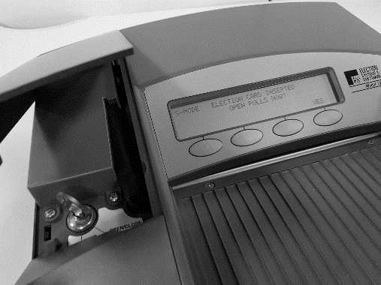

- Turn the key counter-clockwise from the "VOTE" position to the "OPEN/CLOSE POLL" position

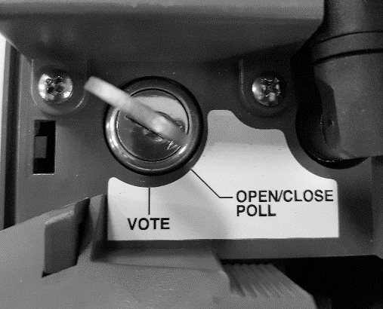

- Press the button under "CLOSE POLLS" on the display screen
    - The display screen will show "POLL CLOSED"
    - The vote tabulator will print two copies of the election results tape

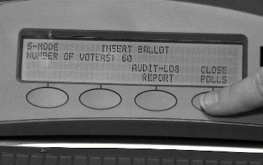

Important to do:
If the tabulator does not print the election results tape, phone the Tabulator Contact Centre immediately.

- Split the tape:
    - The first section contains the zero tape and the first copy of the election results
    - The second section contains a second copy of the election results

- Give the Ballot Officer the second copy of the results tape and the Tabulator Placemat
    - Direct the Ballot Officer to:
- Phone in the results immediately following the steps on the Tabulator Placemat
- Once the results are phoned in, post the second copy of the results tape if there are Scrutineers or Candidates present who wish to view the tape

- Complete the Ballot Statement following the instructions on the form

- Have the first copy of the election results tape that includes the zero tape signed by voting place staff and any Scrutineers present

- Place the signed first copy of the election results tape in the Critical Items Envelope

- Remove all used ballots from the vote tabulator stand and pack them into the white Ballot Transfer Box (Used Ballots)

- Pack the tabulator in its carrying case

- Break down the tabulator stand and used voting screens:
    - Leave them at the voting place for recycling, if agreed to by the on-site contact

- On the Critical Items Envelope, record:
    - The ward and sub
    - The number of spoiled and declined ballots in the Forms File
    - The number of:
- All white copies of completed Voters
- Voters' List Amendment Application Additions, Corrections and Removals

- Ensure items are packed as shown here:

Pack these items: | In here:
- Voter Information Cards  - Yellow copies of Applications to Amend the Voters' List  - Completed Declarations of Identity | Voter Information Envelope
- White copies of Applications to Amend the Voters' List  - Signed, first signed copy of the election results tape that includes the zero tape | Critical Items Envelope
- Spoiled ballots  - Declined ballots  - Ballot Transfers  - Proxy Appointments  - Voters' Lists | Forms File
- Used ballots  - Ballot Statement  - Second copy of the election results tape | white Ballot Transfer Box (Used Ballots)
- Unused ballots | Ballot Transfer Box  (Unused Ballots)
- Forms File | Supply Bag

- Tape all white Ballot Transfer Boxes (Used Ballots) closed using the seals from your supply bag and put your signature on the seals

- Take down all election signs posted in the voting place and place in the supply bag

- Return the voting room to its original state:
    - Tidy up
    - Reposition furniture, if possible

Important to Do:
Make sure the voting place doors do not lock automatically, leaving you outside and the rest of the supplies inside.

- Place the Critical Items Envelope in the front passenger seat of your vehicle

- Place these items in the trunk or back seat of your vehicle:
    - All white Ballot Transfer Boxes (Used Ballots)
    - Supply bag
    - Vote tabulator
    - Tabulator stand and voting screens, if the on-site contact does not allow recycling
    - Any Ballot Transfer Boxes (Unused Ballots) that did not fit in your supply bag

- Advise voting place staff they are free to leave

- Immediately drive to the Receiving Centre to return your supplies:
    - The location is on the Receiving Centre Map/Windshield sign which was in your supply bag
    - Place the Receiving Centre Map/Windshield Sign in your vehicle's windshield when you arrive at the Receiving Centre

Important to Know:
- You must drive directly to the Receiving Centre because staff are expecting you
- Election supplies are critical and must be secured and accounted for
- If you do not arrive when expected, a Supervisor will be dispatched to search and locate you

- When you arrive at the Receiving Centre:
    - Stay in your vehicle
    - Follow the directions of Receiving Centre staff
    - Receiving Centre staff will collect all supplies from your vehicle
    - Exit slowly when told you are free to leave

- Vote Tabulator

Overview

The vote tabulator:
    - Uses a digital optical scanner to read and record how ballots are marked
    - Sits on a cardboard tabulator stand:
- As ballots are inserted into the vote tabulator, they fall into the compartment inside the stand
    - Produces a zero tape when it is plugged in
    - Produces the election results tape after the close of voting

Components of the Vote Tabulator and Stand

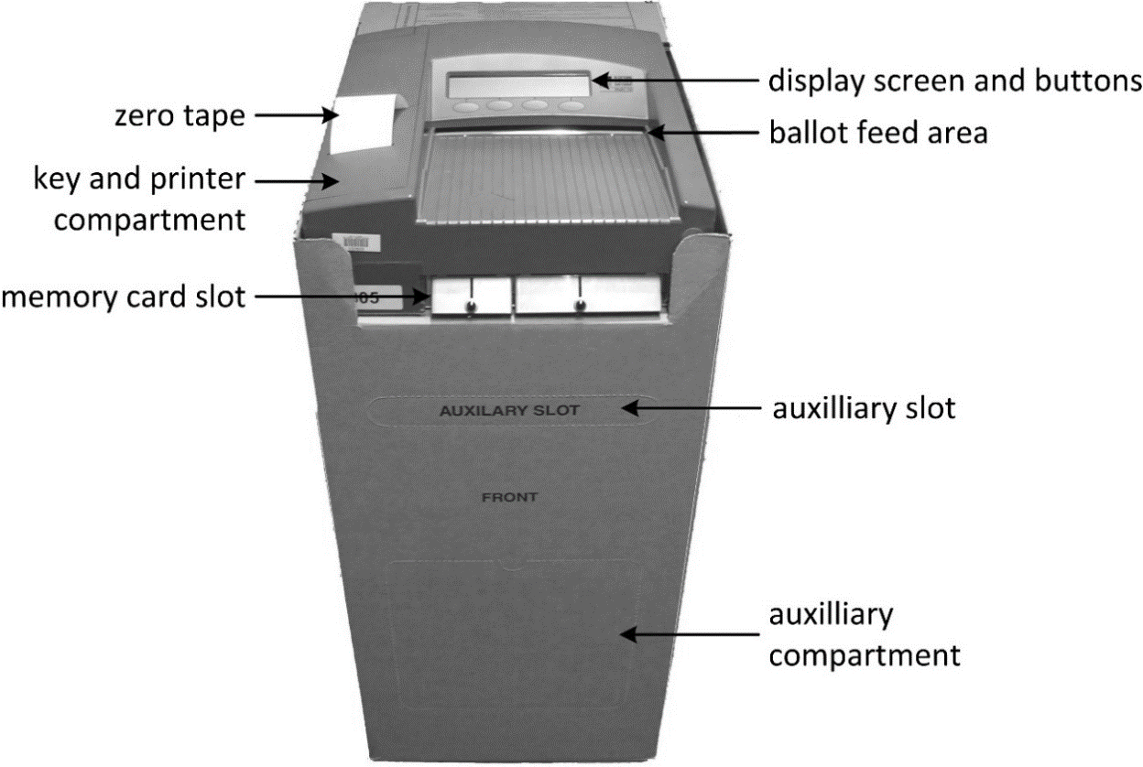

Number of Voters

When a ballot is accepted by the vote tabulator, the "Number of Voters" shown on the display screen will increase by one.

Display Screen and Key Compartment

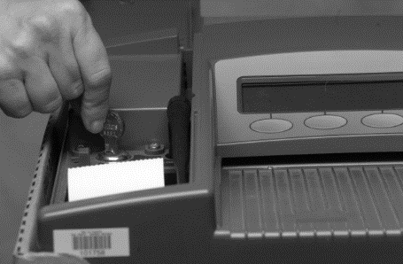
Display screen
Key to close voting

Buttons

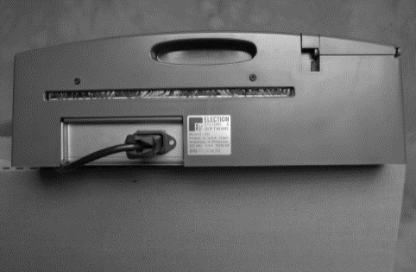
Back of the Vote Tabulator
Rear handle
Paper path
Power cord plug

Tabulator Placemat

The Tabulator Placemat contains instructions on:
    - Serving voters and operating the vote tabulator
    - Troubleshooting vote tabulator issues
    - Phoning in election results

Serving Voters

When a voter hands you their marked ballot in a secrecy folder:
    - Ask the voter to wait while the vote tabulator accepts their ballot
    - Check to ensure the ballot has been initialled by the MDRO and a Ballot Officer
    - Feed the ballot into the vote tabulator face-down and in the secrecy folder
    - Thank the voter for voting when the ballot has been accepted

Important to do:
    - Maintain the secrecy of the vote when checking for initials on the ballot
    - Do not open the secrecy folder or remove the ballot from the secrecy folder
    - If a ballot is rejected by the vote tabulator, follow the steps on the Tabulator Placemat
- Additional Information

Occupational Health and Safety Act and Regulations

    - Voting places and voting place staff are governed by the Occupational Health and Safety Act (OHSA) and its Regulations
    - An OHSA Regulation requires that every worker participate in health and safety awareness training
    - Training is provided by Ontario's Ministry of Labour, which has developed an online Health and Safety Awareness program that focuses on the health and safety rights and responsibilities of workers, supervisors and employers. It also provides a general introduction to workplace health and safety.
    - To access the course, visit:
http://www.labour.gov.on.ca/english/hs/elearn/worker/index.php

City of Toronto Responsibilities

    - Ensuring the safety of the voting place.
- This includes making you aware of any existing or potential hazards in the voting place, and in the duties you perform. A hazard is anything in the voting place that could hurt you or other voting place staff.
    - Informing you about the safe work practices you should follow for your own protection.

Your Responsibilities

    - Following the law and the relevant health and safety policies
    - Following the voting place policies and procedures
    - Working and acting in a way that will not hurt you or any other voting place staff
    - Reporting any hazards you find in the voting place to the Supervisor or Ward Centre

Potential Hazards in the Voting Place

Hazards that could arise in the voting place may include:
    - Slips, trips and falls due to wet floors, food or other spills
    - Damaged tables or chairs
    - Electrical hazards (frayed or damaged extension cords, damaged plugs, damaged wall sockets)
    - Fires and fire alarms
    - Workplace violence or harassment

Fire Alarms

In the event of a fire alarm:
    - Notify the Supervisor or Ward Centre immediately
    - Instruct voters to leave the building and advise they can return once it is safe to do so
    - Notify the on-site contact and call 9-1-1
    - Together with the voting place staff, lock the voting room and secure the voting place.
- If you cannot lock the room ask voting place staff for help removing the tabulator and ballots from the voting place and secure them in your vehicle

Workplace Violence and Harassment

    - Voting places and voting place staff are governed by the City of Toronto's Workplace Violence and Workplace Harassment policies. Voters and other people who enter the voting place are also governed by these policies
    - The City of Toronto will not tolerate acts of violence and will take all reasonable and practical measures to prevent violence and to protect employees from acts of violence. Appropriate remedial, disciplinary and/or legal action will be taken according to the circumstances
    - Workplace violence is the use or attempted use of physical force against a voting place staff that causes or could cause physical injury. Workplace violence may also be a statement or behaviour that could be reasonably interpreted as a threat to use physical force, and that could cause physical injury
    - In case of workplace violence:
- Try to put distance between yourself and the situation
- Do not attempt to physically intervene in a violent situation between individuals
- Call 9-1-1 or instruct a person close to the exit to seek help
- Notify the Supervisor or Ward Centre immediately
    - Workplace harassment can involve unwelcome words or actions that are, or should be known to be offensive, embarrassing, humiliating or demeaning. It can also include behaviour that intimidates, isolates or discriminates against voting place staff

Protection of Privacy

Voting place staff have access to the City of Toronto voters' list for the purpose of performing their election duties. The personal information contained in the voters' list may not be used for any other purposes

- Sample Forms and Training Materials

Item | Page
Ballot Statement | 42
Ballot Transfer Notice | 43
Ballots | 44
Declaration of Identity | 45
Receiving Centre Map / Windshield Sign | 46
Scrutineer Appointment Notice | 47
Voter Information Card | 48
Voters' List | 49-52
Voters' List Amendment Application | 53
Voting Proxy Appointment | 54

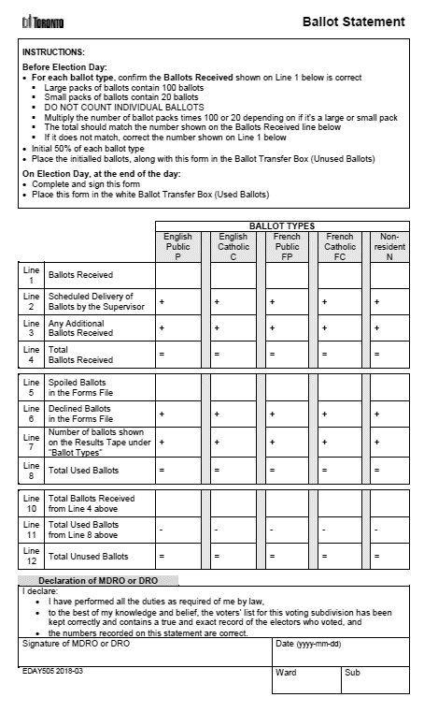
BALLOT STATEMENT

BALLOT TRANSFER NOTICE
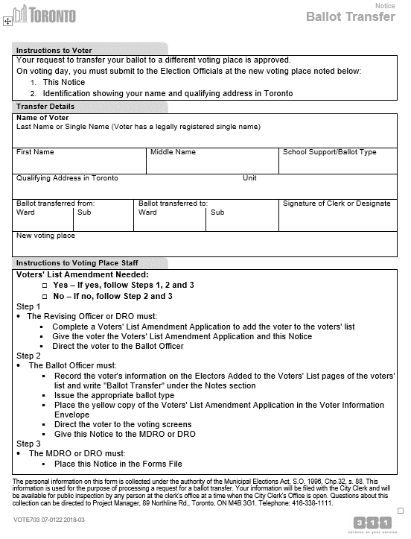

BALLOTS

There are 5 different ballot types.

The type of ballot a voter receives is based on their school support, which is found:
- In the school support (S) column on the voters' list
- On a completed Voters' List Amendment Application

School Support and Ballot Type:
- Public school elector………………….school support is P………..P Ballot
- Catholic school elector……………….school support is C………..C Ballot
- French public school elector………....school support is FP……...FP Ballot
- French catholic school elector……….school support is FC……...FC Ballot

Exception – The N ballot:

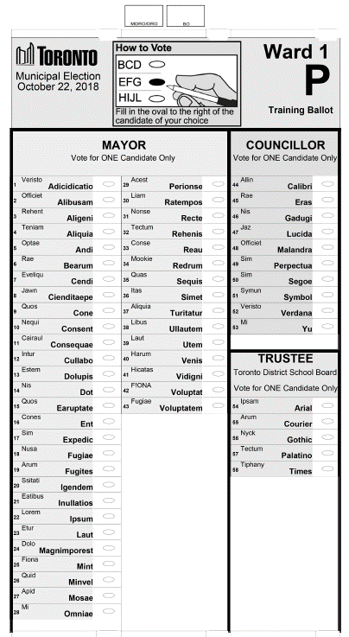
A voter who is a non-resident owner or tenant of commercial or industrial property is not entitled to vote for school trustee.
- They receive an N Ballot, which does not contain the office of trustee.

If an N is shown in the residency status (RS) column of the voters' list the Ballot Officer will:
- Ask the voter if the property is commercial or industrial
- If the answer is yes, issue a N Ballot
- If the answer is no, issue a ballot for the voter's school support

If a voter's Voters' List Amendment Application shows school support/ballot type as "Other", the Ballot Officer will:
- Give the voter an N Ballot

Ballot Sample:

The sample here shows:
- P Ballot, as indicated on the top right hand corner
- Boxes at the top of the ballot for initials MDRO/DRO and Ballot Officer which must appear on every issued ballot
DECLARATION OF IDENTITY

If a voter does not have identification, the Ballot Officer will check to see if they are listed with "MUST SHOW ID" in the NOTES column of the voters' list:
- If they are, the voter cannot complete a Declaration of Identity and must return with identification to be issued a ballot
- If not, they can complete a Declaration of Identity and be issued a ballot

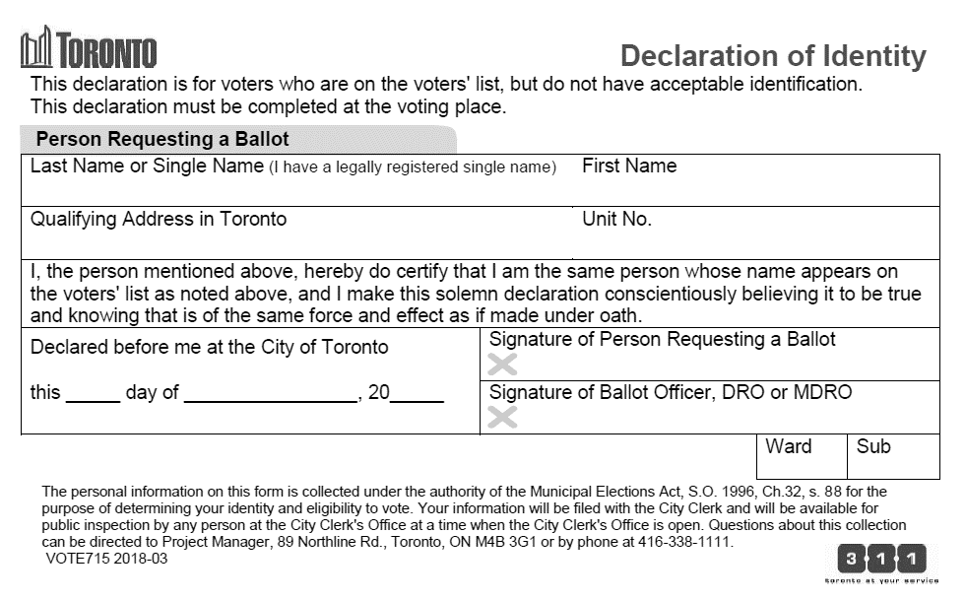

RECEIVING CENTRE MAP / WINDSHIELD SIGN

In your supply bag you find a Receiving Centre Map / Windshield Sign.

A map of your assigned Receiving Centre is on one side.

The other side is a Windshield Sign to place in the windshield of your vehicle when you return your supplies at the end of the day.
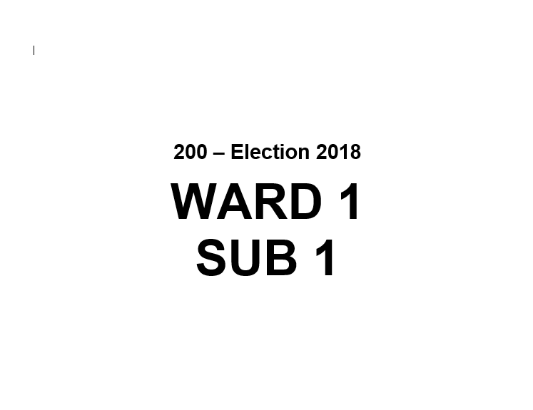
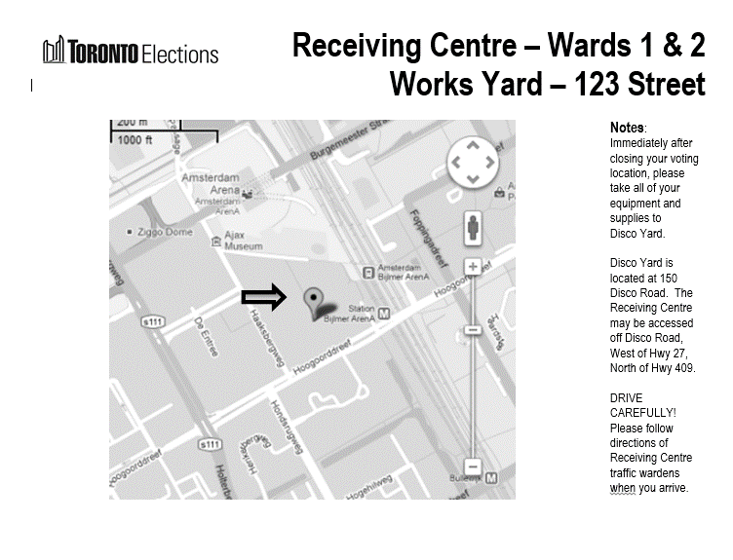
SCRUTINEER APPOINTMENT NOTICE
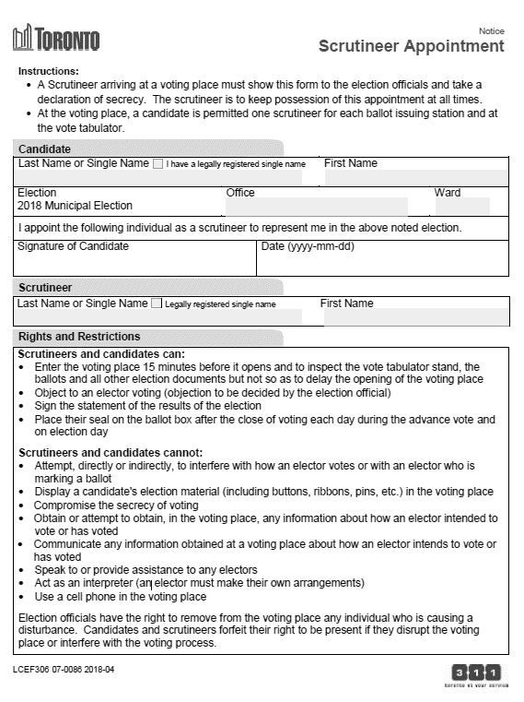

VOTER INFORMATION CARD

A Voter Information Card:
- Is sent to each voter whose name appears on the voters' list
- Tells the voter where and when they may vote
- Can make it easier to find a voter on the voters' list, but it is not mandatory for a voter to show their card
- Is not accepted as identification
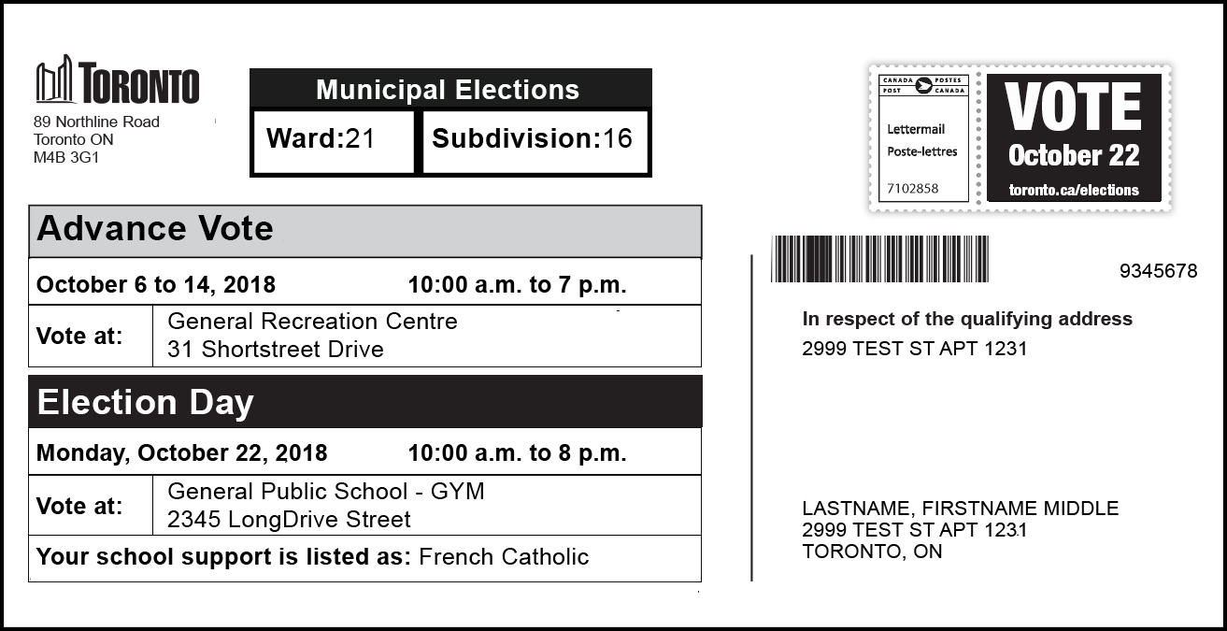

VOTERS' LIST

There are two types of voters' list:
- One for MDROs, DROs and Revising Officers, which is alphabetical by street
- One for Ballot Officers, which is alphabetical by voter's name

MDRO, DRO and Revising Officer Voters' List Cover

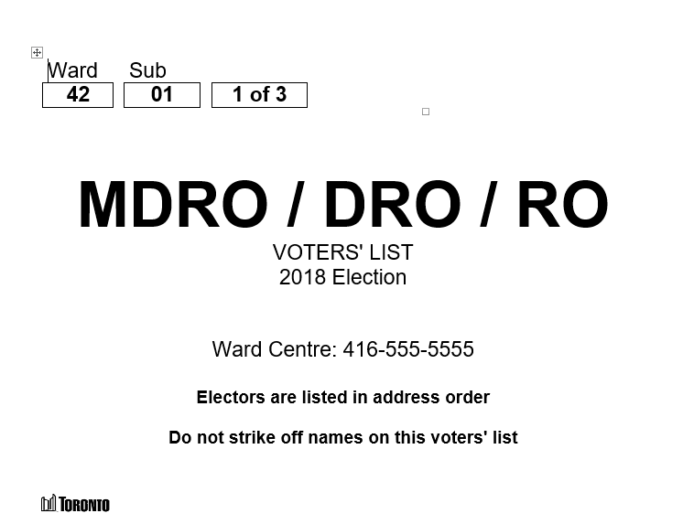

Ballot Officer Voters' List Cover
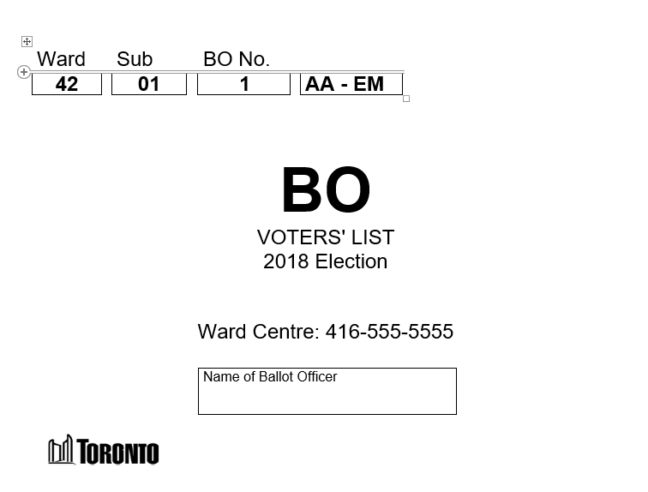

Placard showing name range
VOTERS' LIST

Street Index Page

The first page of the voters' list contains the Street Index which lists the street addresses located in your sub in alphabetical order.

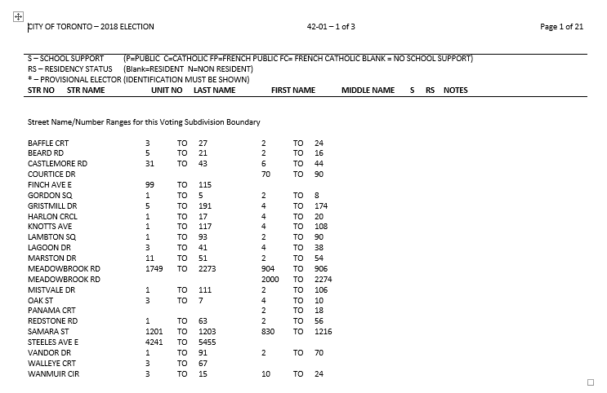
Streets
in the sub
Range of odd
street numbers in the sub
Range of even
street numbers in the sub

VOTERS' LIST

List of Voters Pages
Voters' are listed:
- Alphabetically by street, then
- Numerically by street number, then
- Alphabetically by last name

If a voter has added their name to the voters' list online, they are listed with a * beside their last name and MUST SHOW ID is shown in the NOTES column. The voter must show identification. They cannot complete a Declaration of Identity.

A voter who voted during the advance vote is shown with their information crossed off and VOTED is shown in the NOTES column.
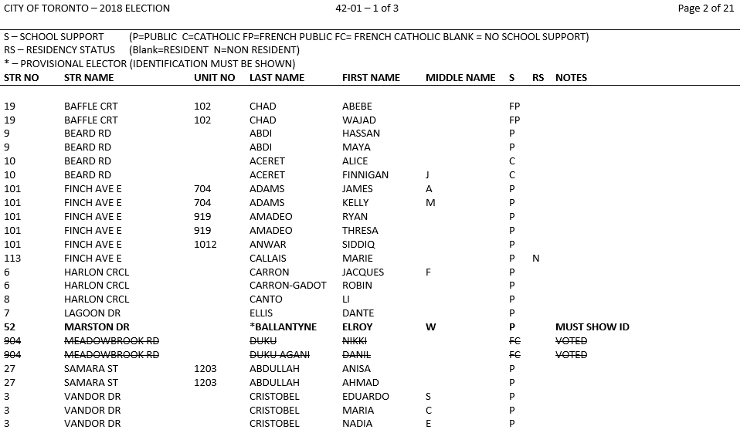
Last
Name
First
Name
Street
Name
Street
Number
School
Support/
Residency Status

Notes
Unit
Middle
Name

VOTERS' LIST

Candidate & Scrutineer Sign-In Sheets

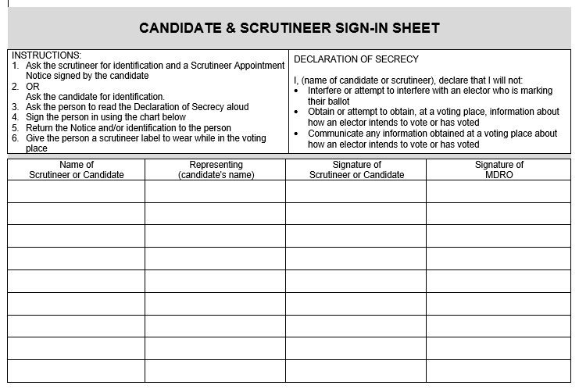
At the back of the MDRO/DRO/RO Voters' List are pages for signing in Candidates and Scrutineers.

VOTERS' LIST AMENDMENT APPLICATION

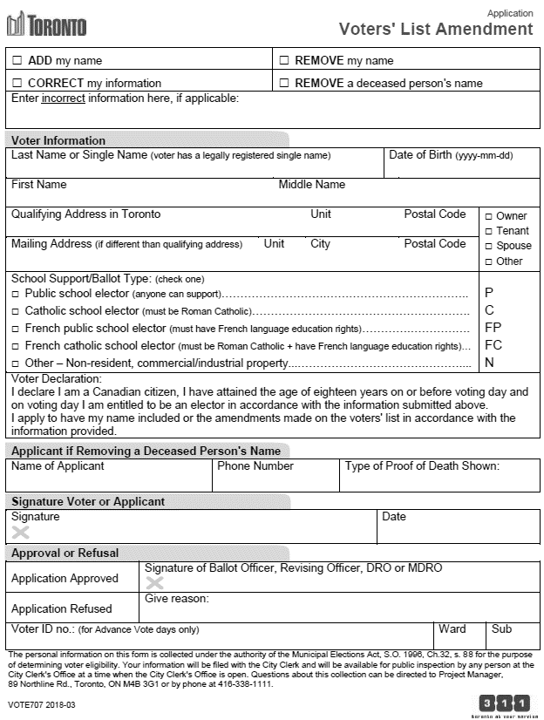
Name and address
is mandatory.
Date of Birth is not mandatory.
Must be completed
If applicable
One box must
be checked
If applicable
One box must
be checked
One box must
be checked

VOTING PROXY APPOINTMENT

When reviewing a Voting Proxy Appointment, check that:
- Check that Box E – Certification by Clerk has been signed by the Clerk or Designate
- The Appointment has been stamped with the Clerk's seal
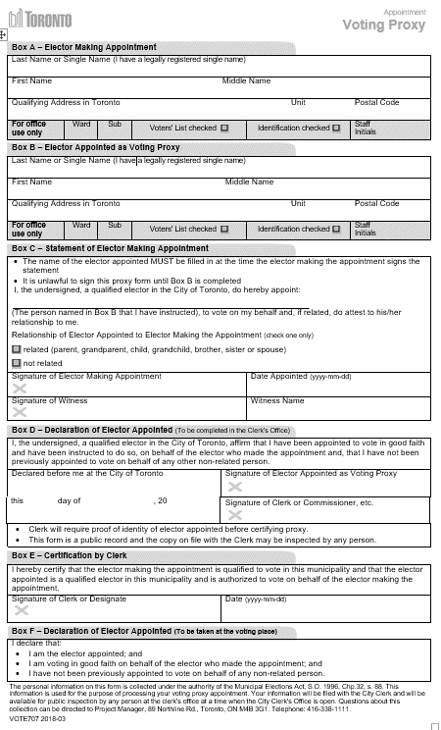

Voter Identification Must Show Name and Qualifying (Toronto) Address

Acceptable Identification:
- Ontario issued photo card, driver’s license or motor vehicle permit (vehicle portion)
- Cancelled personalized cheque, credit card or bank account statement
- Utility bill for hydro, telephone or cable TV, water, gas or a bill from a public utilities commission
- Cheque stub, T4 statement or pay receipt issued by an employer
- Statement of direct deposit for Ontario Works or Ontario Disability Support Program
- Property tax assessment, income tax assessment notice, Child Tax Benefit statement
- Mortgage statement, lease or rental agreement
- Transcript or report card from a post-secondary school
- Document showing campus residence, issued by the office or officials responsible for student residence at a post-secondary institution
- Any other document from the government of Canada, Ontario or a municipality in Ontario or a document issued or certified by a court in Ontario
- Any document from a Band Council in Ontario established under the Indian Act (Canada)
- Insurance policy or insurance statement
- Loan agreement or other financial agreement with a financial institution
- Statement of Employment Insurance Benefits Paid T4E
- Statement of Old Age Security T4A (OAS), Canada Pension Plan Benefits T4A (P), Canada Pension Plan Statement of Contributions
- Workplace Safety and Insurance Board Statement of Benefits T5007
- CNIB card or a card from another registered charitable organization that provides services to persons with disabilities
- Document showing residence at a long-term care home under the Long-Term Care Homes Act, 2007, issued by the Administrator for the home
- Hospital card or record

Electronic Identification:
- Identification is accepted in whichever format it was first issued
- With documents issued electronically (such as e-statements or e-invoices) a hard copy or online version shown on a mobile device is acceptable
- Photocopies or scanned versions of documents that were not issued electronically are not acceptable (such as a passport)

Note: A Voter Information Card cannot be used as identification

