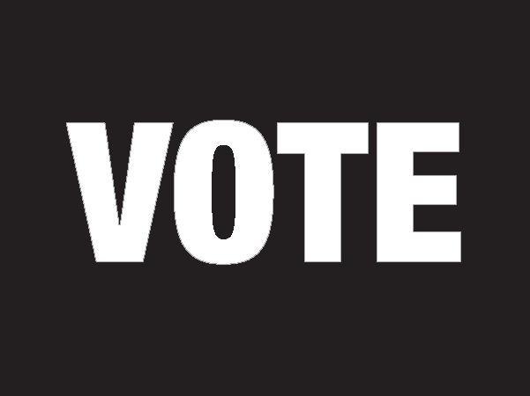` 2018 Election

# VAT Officer

# Manual



Table of Contents

1 Introduction 1

2 People in the Voting Place 2

2.1 The Voting Place Team 2

2.2 Voters and Voting 2

2.3 Scrutineers & Candidates 4

3 Before Voting Day Checklist 5

4 Opening the Voting Place Checklist 6

5 Operating the VAT 8

5.1 VAT Overview 8

5.2 Components of the VAT 8

5.3 Operating the VAT 10

5.4 Serving Voters 10

5.5 VAT Tracking Sheet 10

5.6 Sample VAT Tracking Sheet 11

6 Customer Service and Accessibility 12

6.1 Creating a Positive Voting Experience 12

6.2 Serving People with Disabilities 12

6.3 Inclusive Voting Places 12

6.4 Accommodations and Special Services 13

7 Closing the Voting Place Checklist 15

8 Additional Information 16

1. Introduction
   1. **Welcome**

Thank you for joining the election team!

As an Election Official you play an important part in delivering this election for Toronto.

This manual outlines your duties and is for your use:

* + - Make notes in it
    - Use the checklists included
    - Read the entire manual before voting day

It is not necessary to memorize anything. Just be familiar with the manual so you can find the information you need when you need it.

* 1. **Expectations**

As an Election Official and a representative of the City of Toronto you are expected to:

* + - Be professional (helpful, courteous and patient)
    - Maintain secrecy
    - Act with integrity (be fair, impartial and unbiased)
    - Follow policies and procedures
    - Work together with the voting place team
    - Treat all co-workers and the public with respect
    - Refrain from engaging in harassment and/or discrimination
    - Provide people with disabilities full and equal access to the election process

This election must be conducted according to the principles of democratic elections:

* The secrecy and confidentiality of an individual's vote is paramount
* The election is fair and must not favour one candidate over another
* The election is accessible to all voters
* The integrity of the process is maintained throughout the election
* Voters and candidates are treated fairly
* There should be certainty that the results of the election reflect the votes cast
* The proper majority vote governs by ensuring that valid votes are counted and invalid votes are rejected, so far as reasonably possible

1. People in the Voting Place
   1. The Voting Place Team

Your Role

As a **VAT Officer**, it is your role to:

* + - Set up and operate the VAT (Voter Assist Terminal)
    - Assist voters using the VAT
    - Assist other voters when the VAT is not in use

Your Team

The **MDRO** is the voting place manager and they will:

* + - Provide you with supplies
    - Ensure procedures are followed
    - Direct you to complete certain tasks
    - Provide you with advice and support
    - Resolve issues in the voting place

**Ballot Officers** issue ballots to voters.

**Revising Officers** add people to the voters' list and make changes to voter information on the list.

The **Information Officer** greets voters and directs them to the Ballot Officers and Revising Officers.

The **Tabulator Officer** accepts ballots from voters and feeds them into the vote tabulator.

If an **Accessibility Officer** is assigned to the voting place, they ensure voters can get into the voting place by opening a door, operating an elevator or directing voters to the voting room.

* 1. Voters and Voting

Qualifications

Every person is entitled to vote who, on voting day:

* + - Is a Canadian citizen and
    - Is at least 18 years of age and
    - Lives in the city of Toronto or
* Owns or rents property in Toronto or
* Is the spouse of a person who owns or rents property in Toronto
  + - And is not prohibited from voting under any law

Important to Know:

* + - A person may only vote once in this election
    - If a person lives in Toronto and owns or rents another property in Toronto, they must vote in the ward in which they live

Identification Requirements

Each voter must be asked for identification.

Identification must show the voter's name and Toronto address.

If a voter wishes to complain about the identification requirements they may contact Election Services at 416-338-1111.

Voting

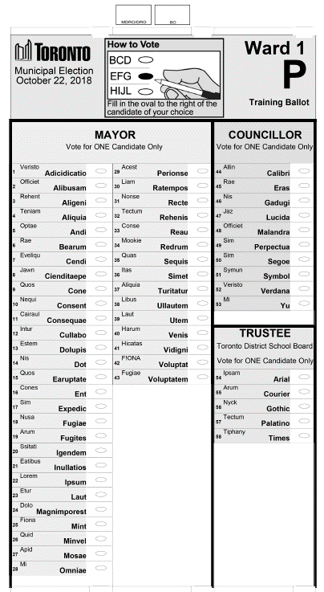

Voters may vote for one candidate for each of these offices:

* + - Mayor
    - Councillor
    - Trustee

Important to Know:

A non-resident owner or tenant of commercial or industrial property is not eligible to vote for Trustee. They receive a Non-resident ballot which does not include the office of Trustee.

Voters will:

* + - Receive a ballot in a secrecy folder
    - Mark their ballot by filling in the oval to the right of the candidate of their choice

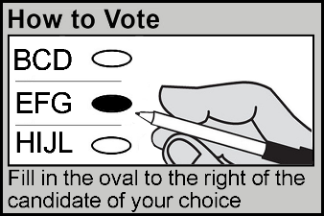

* 1. Scrutineers & Candidates

A Candidate may appoint Scrutineers to represent them in the voting place.

Each Candidate may station one Scrutineer at each Ballot Officer and one at the tabulator.

A Candidate may act as a Scrutineer.

When a Scrutineer arrives at your voting place, they must:

* + - Sign in with the MDRO
    - Wear a Scrutineer label provided by the MDRO

1. Before Voting Day Checklist

* Plan your travel route
  + - To arrive at your voting place at 9:00 a.m.
* Expect a phone call from the MDRO asking if you intend to work
* View the Voter Assist Terminal video on the Elections website
* Read your Accessible Customer Service Handbook
* Plan your needs for voting days:
  + - Refreshments: Bring enough food and drinks for the day
    - Dress: Indoor temperatures vary; dress in layers
    - Medication: Bring any medication you will need to take during the day

1. Opening the Voting Place Checklist

Work with your team to complete these tasks and open the voting place at

10:00 a.m.

* Arrive at the voting place at **9:00 a.m. sharp!**

Important to Know:

**During Advance Vote the VAT may already be set up in the voting room and minimal other setup may be required.**

* With the Assistance of the MDRO, move the VAT from where it is stored into the voting room
* Unpack the supplies which come with the VAT:
  + - Sip and puff device
    - Disposable gloves
    - Sanitizing hand-wipes
    - VAT Tracking Sheet
    - VAT Placemat
    - Cable ties
    - Cable path tape
    - Lap tray
    - Rocker paddle
* Set up the VAT table
  + - Follow the instructions listed on the box
    - Situate the table in the room to ensure:
* Secrecy and privacy for voters
* At least 5 feet of space between the VAT and any wall
* An electrical outlet is near
* Place the VAT on the table
* Plug the VAT into the electrical outlet
* Set up the VAT
  + - Slide the tabs on the top of the VAT to the side and flip the lid back
    - Lift the touch-screen and close the lid behind it
    - Lift the ballot feed tray and gently move it towards you
    - Plug in the headphones
    - Place the privacy screen on the VAT
* Get the VAT ready for voting
  + - Insert the key and turn it to the "On"position
    - Once the "Insert Your Ballot" screen appears, remove the key and store it in the VAT case
    - Feed a blank ballot into the VAT to ensure it reads the ballot and displays voting instructions
    - Press the "EXIT Return Ballot" button and return the blank ballot to the MDRO
* Work with your team to set up tables and chairs
* Assemble voting screens:
  + - Tie a piece of string from the MDRO's supply bag to each marking pen cap
    - Attach a marking pen to each voting screen by threading the string through the hole in the side of the screen and knotting the string
* At about 5 feet above the ground or floor so they can be easily seen, post:
  + - Vote Here sign in an area near the main entrance to the building, where it can be seen from the street
    - Directional Arrow signs on doors and walls leading to the voting room
    - Accessible Entrance sign at the accessible entrance noted on the Final List of Voting Places in your supply bag
    - Accessible Entrance Directional Arrow signs directing voters to the accessible entrance at all other entrances
    - Translations signs in a highly visible area (front entrance of building, entrance to voting room, near Information Officer)
    - No Cell Phones/Cameras signs in the voting room
    - Ward Map, where space permits

* Open the voting place at **10:00 a.m. sharp!**

1. Operating the VAT

* 1. VAT Overview

The VAT (Voter Assist Terminal):

* + - Is a paper ballot-marking device that enables voters with disabilities to mark their ballot privately and independently
    - Can be equipped with accessible devices to assist voters with marking their ballot
  1. Components of the VAT

The Terminal

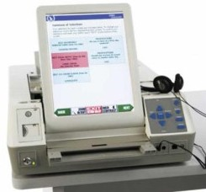

Exit/Return Ballot button

Touch-screen

Next button

Keypad with Braille

Back button

Input for rocker paddle or sip/puff device

Zoom

On/off/test switch

Input for headphones

Ballot feed tray

Adjust contrast

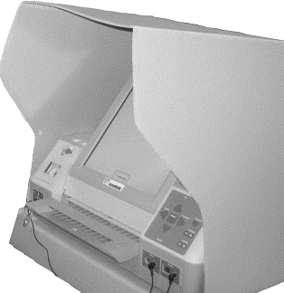Privacy Screen

Keypad with Braille

Image of Braille Keypad

The keypad allows voters to:

* + - Move between screens
    - Scroll through a list of candidates
    - Select the candidate of their choice

Each button has a description in Braille for voters who are blind or partially- sighted.

Touch-Screen Buttons

Voters can use buttons on the touch-screen to:

* + - Move between screens
    - Scroll through a list of candidates
    - Select the candidate of their choice
    - Zoom in and out on the ballot being displayed
    - Choose a high contrast black and white display

Sip/Puff Tube and Rocker Paddle/Foot Switch

A sip/puff tube and rocker paddle/foot switch may be used by voters with limited motor function, or who are, unable to use the touch screen or touch pad.

Image of Rocker Paddle/Foot Switch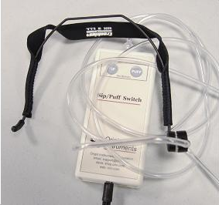

* 1. Operating the VAT

To operate the VAT, follow the steps on the VAT Placemat which include:

* The steps for serving voters
* Steps voters will follow to mark their ballot
* Features of the VAT
* Troubleshooting steps
  1. Serving Voters

If a voter wishes to use the VAT you will:

* + - Greet each voter
    - Ensure the ballot has been initialled by the MDRO and Ballot Officer
    - Explain:
* Features of the VAT
* The steps the voter will follow
  + - Ask the voter if they have questions or need assistance
    - Give the voter space and privacy when they are voting, but remain nearby in case they have any questions or need assistance
    - Direct or accompany the voter to the Tabulator Officer
    - Update the Voter Assist Terminal Trackingform
    - Use sanitizing wipes for the touch-screen, keypad and assistive devices, if needed

While the VAT is made available for voters with disabilities, any voter is welcome to mark their ballot using the VAT.

* 1. VAT Tracking Sheet

A VAT Tracking Sheet is included in the supply bag with your VAT.

* + - Record your name, the date, ward and sub
    - Each time the VAT is used:
* In the Number of Voters Using the VAT section, cross off the next number
* In the Assistive Devices Used section, cross off the next number if a person uses one of the assistive devices listed
  + - After the close of voting:
* Record the total number of times the VAT was used
* Record for each type of device, the total number of times that device was used
* Place this sheet back in the supply bag and pack it in the VAT
  1. Sample VAT Tracking Sheet

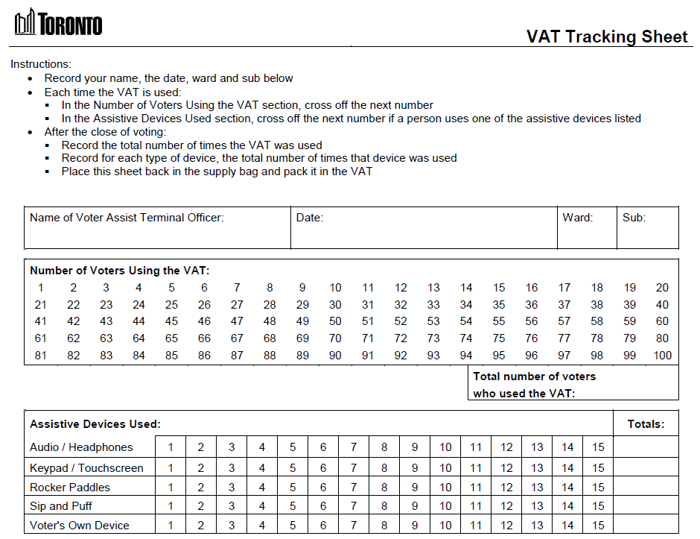

1. Customer Service and Accessibility
   1. Creating a Positive Voting Experience

It is important that you and your team create a positive voting experience for all voters:

* + - Make eye contact
    - Smile
    - Greet voters as they arrive
    - Use a welcoming tone
    - Listen
    - Be polite and respectful
    - Focus on problem solving
  1. Serving People with Disabilities

It's important that people with disabilities have full and equal access to elections and can vote in the same place and in similar ways as others. Sometimes, this may require an approach that is flexible and responsive to the individual needs of the voter.

Remember to TALK!:

* **T**ake a moment to ask "May I help you?"
* **A**sk, don't assume. Never assist unless asked to.
* **L**isten and speak directly to the person.
* **K**now the accommodations and special services available.

Important to do:

* + - Be welcoming and treat the voter with respect
    - Do not single out a voter if you believe they may have a disability
    - Do not discuss a voter's needs or disability in front of others
    - When assisting a voter, keep the voter's privacy and independence in mind
  1. Inclusive Voting Places

Everyone in the voting place has the right to be treated respectfully.

During the day, you will be interacting with many different people and the words you use can be important.

Follow these tips to ensure your words are respectful and your voting place is inclusive for all voters.

Don't Assume

Don't assume someone is a man or a woman. You can't tell someone's gender identity by just looking at them.

Avoid Using Gendered Language

Avoid using words that are based on gender, such as:

* + - Mr. / Sir
    - Miss / Mrs. / Ms / Madam / Ma'am
    - He / him / his / gentleman / man
    - She / her / hers / woman / lady

Even though we use titles like Mr. or Ms. to be respectful, this may end up having the opposite effect and it might impact someone negatively.

Use words which are gender neutral, such as:

* + - You
    - They
    - The voter
    - This person
    - The Election Official

Another option is to identify the person by what they are wearing:

* + - "Excuse me, the person in the blue shirt"
    - "Can you help the person in the blue shirt?"

If at any time a person tells you how they would like to be addressed or corrects you – tell them thank you for the information and move forward using that language.

As always, a warm smile and a wave can go a long way in creating a welcoming space!

* 1. Accommodations and Special Services

To meet the needs of voters, including voters with disabilities and voters whose first language is not English, these accommodations and special services are available:

Accessible Voting Equipment

* + - During advance voting, a VAT is located in each voting place
    - On election day, a VAT is located in one voting place in each ward

Assistance to Voters

* + - If a voter needs assistance inside the voting place, they may bring a friend along or ask an Election Official for assistance
    - Accessibility Officers are placed at sites with physical barriers to provide assistance to voters when required
    - All Election Officials receive customer service training and an Accessible Customer Service Handbook

Ballot Transfers

* + - If a voter is unable to vote at their designated voting place, they can transfer their ballot to an alternate voting place within the same ward. This is done through Election Services

Curbside Voting

* + - If a voter is able to travel to a voting place but is physically unable to go inside, they can ask to have their ballot brought to their vehicle, outside of the building or to another area within the voting place

Proxy Voting

* + - If a voter is unable to attend a voting place to cast their ballot, they may appoint a proxy to vote on their behalf. This is done through Election Services

Translated Materials and Language Services

* + - Election information is available in other languages on the Elections website (www.toronto.ca/elections)
    - If a voter needs assistance in a language that is not on the website, they can call 3-1-1 for over-the-phone interpretation in more than 180 languages
    - A voter may ask anyone who is not a candidate or a scrutineer to act as an interpreter for them
    - 'How to Vote' booklets are available in multiple languages and Braille at each voting place

Other Items in the Voting Place

* + - Magnifying sheets to assist voters with low vision
    - Pads of paper to communicate with voters who are deaf, deafened or hard-of-hearing
    - How to Vote Sample Pads for Election Officials to show voters how to mark the ballot
    - Translation posters with voting information

1. Closing the Voting Place Checklist

The MDRO will close the voting place:

* **During Advance Vote the voting place closes at 7:00 p.m.**
* **On Election Day the voting place closes at 8:00 p.m.**
* Serve the remaining voters:
  + - Allow any voters in line to complete voting
    - If there is a line-up of voters when the voting place closes voting place staff must ensure no other person joins the line
* Once the last voter is served, turn off and pack up the VAT:
  + - Insert the key and turn it to "Off"
* Pack the VAT Tracking Sheet and all supplies back into the plastic supply bag
* Leave when the MDRO says you are free to leave



Tasks for the Last Day of Advance Vote or Election Day Only:

* Once the last voter is served, turn off and pack up the VAT:
  + - Insert the key and turn it to "Off"
    - Remove the key and place it in the VAT case
    - Remove the headphones and power cord
    - Lift the front of the ballot feed tray and fold it inward toward the VAT
    - Open the lid and fold the touch-screen into the compartment
    - Lower the lid over the touch-screen
    - Lower the lid flap over the ballot feed tray
    - Slide the tabs on top of the VAT toward each other to secure the lid

* Pack the VAT Tracking Sheet and all supplies back into the plastic supply bag
* With assistance:
  + - Place the VAT, power cord, headphones and supply bag into the VAT case
    - Fold the table and place it in the box
* Sign the first copy of the election results tape that includes the zero tape when directed to by the MDRO
* Assist the MDRO with any other tasks
* Assist the MDRO with loading equipment and supplies into their vehicle

* Leave when the MDRO says you are free to leave

1. Additional Information

Occupational Health and Safety Act and Regulations

* + - Voting places and voting place staff are governed by the Occupational Health and Safety Act (OHSA) and its Regulations
    - An OHSA Regulation requires that every worker participate in health and safety awareness training
    - Training is provided by Ontario's Ministry of Labour, which has developed an online Health and Safety Awareness program that focuses on the health and safety rights and responsibilities of workers, supervisors and employers. It also provides a general introduction to workplace health and safety
    - To access the course, visit:

<http://www.labour.gov.on.ca/english/hs/elearn/worker/index.php>

City of Toronto Responsibilities

* + - Ensuring the safety of the voting place
* This includes making you aware of any existing or potential hazards in the voting place, and in the duties you perform. A hazard is anything in the voting place that could hurt you or other voting place staff
  + - Informing you about the safe work practices you should follow for your own protection

Your Responsibilities

* + - Following the law and the relevant health and safety policies
    - Following the voting place policies and procedures
    - Working and acting in a way that will not hurt you or any other voting place staff
    - Reporting any hazards you find in the voting place to the MDRO or Supervisor

Potential Hazards in the Voting Place

Hazards that could arise in the voting place may include:

* + - Slips, trips and falls due to wet floors, food or other spills
    - Damaged tables or chairs
    - Electrical hazards (frayed or damaged extension cords, damaged plugs, damaged wall sockets)
    - Fires and fire alarms
    - Workplace violence or harassment

Fire Alarms

In the event of a fire alarm:

* + - Notify the MDRO or Supervisor immediately
    - Instruct voters to leave the building and advise they can return once it is safe to do so
    - Notify the on-site contact and call 9-1-1
    - Together with the voting place staff, lock the voting room and secure the voting place.
* If you cannot lock the room assist the MDRO with removing the tabulator and ballots from the voting place and securing them in their vehicle

Workplace Violence and Harassment

* + - Voting places and voting place staff are governed by the City of Toronto's Workplace Violence and Workplace Harassment policies. Voters and other people who enter the voting place are also governed by these policies
    - The City of Toronto will not tolerate acts of violence and will take all reasonable and practical measures to prevent violence and to protect employees from acts of violence. Appropriate remedial, disciplinary and/or legal action will be taken according to the circumstances
    - Workplace violence is the use or attempted use of physical force against a voting place staff that causes or could cause physical injury. Workplace violence may also be a statement or behaviour that could be reasonably interpreted as a threat to use physical force, and that could cause physical injury
    - In case of workplace violence:
* Try to put distance between yourself and the situation
* Do not attempt to physically intervene in a violent situation between individuals
* Call 9-1-1 or instruct a person close to the exit to seek help
* Notify the MDRO or Supervisor immediately
  + - Workplace harassment can involve unwelcome words or actions that are, or should be known to be offensive, embarrassing, humiliating or demeaning. It can also include behaviour that intimidates, isolates or discriminates against voting place staff