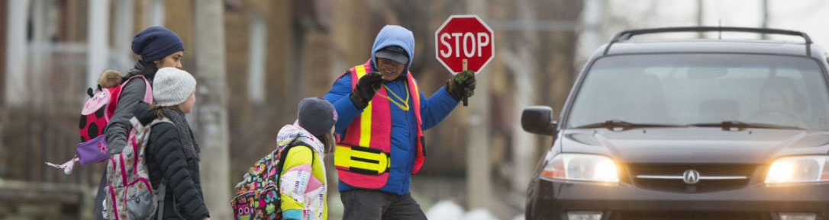

Request for a School Crossing Guard

School crossing guards help students stay safe from traffic as they make their way to and from school.
If you are interested in having a traffic survey conducted in your area to determine whether your school community meets the minimum required criteria (based on data collection at the requested location) for a school crossing guard, please complete the following online form.

APPLICANT CONTACT INFORMATION:

Please provide the date of this request: Click here to enter a date.

First Name: Click here to enter text.
Last Name: Click here to enter text.
Street Number: Click here to enter text.
Street Name: Click here to enter text.
Apartment Number: Click here to enter text.
Postal Code: Click here to enter text.
Contact Phone Number: Click here to enter text.
Email: Click here to enter text.

SCHOOL DETAILS:

Please provide the full name of the school: Click here to enter text.

Please provide the school's address
Street Number: Click here to enter text.
Street Name: Click here to enter text.
Postal Code: Click here to enter text.

Please provide the school's grade level of school (check all that apply)

☐ Primary/Junior (Kindergarten – Grade 6)
☐ Junior/Intermediate (Grade 4 – Grade 10)
☐ Intermediate/Senior (Grade 7 – Grade 12)
☐ Other, please specify: Click here to enter text.
Please provide the start of school's bell time(s).
A.M. Morning Period:
☐ 8:00 a.m.
☐ 8:15 a.m.
☐ 8:30 a.m.
☐ 8:45 a.m.
☐ 9:00 a.m.
☐ 9:15 a.m.
☐ 9:30 a.m.
☐ Other, please specify: Click here to enter text.

Please provide the start of school's bell time(s).
Lunch Period:
☐ 11:00 a.m.
☐ 11:15 a.m.
☐ 11:30 a.m.
☐ 11:45 a.m.
☐ 12:00 p.m.
☐ 12:15 p.m.
☐ 12:30 p.m.
☐ Other, please specify: Click here to enter text.

Please provide the start of school's bell time(s).
Dismissal Period:
☐ 3:00 p.m.
☐ 3:15 p.m.
☐ 3:30 p.m.
☐ 3:45 p.m.
☐ 4:00 p.m.
☐ 4:15 p.m.
☐ 4:30 p.m.
☐ Other, please specify: Click here to enter text.

REQUEST FOR A SCHOOL CROSSING GUARD:

Please provide the requested location (intersection):
Click here to enter text.

Please attach to this form a diagram, or image identifying the desired location.

Is there any additional information about this location you would like to share?
Click here to enter text.

ADDITIONAL INFORMATION:

Indicate the reason for requesting a new school crossing guard.
Click here to enter text.

Are you a parent/guardian of a child that attends this school?
☐ Yes
☐ No

If you answered yes to the above question, does your child walk to this school?
☐ Yes
☐ No

If you are not a parent/guardian of a child that attends this school, what is your affiliation?
☐ Community Member
☐ School Staff
☐ Other, please specify: Click here to enter text.

I acknowledge the Principal (or delegate) of the school referenced has been made aware of this Request for a Crossing Guard.
☐ Yes
☐ No

Indicate the date on which the Principal was informed about the request for a school crossing guard (or delegate).
Click here to enter a date.

Enter the Principal (or delegate) information:
First Name: Click here to enter text.
Last Name: Click here to enter text.
Street Number: Click here to enter text.
Street Name: Click here to enter text.
Apartment Number: Click here to enter text.
Postal Code: Click here to enter text.
Contact Phone Number: Click here to enter text.
Email: Click here to enter text.
I acknowledge the Councillor (or delegate) of the school referenced has been made aware of this Request for a Crossing Guard.
☐ Yes
☐ No

Indicate the date on which the Councillor was informed about the request for School Crossing Guard.
Click here to enter a date.

Enter the Councillor (or delegate) information:
First Name: Click here to enter text.
Last Name: Click here to enter text.
Street Number: Click here to enter text.
Street Name: Click here to enter text.
Apartment Number: Click here to enter text.
Postal Code: Click here to enter text.
Contact Phone Number: Click here to enter text.
Email: Click here to enter text.

Please note that only fully completed forms will be processed.
If you have any questions or inquiries, please contact schoolcrossingguard@toronto.ca
For more information on school crossing guard program, please visit: toronto.ca/SchoolCrossingGuard

