Odours Related to Sewer Upgrades
The City of Toronto is currently rehabilitating the sewer pipes in your area using a trenchless process called Cured-In-Place Pipe (CIPP). Trenchless technology requires minimal digging and therefore involves less construction disturbance to the neighbourhood.
The process involves inserting a liner containing a styrene resin into the sewer pipe where it cures to form a new sewer pipe wall. This project is part of the Toronto City Council-approved Capital Works Program to renew Toronto's aging infrastructure, reduce the risk of leaks, and ensure continued long-term reliable sewer service.

You are receiving this notice because you may have experienced short-term odours while the sewer is being relined during construction. Please see attached Fact Sheet for more information about styrene.
To help stop odours from entering your home or business, please take the following action described below.

POSSIBLE ODOUR DURING CONSTRUCTION
Odour: You may experience short-term odours while the sewer is being relined during this phase of construction.
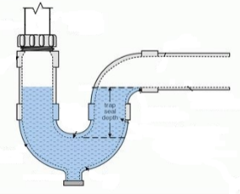
To reduce the odour, it is recommended that you pour at least one to two litres of water down every drain (i.e. sinks, showers, bathtub, floor drains) once each day for three days in order to maintain a water barrier. Do not continuously run your taps as it may result in a backup.
If a strong odour is present and persists after taking the above noted action, please contact the Field Ambassador indicated at the bottom of this notice for assistance.

NEED MORE INFORMATION?
If you have questions about the work, please contact us.
Field Ambassador | Email: xxxxxx@xxxx.com  Phone: 416-xxx-xxxx
TTY Hearing Impaired Service | 416-338-0889  (7 Days a week, 8:00 a.m. – 5:00 p.m., closed holidays)
General inquiries | 3-1-1
Thank you for your patience. Building a great city takes time. Better infrastructure for all of us is worth the wait.

