Toronto’s Transportation Innovation Zones

Stakeholder Workshops - Participant Briefing
September 14-16 2020

Introduction to the TIZ
- The Transportation Innovation Zones (TIZ) program will facilitate trials of new transportation approaches and technologies in the public right of way, in specific geographical areas of the City.

Benefits to the City & the public
- Understand emerging technologies and approaches prior to implementation/regulation
- Support economic development, including local small & medium-sized enterprises
- Support COVID-19 recovery & rebuild

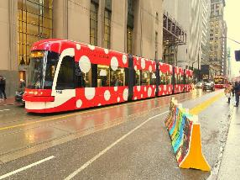

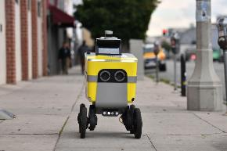

Benefits to participants
- Access to a controlled, “real-world” environment for testing through a transparent and predictable process
- Demonstrate value & track record to investors, other businesses, City, public
- Access to evaluation partners
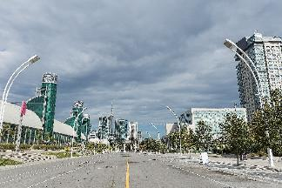

Timeline
- Oct 2019: City Council asked staff to develop the TIZ program as part of the Automated Vehicles Tactical Plan
- Fall 2019: Internal City & industry engagement – round 1
- June 2020: Exhibition Place Board of Governors supported the Exhibition Place Master Plan Phase 1 and directed staff to work with Transportation Services on the development of a flagship TIZ at Exhibition Place
- July 2020: City Council asked staff to work with Exhibition Place to establish a flagship TIZ on the Exhibition Place
- Sept 2020: Stakeholder workshops
- Dec 2020: Transportation Services staff to report back to Council with framework for TIZ
- Winter 2020-21: Pilot call for applications at Exhibition Place: Automated Winter Maintenance
- 2022+: Designation of future TIZ

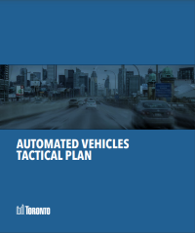

Why Exhibition Place as a flagship zone?
- Long history of innovation (green energy, transportation) at Exhibition Place
- Dynamic, semi-controlled environment with a range of assets (intersection, cycling lanes, indoor space, chargers, transit stops, etc.)
- Alignment with Exhibition Place Strategic Plan, Master Plan

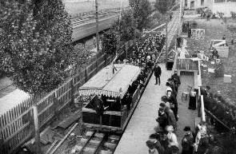
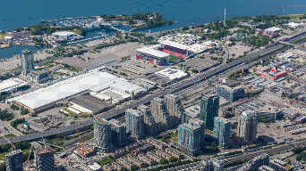
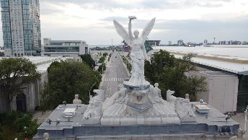

Scope of the TIZ program
The TIZ program would not be:

- A procurement tool
- A process for city-wide regulatory approvals
- A replacement for all innovation initiatives
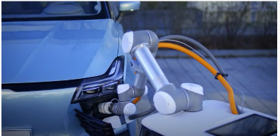

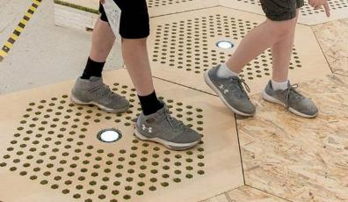

Definitions & principles

Innovation has the following ingredients:
- Products, services, and/or processes
- Using research, ideas, knowledge
- Something is new
- Public interest; social and environmental benefits
- Can be done by any actor (communities, academia, governments, private sector)

Transportation innovation means improving:
- Movement of people and/or goods
- Transportation operations
- Streets, curbs, cycling lanes & sidewalks

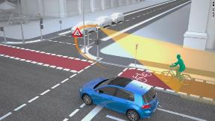

Principles
The City’s Automated Vehicles Tactical Plan states that the City of Toronto will encourage the adoption of transportation innovations that:
- Improve social equity and health
- Increase environmental sustainability
- Support and enhance economic sectors with a focus on attracting industries, investment, and employment, as well as exporting products and services
- Support and enhance data privacy
- Create a net benefit to road safety and security
- Integrate space-efficient and active modes of travel, and better manage all traffic impacts from the movement of goods
- Enhance the ability of the City to manage traffic in real-time for the purpose of increasing efficiency of people and goods movement

The City’s Digital Infrastructure Plan Working Principles state that Digital Infrastructure will:
- Create and sustain equity, inclusion, accessibility, and human rights in its operations and outcomes
- Enable a well-run City and high quality, resilient and innovative public services
- Contribute to positive social, economic and environmental benefits
- Operate in a way that protects the privacy of individuals and be safe from misuse, hacks, theft or breaches (security)
- Be developed in a way that is democratic and transparent

“Decisions about Digital Infrastructure will be made democratically, in a way that is ethical, accountable, transparent and subject to oversight. Torontonians will be provided with understandable, timely, and accurate information about the technologies in their city, and opportunities to shape the digital domain.”

Types of innovations anticipated
- automated and electric passenger or delivery vehicles
- sidewalk
- roadway
- automated snow plows and mowers
- pavement materials or paint
- electric vehicle charging
- methods for protecting vulnerable road users
- dynamic signage & wayfinding
- smart signals & connected infrastructure
- monitoring devices
- Examples from around the world

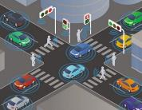
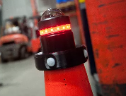
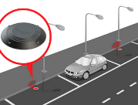
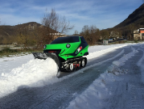
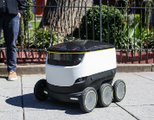
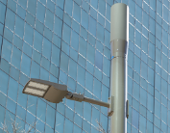
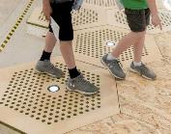
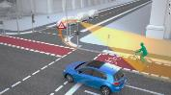

Municipal innovation programs around the world
Logos of: SmartSA Innovation Zoenes, Translink, Urban Movement Labs, Torino CityLab, Calgary, City of San Jose, Gov-PACT, Transit Innovation Partnership

Test facilities around the world
Logos of: Millbrook, MCity, Transportation Research Center Inc., American Center for Mobility, GoMentum Station, AVIN

Ontario
- Ottawa L5 Test Track
- Stratford Demonstration Zone
- Automated Vehicles Innovation Network – Regional Technology Development Sites

How the TIZ would work

Proposed process
- Infrastructure to support testing
- Call for applications
- Admission
- Trials
- Evaluation
- (Future) Advanced trials
Minimum requirements:
- Protections for safety, privacy, cybersecurity
- Liability, insurance
- Proven in lab setting
Evaluated by:
- City
- Participant
- Evaluation partners
- Others

Approach
- Start small & build on the program
- Build in flexibility
- Keep the process simple and transparent
- Collaborate with the public and stakeholders, including in monitoring & evaluation
- Ongoing government involvement
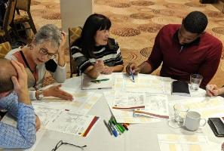

Your questions about the TIZ so far

Group map activity

Call for applications: models
At left side of spectrum:
Open call:
Any technology/approach meeting minimum requirements can test in the Zone
At right side of spectrum:
Challenge-based call:
City and/or its partners call for a specific challenge or issue to be addressed

Example: Specific challenge-based call
Singapore
Joint innovation call from Land Transport Agency and Enterprise Singapore to seek innovative solutions from the industry to meet the sector’s needs:
- Conduct road tunnel in-situ inspection checks for defects on bare concrete walls behind cladding
- Accurately measure street lighting levels and produce report with average lux results, uniformity, and 360 degrees images/videos
- Explore the use of safety systems to alert drivers and prevent instances where crane-mounted heavy vehicles move off without having the boom being put in a safe way

Example: Broad challenge-based call
Translink – Vancouver

We’re seeking ideas on how innovative technologies, solutions, processes, business models, and partnerships can help welcome customers back to public transit in Metro Vancouver [in light of COVID-19], such as:
- Further reducing physical touch points and enhancing sanitation and ventilation on the system;
- Supporting physical distancing while managing customer flow in transit facilities and vehicles;
- Analytics capabilities;
- Ensuring good and equitable transit access for residents of all ages and abilities;
- …

Ways to get involved
- Run a trial in the TIZ (individually or in partnership with other organizations)
- Join a roster of Evaluation Partner organizations
- Sit on the City’s TIZ Program Advisory Committee
- Share information about the TIZ in other networks
- Fund trials
- Other?

Next steps
- Participate in the Group Map until Wednesday, September 23 at 5pm
- Workshop summary sent to all registrants and posted online – October 2020
- Draft framework published for comment – October 2020
- Report to Infrastructure & Environment Committee and City Council – December 2020

Lindsay Wiginton
Project Manager, Transportation Services – Strategic Policy & Innovation
Lindsay.Wiginton@toronto.ca
c. 416-989-4735

Jason Diceman
Senior Public Consultation Coordinator Jason.diceman@toronto.ca
c. 416-338-2830

