Transportation Innovation Framework
  - Draft for Public Comment

Version: 1.0
Date: November 16, 2020
To provide comments by December 8, 2020:
- Visit Toronto.ca/TIZ, or
- Send comments by email to Jason Diceman, Senior Coordinator, Public Consultation at Jason.diceman@toronto.ca

Table of Contents
Table of Contents 2
1 About 4
1.1 Goals 4
1.2 Benefits 5
1.3 Defining innovation 5
1.4 Principles 5
1.5 Plan-at-a-glance 6
2 Scope 7
2.1 Technologies 7
2.2 Eligible Organizations 7
3 Transportation Innovation Zone at Exhibition Place 8
3.1 History of innovation at Exhibition Place 8
3.2 2020: Innovation Zone established 9
3.3 Infrastructure to support testing 9
3.4 Open Calls for Application at Exhibition Place 10
4 Transportation Innovation Challenges 11
4.1 Choosing the challenge themes 11
5 Application and Trial process 13
5.1 Application process 13
5.2 Trial location and duration 13
5.3 Future Trial locations outside of Exhibition Place 13
5.4 Limitations 14
5.5 Scaling up 14
5.6 Funding 14
5.7 Fees 15
6 Monitoring and evaluation 16
6.1 Evaluation of technological performance 16
6.2 Evaluation of impacts and benefits to public realm & City operations 16
6.3 Program evaluation 17
6.4 Data collection, open data and intellectual property 17
7 Governance and engagement 19
7.1 Leadership 19
7.2 Ongoing public engagement 19
7.3 Steering Committee 19
7.4 Trial advisors 20
7.5 Evaluation partners 20
8 Glossary of terms 21
Appendix 1: Existing transportation-related policies and plans 22
Appendix 2: Exhibition Place Site Plan 24

About
A transportation innovation zone is be a geographic area that hosts testing of transportation and public realm approaches and technologies in a real-world environment. A Transportation Innovation Zone (TIZ) has been established on the Exhibition Place grounds. The City is also developing a Transportation Innovation Challenge program to invite and manage Trials at that site and, in the future, in other areas of the city. These initiatives will last until at least 2025.
The Transportation Innovation Challenges are being developed to help the City of Toronto learn about emerging transportation technologies and approaches. With careful design, these initiatives can advance the City's mobility-related priorities such as Vision Zero, universal accessibility, and TransformTO, while supporting research and development, tapping into Toronto's burgeoning talent in the technology and transportation sectors, and driving local economic development.
The Transportation Innovation Challenges are an opportunity for the City of Toronto to expand its role as a leader in innovation and communicate Toronto's needs to the market. This is important because Toronto is the fastest-growing metropolis in Canada and the U.S. The City regulates and manages over 5,500 km of public roads and laneways and 7,900 km of sidewalks; purchases and manages large volumes of transportation equipment, fleet vehicles, and services; and – through the TTC – operates North America's third largest transit system. Choices about the transportation system made by the City of Toronto may influence many other municipalities in Ontario, Canada, and beyond.
A real-world test environment and testing program can help address a current gap in the local economic infrastructure, particularly for small and medium-sized enterprises (SMEs) who cannot build their own testing facilities. These initiatives will also help the City adapt its systems to a changing world, focus efforts, and work with other governments and stakeholders on pandemic-related rebuild and recovery initiatives.

Goals
The City's goals in creating the Transportation Innovation Challenges are to:
- Understand emerging transportation technologies and approaches prior to their implementation or regulation
- Foster economic development, including for local small & medium-sized enterprises (SMEs)
- Support COVID-19 recovery & rebuild
- Promote learning and knowledge sharing across the region
By issuing Calls for Application, the City will help set the agenda for transportation innovation and connect innovation efforts to the City's established priorities of building a healthier, safer, more equitable and more sustainable city. The City will work with Participants through the Trials to produce new knowledge about transportation innovations and how they might function in a major urban setting, and impact Toronto's streets and systems. A list of existing transportation plans and priorities is provided in Appendix 1.

Benefits

Benefits to the Public
The anticipated benefits of the Transportation Innovation Challenges for Torontonians and local organizations are:
- Increased visibility regarding how transportation Trials are selected and monitored in Toronto
- Opportunities to interact with new transportation solutions, help evaluate which ones will work for Toronto in the long term, and influence the development of new technology
- Support for local talent development, job growth and economic development
- Increased connections between public sector research institutions (universities, colleges) and real-world innovation activities
Public input will be gathered at regular review points throughout the course of the program, at least annually.

Benefits to Participants
Participants are the organizations that respond to challenges and run Trials. The anticipated benefits to Participants are:
- Access to a controlled, real-world environment for testing through a transparent and predictable process
- Access to evaluation partners and interaction with City staff (such as Transportation Services, Exhibition Place, Fleet Services, Toronto Parking Authority, City Planning, etc.), including opportunities to better understand municipal specifications, use cases, and needs
- Opportunities to demonstrate the potential value of their solution to investors, other businesses, City staff, and the public
In particular, Participants in Trials will benefit from opportunities to gain valuable insight into how to advance their technology for application in Toronto's unique context in a way that meets tangible transportation needs in Toronto.

Defining innovation
While it is common to associate "innovation" with gadgets and technology, innovation is much broader than this. For the Transportation Innovation Challenges, innovation has the following ingredients:
- Involves products, services, and/or processes
- Uses research, ideas, and knowledge in an applied way
- Creates something new or applies knowledge in a new manner
- Involves serving the public interest and generating net social and environmental benefits
- Can be done by any actor (communities, academia, governments, private sector)
Governments have always had a key role to play in supporting innovation. The Transportation Innovation Challenges will recognize that the City can support, and participate in, the development of technologies and approaches that make moving around and accessing Toronto better.

Principles
Though the Transportation Innovation Challenges will be flexible and evolve over time, decision making will be guided by core principles. These principles are drawn from the City's Automated Vehicles Tactical Plan and the Digital Infrastructure Plan Working Principles.
The City’s Automated Vehicles Tactical Plan states that the City of Toronto will encourage the adoption of transportation innovations that:
- Improve social equity and health
- Increase environmental sustainability
- Support and enhance economic sectors with a focus on attracting industries, investment, and employment, as well as exporting products and services
- Support and enhance data privacy
- Create a net benefit to road safety and security
- Integrate space-efficient and active modes of travel, and better manage all traffic impacts from the movement of goods
- Enhance the ability of the City to manage traffic in real-time for the purpose of increasing efficiency of people and goods movement
The City’s Digital Infrastructure Plan Working Principles state that Digital Infrastructure will:
- Create and sustain equity, inclusion, accessibility, and human rights in its operations and outcomes
- Enable a well-run City and high quality, resilient and innovative public services
- Contribute to positive social, economic and environmental benefits
- Operate in a way that protects the privacy of individuals and be safe from misuse, hacks, theft or breaches (security)
- Be developed in a way that is democratic and transparent

Plan-at-a-glance
The City is taking a flexible approach to establishing the Transportation Innovation Zones and Challenges, building in opportunities to revise the process to adapt to lessons learned in early Trials. Figure 1 shows how different elements will come online over the first two years. These elements will be described in the sections to follow.
Figure 1. Plan-at-a-glance showing staged approach
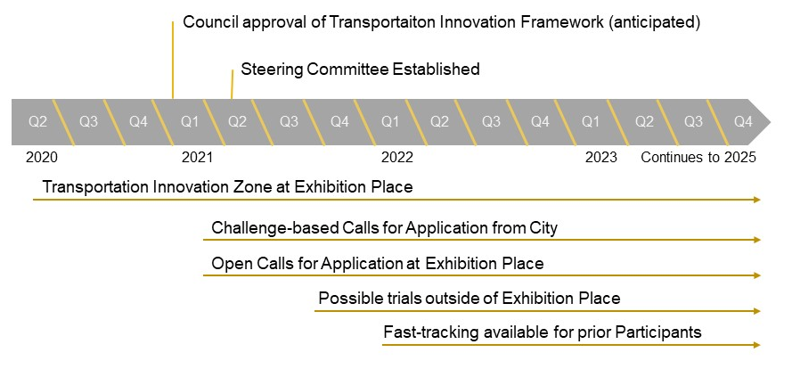

Scope

Technologies
Broadly, technologies and approaches in scope for testing at the TIZ are those that:
- Use streets and sidewalks for the movement of people and goods
- Improve ground transportation and public realm operations
- Improve the streets and sidewalks themselves (e.g., infrastructure)
Some innovations that could be tested in the Zones are: automated vehicles for moving people and goods or for City operations, smart lights and traffic sensors, signage, transit-supportive infrastructure and signals, smart electric vehicle charging, dynamic curbside management, automated parking enforcement, pavement materials to support stormwater management and street tree health, solutions for providing accessibility, and opportunities to enhance protection of vulnerable road users. As aerial drones and urban air mobility are regulated by Transport Canada, they are not in scope for the TIZ at this time.
The City will work with program applicants to ensure that their solutions are tested in compliance with City bylaws and the Highway Traffic Act.

Technology Readiness Level
The TIZ Program targets solutions at Technology Readiness Levels 4 to 9 as defined by Innovative Solutions Canada, a program under the federal department of Innovation, Science and Economic Development (ISED) Canada. This means that technologies should be past the concept stage, and could include prototypes, pre-commercial technologies, or already-commercialized ideas that could be applied in new ways in Toronto.

No commercial use
Technologies and approaches cannot be trialled with a direct commercial function in the TIZ. This means that payment cannot be accepted from the general public for services while the trial is underway.

Eligible Organizations
Companies, not-for-profit organizations and academic institutions looking to develop, test, research or analyze transportation technologies and approaches are welcome to apply. Applicant organizations must be incorporated or registered as a not-for-profit.

Transportation Innovation Zone at Exhibition Place

History of innovation at Exhibition Place
A first Transportation Innovation Zone has been established on the Exhibition Place grounds by Exhibition Place (an agency of the City of Toronto) and the City of Toronto.
Exhibition Place is a landmark entertainment, tradeshow and business destination and urban parkland on Toronto’s waterfront that has been a hallmark of innovation to Torontonians and Ontarians for over a century. In a typical year, Exhibition Place hosts over 350 events and attracts over 5.3 million visitors.
Figure 2. Canada's first electric railway premiered at the CNE in 1883
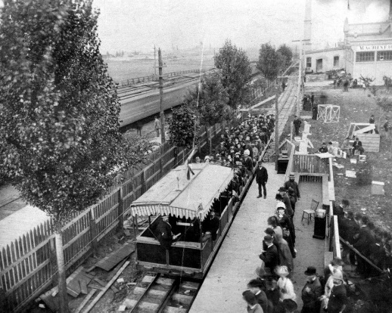
Figure 3. The Transportation Building was built to showcase transportation technologies such as motor cars, carriages, street cars and railways in 1909
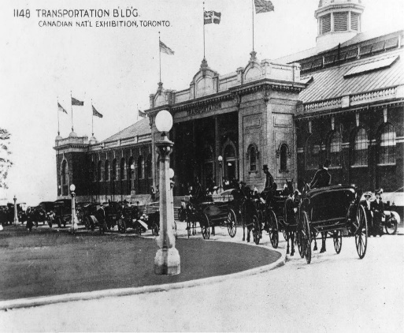
Over its history, Exhibition Place has been an important site for peoples living in what is now Toronto. For thousands of years, the lands that form Exhibition Place were used and occupied by Indigenous peoples. In the late 1700s as colonization by settlers expanded, the French established a defensive and commercial fort at this location. Beginning in the 19th century, the City and the Province created a hub at Exhibition Place to promote agricultural education and excellence. The innovative complexes and features established in the 20th century signaled that Ontario’s capital had become a world class and cosmopolitan city.
Today, Exhibition Place continues to reinvent itself and its programming. It has pioneered innovations in green energy, with the first permanent wind turbine in Toronto, LED streetlights, and an early geothermal system. Exhibition Place’s tenant, the Canadian National Exhibition (CNE), has a long history of showcasing new transportation technologies including Toronto’s first electric streetcar, a preview of Toronto’s Bloor-Yonge subway station, and more recently Metrolinx light rail vehicles.

2020: Innovation Zone established
The Phase 1 Report for the Exhibition Place Master Plan recognized this history of innovation and outlined a vision for Exhibition Place as a place of innovation, inspiration and economic development, alongside other pillars including history, green open space, recreation and entertainment. The Report proposed enhancing sustainability, mobility and connectivity to Exhibition Place. As one of the recommended "quick start" interventions, the Report proposed a Transportation Innovation Zone. This Phase 1 Proposal for the Exhibition Place Master Plan was supported by the Exhibition Place Board of Governors at its meeting on June 24, 2020. At this same meeting, the Board of Governors also directed Exhibition Place staff to continue working with Transportation Services staff on the development of a Flagship Transportation Innovation Zone at Exhibition Place.
On July 28, 2020, City Council similarly directed the General Manager, Transportation Services to work with the Board of Governors of Exhibition Place as may be required to establish and implement a Transportation Innovation Zone at Exhibition Place.
Figure 4. Exhibition Place today, looking east along Princes Blvd. (source: Exhibition Place)
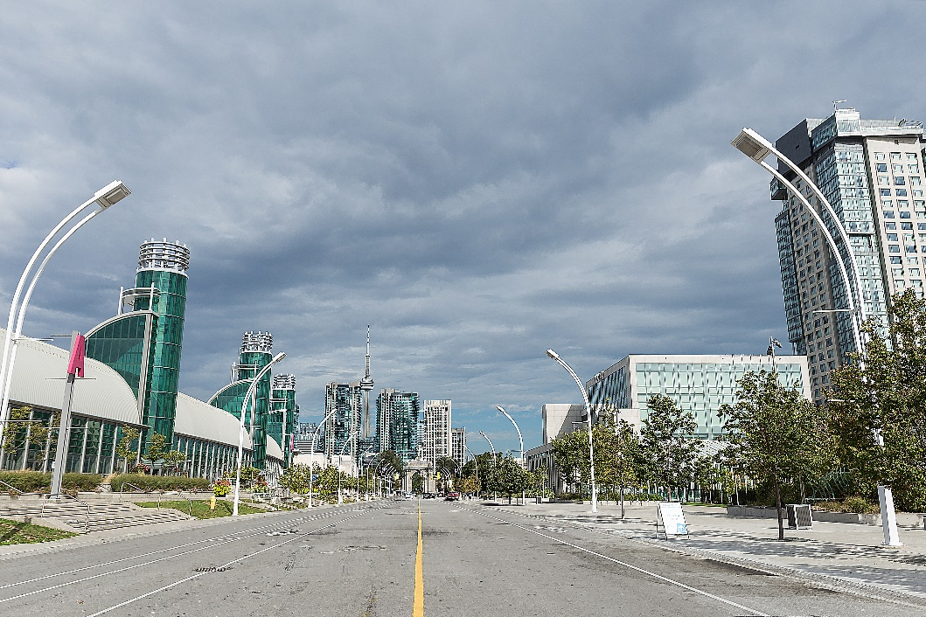

Infrastructure to support testing
As a testing site, the Exhibition Place grounds, buildings and infrastructure offer a range of opportunities and assets. When major events are not happening, the grounds are a semi-closed environment: the site is open to public car, bike and pedestrian traffic, but volumes are generally low compared to the surrounding network and other areas in downtown Toronto. These quieter periods are when most Trial activities will take place.
When Exhibition Place and its tenants host a variety of exhibitions, international conferences and conventions, professional sports, entertainment, green technology fairs and public celebrations, Exhibition Place transforms. These periods may provide opportunities to test dynamic, modular and adaptable technologies designed for a changing environment, as well as last-mile passenger transport and delivery of goods.
The Exhibition Place site has the following assets that can potentially be used for Trials (see Appendix 2 for a map of the site):
- Approximately 8 km of roads
- Approximately 12 km of sidewalks, with various surfaces (asphalt, concrete, pavers, etc.)
- Approximately 3 km of cycling lanes
- Thirty (30) intersections, including four (4) intersections with traffic lights
- Large outdoor and below-ground parking facilities
- Five (5) electric vehicle chargers, located in the below-ground parking facilities
- Loading bays at certain buildings
- Access to indoor space and rooftops
- Three (3) connections to the TTC system at Dufferin Street, Manitoba Drive and Strachan Avenue
- One (1) connection to the GO Train system at Exhibition Place GO Station.
- Access to Lakeshore Boulevard, Gardiner Expressway, and several local streets
Over the five-year program horizon, Exhibition Place may work with partners to install infrastructure on the Exhibition Place grounds that will support testing. This could include connected infrastructure and networks, monitoring devices, or other assets.

Open Calls for Application at Exhibition Place
Starting in 2021, eligible participants may propose Trials of their own innovative technology or approach to Exhibition Place under the Open Calls for Application Stream.

How it works
In applying to the Open Calls stream, Participants will be asked to provide basic information about their solution and show that they meet minimum requirements, such as having appropriate insurance and measures in place to protect safety, accessibility, and privacy while testing. Participants will be required to enter into an Agreement with Exhibition Place for use of the public space and/or indoor space.

Main advantages and examples
An open approach will allow industry, not-for-profit organizations, and academic researchers to access the Transportation Innovation Zone for research and development, as long as the solutions are connected to existing transportation priorities and minimum requirements are met.
Some government-led innovation programs use an open calls model. Some examples are Calgary's Living Labs and the San Jose Demonstration Framework.

Transportation Innovation Challenges
The City is developing a parallel stream, the Transportation Innovation Challenges, to conduct directed, goal-oriented Trials.

How it works
With a Challenge-based Call for Application, the City will identify a transportation-related challenge or opportunity and invite any interested organizations to apply to run a Trial of an innovative solution to address that challenge. While Transportation Services is the lead division, the City's agencies (like Exhibition Place) and other divisions (Economic Development, Fleet Services, Toronto Parking Authority, etc.) may partner with the City to issue a Challenge-based Call.
In applying, Participants will be asked to provide basic information about their solution and show that they meet minimum requirements, such as having appropriate insurance and having measures in place to protect safety, accessibility, and privacy while testing. Participants will also be asked to discuss the potential social, economic and environmental benefits of their transportation solution. Participants will be required to enter into an Agreement with the City to conduct the Trial and use public space.

Main advantages and examples
Challenge-based calls for application are the best way to ensure that the program spurs innovation around Toronto's key transportation needs, which have been identified through public consultation and studies and embedded in the City's plans and policies. See Appendix 1 for a list of applicable plans and policies.
Many government-led innovation programs around the globe use a challenge-based model. Some examples are Translink's Calls for Innovation, Singapore's Gov-PACT program, and the City Lab in Torino, Italy.

Outcomes-oriented vs. technology-focused
Challenge-based Calls for Application work best when they do not pre-determine the solution, but instead speak to the desired outcome. For example, an outcomes-oriented challenge would call for solutions to "reduce congestion and improve access at the curb" rather than calling for "sensors to detect vehicles at the curb." Where possible, the Challenges will be outcomes-oriented.

Choosing the challenge themes
In year one (2021), the City, together with Exhibition Place, will announce two to four Challenge-based Calls for Application. The shortlist of year one challenge themes will be provided in the January 2021 report to City Council.
In subsequent years, Transportation Services staff will develop the proposed list of themes using the inputs, criteria and factors listed below. Exhibition Place staff will also participate in the identification of themes for Trials to be held at Exhibition Place.
At the beginning of each calendar year, the City will publicly announce the themes for the Challenge-based Calls for Application to be issued that year. These announcements will help industry anticipate opportunities, and help prospective participants in the TIZ to prepare. Possible themes for calls will be gathered by Transportation Services staff from the following sources:
- Established transportation priorities listed in existing City of Toronto plans and policies
- Opportunities identified by City staff to meet long term operational or programmatic objectives
- Input from the public and stakeholders via public engagement at regular intervals

Criteria to identify themes
Themes for Challenge-based Calls for Application must meet the following criteria, as assessed by City staff:
- Solves real problems: The theme is named as a challenge or opportunity in existing City policies and plans (see list in Appendix 1)
- Needs real-world testing: According to a Market Scan conducted by the City or an independent third party, at least some of the solutions applicable to the challenge are at Technology Readiness Levels 4 to 9 as defined by Innovative Solutions Canada (see Section: Market sounding)
- Environment matches the solution: A testing environment appropriate for the intended use case of the solution and/or its research and development needs can be offered
  - In year one (2021), all trials will take place at Exhibition Place
  - Beyond year one (2022-25), Trials may be considered elsewhere in the City (see Section: Future Transportation Innovation Zones)

Additional factors for prioritization
If there are more proposed themes than can be supported in a given year, City staff will use these factors to prioritize from among options:
- Local interest: Based on a Market Scan, there are locally-based enterprises working on solutions related to this theme
- Multiple participants: Based on a Market Scan, there are two or more organizations who may be interested in participating in a Trial, either individually or in partnership
- Relevance: Based on a Market Scan, it is likely that the City will be required to regulate this technology in the public right-of-way in the next five years
- Scalability: Based on a Market Scan or submitted information, there is evidence that the solution has potential to scale or commercialize in Toronto in the future
- Capacity: There is a staff team within the City and/or its agencies that is has capacity to engage with the Trial and provide subject matter expertise
- Quick implementation: There are minimal or reasonable infrastructure and equipment needs to support the Trial
- Synergies: There is an opportunity to connect a theme to an existing Trial already underway to accelerate learning

Market scan
To see whether a proposed theme is a good fit for the TIZ, a Market Scan will be conducted by City staff or commissioned by an expert third party with no commercial interest in the Trial. The purpose of the Market Scan is to collect information about the criteria and factors listed above (technology readiness, applicability, local interest, etc.) to support decision-making by City and Exhibition Place staff.

Application and Trial process

Application process
Application to conduct Trials will take place via an online portal. Applicants will be asked to provide basic information about their solution and show that they have measures in place to protect safety, accessibility, and privacy while testing. Participants will also be asked to discuss the potential social, economic and environmental benefits of their transportation solution. City staff (and for Trials at Exhibition Place, Exhibition Place staff) will review applications and will be available to provide feedback to applicants. Applicants may be given the opportunity to resubmit applications with supplementary details, keeping the process iterative. Any applicant that meets the minimum requirements set out in the call will be invited to run a Trial, so there could be multiple Participants in one Trial.

Trial location and duration
Initially, all Trials will take place in the TIZ at Exhibition Place (see Figure 1). City and Exhibition Place staff will work with applicants to find the right location within the grounds for testing to meet Trial learning objectives. Indoor space may be available. Timing and location will be planned so as not to interfere with future events or public access at Exhibition Place. Trials may last between two weeks and six months. Figure 5 shows the proposed process, from application to reporting.
Figure 5. Call for Applications, review, Trial and evaluation process

Future Trial locations outside of Exhibition Place
Starting in Q3 2021, temporary innovation zones may be set up elsewhere in the City of Toronto, at the discretion of the General Manager, for Trials that need a testing environment other than Exhibition Place. For example, certain solutions may need a residential neighbourhood or commercial street to be tested in their intended use case. Other innovation zones will be considered if these two conditions are both in place:
- Proof-of-concept secured: The technology/approach has undergone proof-of-concept testing and validation either at Exhibition Place, or under rare circumstances, at another location with independent third-party documentation of results
- Needs a different environment: The technology/approach cannot be tested meaningfully in its intended use case at Exhibition Place
Priority may be given to locations where community members and stakeholders (e.g. a University, a BIA, or another organization) have demonstrated interest in supporting the Trial.
Because other innovation zones will be identified on a case-by-case basis, the City will not be establishing any additional innovation zones before Q3 2021. Any City divisions and agencies potentially impacted by the establishment of other Trial locations would be engaged by Transportation Services in these decisions.

Limitations
A Call for Application is not a procurement process, as any applicants meeting the minimum requirements will be invited to participate in a Trial. The City will not be purchasing the products and services that are tested. While the City will be monitoring and evaluating the Trials to ensure learning, the Trial will not be a competition, and the City will not name "winners." Participants will have no advantage in future procurement initiatives from the City.

Scaling up
The Transportation Innovation Challenges are being designed to support scaling and commercialization of successful solutions. They are meant to drive innovation, not just demonstration.
To facilitate development and iteration, the Transportation Innovation Zones and Challenges will be structured so Participants can return to conduct Trials with improved solutions. Participants that have already conducted a Trial will be fast-tracked if they re-apply to Trial (starting in 2022 – see Figure 1). At this time, the City may work with the Participant to select of a new location outside of Exhibition Place if appropriate.
At a certain scale, the Trial will no longer be appropriate for the Transportation Innovation Challenge program and will be ready for a different, existing process. For example, a technology or approach that is seeking to be deployed City-wide and/or for commercial public use will need to follow the City's existing channels for regulation (e.g. licencing, bylaw amendments, etc.).
If the innovation relates to the provision of City services or City operations, a move toward scaling will require the use of the City's existing procurement tools and/or programs available through the Toronto Office of Partnerships.
Figure 6 shows how the TIZ can provide input into, and influence, the broader scaling/commercialization process in the market.

Funding
At this time, the City is not in a position to provide funding for the Trials. However, as the program grows the City will to seek opportunities to help connect Participants to external funding opportunities. Further, the Transportation Innovation Challenges are designed to provide value by providing Participants with access to real-world testing environments, engagement from City staff, and opportunities to build a proven track record and demonstrate value to investors and funders.

Figure 6. How the Transportation Innovation Challenges support the innovation cycle for a given solution
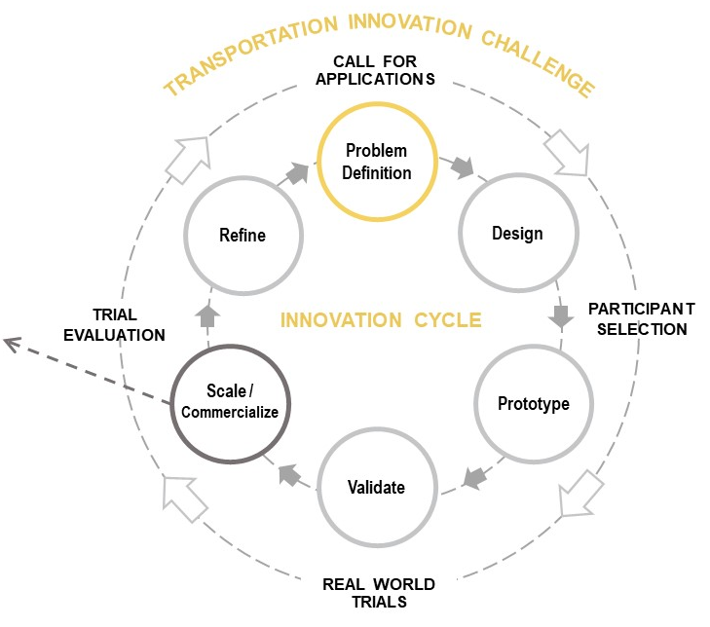

Fees
Two types of fees will be established related to the Calls for Application.
- Application fee: nominal fee charged to applicant to cover cost to City of reviewing the application
- Participation fee: fee charged to successful applicants (i.e., Participants) for use of public space
The City and Exhibition Place understand that fees may be prohibitive to participation in the program and will make efforts to reduce or eliminate these fees where appropriate.
For Challenge-based Calls for Application at Exhibition Place, the City will charge a cost-recovery application fee to all applicants. The Exhibition Place Board will charge a participation fee to Participants at rates determined by the Board. The Board will make an effort to minimize or eliminate participation fees where possible.
For Open Calls for Application at Exhibition Place, the Board will charge a participation fee to Participants at rates determined by the Board. The Board will make an effort to minimize or eliminate participation fees where possible.

Monitoring and evaluation
Monitoring and evaluation will take place at three levels, each with its own key questions and evaluation activities. Across each of these three levels, the Digital Infrastructure Principles and the AV Tactical Plan principles (see Section 1.4) will be a primary source of evaluation criteria. More specific criteria will be developed to match the context of a given Trial. See Table 1, below, for more information. The three levels of evaluation are the evaluation of technical performance, the public realm & City operations impacts and benefits evaluation, and the program evaluation.

Evaluation of technological performance

Purpose
The purpose of the evaluation of technological performance is to determine whether the technology or approach achieves its desired outcomes. In the case where the solution would provide a City service or operation, the purpose of this evaluation is also to compare performance outcomes to the City's existing levels of service and standards. The results of this evaluation will help reveal the opportunities to improve and further develop the solution, and whether it is ready for scaling/commercialization.

Example evaluation questions
- How well does the solution meet its performance/service objectives?
- How can the technology improve to provide better service?
If the solution has the potential to be applied to City operations and services, this evaluation will also ask:
- Is the solution able to perform at the City's existing standard for level of service? What needs to change to get there?
- Is the solution able to readily integrate with City systems?
- What training is required to use the solution?
- Can the solution integrate with City systems such that continuity of operations (CONOPS) is assured?
- What assurances can the Participant provide regarding the ongoing, well-behaved cyber state of its product?

Lead
The City will be involved in setting performance metrics for the Trial, in consultation with agencies and divisions that have subject matter expertise. The Participant may have additional performance aspects that it wishes to measure independently. The Participant will have the option to work with a third party Evaluating Partner to develop and implement a performance evaluation plan. Participants will share results of the technical performance evaluation with the City.

Evaluation of impacts and benefits to public realm & City operations

Purpose
The purpose of the evaluation of impacts and benefits to public realm & City operations is to determine whether, and to what degree, the technology or approach positively or negatively impacts key factors in the public realm such as safety, accessibility, health, sustainability, privacy, and efficiency (see Section 1.4 Principles). The results of this evaluation will help determine whether the solution is currently appropriate for Toronto's streets, and how it may need to be regulated in the future.

Example evaluation questions
- How well does the solution interact with pedestrians, cyclists, people with disabilities, other vulnerable road users, and the built environment? What are the net safety benefits to these users?
- How does the solution affect traffic flow and volumes across all modes?
- Is the solution able to operate while respecting traffic bylaws, in particular with respect to speed, use of sidewalks and curbs, and parking?
- Does the solution threaten or improve accessibility, privacy and safety in the public realm? How?
- What net carbon emissions and air pollution impacts are associated with this solution?
- What net social benefits and impacts are associated with this solution?
- In which urban environments does this technology work?

Lead
In collaboration with its evaluation and monitoring partners, the City will conduct this assessment and share the results publicly where the information does not constitute proprietary information. Over time, the TIZ may be equipped with monitoring devices, such as traffic counters, bike counters, pedestrian counters and Bluetooth detectors in order to evaluate the effects of new technologies on the public realm, the results of which would be shared publicly where they qualify according to the City's Open Data standards.

Program evaluation

Purpose
The purpose of the program evaluation is to determine whether the Transportation Innovation Challenges are achieving the program goals (see Section 1.1 Goals) and stakeholder needs. The results of this evaluation will help determine how the program needs to evolve and be modified.

Example evaluation questions
- Is the program achieving its stated goals and adhering to its principles?
- Are Participants getting value from the program?
- How can the program attract more Participants?
- Are the technologies and approaches being trialled being modified or scaled as a result of their experience in the Program?
- Is the program generating new knowledge?

Lead
The City will lead the program evaluation. Through exit surveys of participants and third party assessments, the City will be sure to revise the program as required to meet evolving needs, while sharing the results publicly.

Data collection, open data and intellectual property
Participants will be asked to share certain performance data and/or data summaries with the City in order to help the evaluation and monitoring team evaluate the impacts and benefits of the solution on the public realm and City operations, in particular factors such as safety, accessibility, and privacy.
Data collected through the Transportation Innovation Challenges will be shared by the City, except data that is specific to a Participant technology and that would constitute intellectual property. Intellectual property related to the technology or approach itself will be vested with the Participant, unless otherwise agreed upon.
Table 1. Monitoring and evaluation plan
Evaluation | Purpose | Lead data collector | Example KPIs (where applicable) | Open Data¹
Evaluation of technical performance | Determine whether the technology or approach achieves its desired outcomes | Where technology is not used to perform a municipal service: Participant  Where technology is used to perform a municipal service: City and Participant | -Operating speed, weight, dimensions  -Fuel use/source/emissions  -Readability to people with disabilities  -Ability to navigate around vulnerable road users  -# person-hours required for oversight  -Cybersecurity measures in place  -Performance in weather conditions  -Required training | No
Public realm & City operations impacts and benefits evaluation | Determine whether, and to what degree, the technology or approach positively or negatively impacts key factors in the public realm such as safety, accessibility, health, sustainability, privacy, and efficiency | City, in collaboration with Participant | -# safe interactions with pedestrians, cyclists, people with disabilities/#conflicts  -Impact on traffic flow and volumes  -Impact on pedestrian clearway  -Frequency and nature of collection of personal information and ability to protect data  -Applicability to the urban environment in question  -Qualitative feedback from neighbourhood survey (future Zones) | Yes (aggregated for all Trial Participants)
Program evaluation | Determine whether the Transportation Innovation Challenges are achieving the program goals and stakeholder needs | City, in collaboration with Participant | Short term – Trials  # applicants to call  # Participants in Trial  # days for City to review and approve application  Qualitative feedback on process from Participants, neighbours, stakeholders  Medium term – Program  # Participants that return to TIZ for more testing  # Participants that take solution to scale  # key insights developed  # knowledge sharing activities with other municipalities, stakeholders | Yes
¹ Data will be posted to Toronto's Open Data portal where the data meets the City's standards for Open Data, and where the data does not represent proprietary information.

Governance and engagement

Leadership
The site of the Transportation Innovation Zone at Exhibition Place is led and managed by Exhibition Place, via the Board of Governors under authority from City Council.
The Transportation Innovation Challenges will be led and managed by the Transportation Services division of the City of Toronto. Decisions about Calls at the TIZ at Exhibition Place will be made jointly by Transportation Services and Exhibition Place. Transportation Innovation Challenges in locations outside of Exhibition Place will be led and managed by Transportation Services, and the City's other divisions and agencies will be engaged where necessary. Certain decision-making authorities will be requested from City Council for the General Manager of Transportation Services to support implementation.
Transportation Services is working closely with other divisions and agencies to develop and deliver the Transportation Innovation Zones and Challenges, including: Exhibition Place, Economic Development and Culture, City Planning, the Toronto Office of Partnerships, and Technology Services.

Ongoing public engagement
The Transportation Innovation Zone and Challenge concepts were first developed in 2018-19 as part of the public consultations for the development of the Automated Vehicles Tactical Plan, as well as through public consultations held for the Exhibition Place Master Plan and the City's Digital Infrastructure Plan. In September 2020, a series of by-invitation online stakeholder workshops was held to discuss the details of the Transportation Innovation Framework. The results are available online at Toronto.ca/TIZ.
Members of the public and other stakeholders will be engaged annually to discuss the results; how the program is serving the broader needs of the City, its organizations and its residents; and opportunities for improvement. Trials will be announced publicly along with information about how the public can observe the Trials. The City will publish annual reports on the program, as well as reports on each Trial.

Steering Committee
The City will set up a Steering Committee, with members internal and external to the City, by March 2021 to provide advice and ensure that the Transportation Innovation Challenges respond to the needs and perspectives of stakeholders. Members must have no conflicts of interest or commercial interests associated with the industries potentially involved in Trials. The Steering Committee will meet approximately every six months and serve and advisory, not a decision-making, function.

Mandate
- Review and provide input on draft Calls for Applications (both from the perspective of industry and user/impacted groups)
- Provide input on Trial area set up requirements
- Review and provide input on evaluation metrics for the Trials
- Review results of the Trial before City publishes final report
- Provide input into the choice of future themes for Calls for Application by identifying current needs and anticipating future trends
- Review annual results from program evaluation and provide input on opportunities to improve and evolve the program

Anticipated membership
- Members to be invited by Transportation Services staff based on required expertise and representation
- Approximately 15 members; members at staff level with responsibility to report to senior management where necessary
- Organizations with a seat on the committee will include:
  - City divisions: Transportation Services, Economic Development & Culture, Technology Services
  - Academic institutions (universities & colleges)
  - Organization(s) representing safe, active, and accessible transportation perspectives
  - Organization(s) representing privacy and digital government perspectives
  - Other orders of government

Trial advisors
The City will assemble subject matter experts to provide input into individual trials. Trial advisors must not be planning to apply to the trial or have a financial interest in the particular industry.

Mandate
- Review and provide input on a draft Call for Applications (both from the perspective of industry and user/impacted groups)
- Provide input on testing area set up requirements
- Review and provide input on evaluation metrics for the trial
- Review results of the trial before City publishes final report

Anticipated membership
- Staff from the City or any of its divisions or agencies who could use the solution in the future, or whose operations may be impacted by the trial
- Representatives from communities or interest groups that could use the solution in the future, or be impacted by its deployment or the trial (e.g. people with disabilities, user groups, etc.)

Evaluation partners
Many public sector institutions and not-for-profit organizations in the region offer expertise that can help Participants refine their Trial plans and monitor and evaluate results. City staff will facilitate connections between these organizations so that Participants will have the option to work with evaluation partners to conduct more robust evaluations of their Trials, creating stronger networks and relationships across the local transportation innovation sector.

Glossary of terms
Call for Applications means the invitation issued to third parties to apply to conduct Trials.
Challenge-based Call for Applications means a theme-specific Call for Applications seeking to solve a specific problem.
Market Scan means an analysis conducted by City staff or commissioned by an expert third party about a given area of transportation innovation to determine the types of technological solutions being developed, their degree of technology readiness, their applicability to the Toronto context, and the presence of local actors involved in their development.
Open Call for Applications means a Call for Applications that does not prescribe a theme.
Participants means the third parties that apply and are accepted to conduct Trials.
Steering Committee means a non-decision-making , with members internal and external to the City, will be set up by March 2021 to provide advice and ensure that the Transportation Innovation Challenges respond to the needs and perspectives of stakeholders.
Transportation Innovation Challenge (see Challenge-based Call for Applications)
Transportation Innovation Zone (TIZ) means a geographic area that hosts testing of transportation and public realm approaches and technologies in a real-world environment.
Transportation Innovation Zone (TIZ) at Exhibition Place means the activities and procedures associated with the establishment and implementation of the TIZ at Exhibition Place.
Trial means time-limited testing activities carried out by a Participant of a given technology or approach.

Appendix 1: Existing transportation-related policies and plans
For more information, visit the City's website.
Vision, Plan or Strategy | Description | Division
Corporate Strategic Plan | Outlines the Toronto Public Service’s commitment to People, Partnerships, Performance and Priorities. | City Manager
Automated Vehicles | Outlines how the City should prepare for AVs and how it can influence the local introduction of the technology in these early stages. The overall goal is to be proactive, ensuring that Toronto is well-placed to both maximize opportunities and mitigate impacts arising from the arrival of AVs in Toronto. | Transportation Services
Congestion Management Plan | Through innovation and technology maximize the safety, efficiency, reliability and sustainability of the transportation network for all users while reducing the impact on the environment. | Transportation Services
Curbside Management Strategy | Provides the strategies and tools necessary to effectively manage curbside space in a way that supports mobility and access for people and goods. | Transportation Services
Cycling Network Ten Year Plan, 2016-2025 | A 10-year plan to connect, grow and renew infrastructure for Toronto’s cycling routes. This plan consists of a longer-term overall proposed network, as well as a detailed three-year rolling implementation program. | Transportation Services
Freight & Goods Movement Strategy Study | A strategy that provides an integrated and adaptable goods movement system that promotes safe, reliable and sustainable freight operations and ensures Toronto’s continued vibrancy and economic competitiveness. | Transportation Services
Green Streets Implementation Strategy | Contributes to building a resilient city by implementing Green Streets — roads or street that incorporate green infrastructure such as trees, green walls and stormwater infrastructure that provide ecological and hydrological benefits. | Transportation Services
Toronto Walking Strategy | Aims to build a physical and cultural environment that supports and encourages walking – with vibrant streets, parks, public spaces and neighbourhoods where people will choose to walk more often. | Transportation Services
Vision Zero Road Safety Plan, 2017-2021 | A comprehensive five-year action plan focused on reducing traffic-related fatalities and serious injuries on Toronto’s streets. | Transportation Services
Official Plan | The Official Plan is intended to ensure that the City of Toronto evolves, improves and realises its full potential in areas such as transit, land use development, and the environment. | City Planning
TOcore: Planning Downtown | An initiative to prepare and implement a new plan for Toronto’s Downtown. A series of five infrastructure-related strategies have been developed to support implementation. These strategies cover community facilities, parks and public realm, mobility, energy and water. The Downtown Plan is a 25-year vision that sets the direction for the city centre as the cultural, civic, retail and economic heart of Toronto and as a great place to live. | City Planning
Resilience Strategy | Toronto’s Resilience Strategy sets out a vision, goals, and actions to help Toronto survive, adapt and thrive in the face of any challenge, particularly climate change and growing inequities. | Deputy City Manager’s Office, Infrastructure and Development Services
Economic Development & Culture Divisional Strategy 2018-2022 | The Economic Development & Culture Divisional Strategy 2018-2022 establishes goals and actions to support Toronto’s business and culture sectors – and ensure that all Torontonians can share the benefits of a vibrant economy and culture. | Economic Development & Culture
Electric Vehicle Strategy | Puts the City of Toronto on the path to support increased electric vehicle adoption in a way that is equitable and realizes the co-benefits through improved air quality and economic opportunities achieved by shifting to zero-carbon energy transportation. | Environment & Energy
Transform TO: Climate action for a healthy, equitable, prosperous Toronto | Toronto’s ambitious climate action plan identifies how we’ll reduce our greenhouse gas emissions and improve our health, grow our economy, and improve social equity. | Environment & Energy
Toronto Seniors Strategy 2.0 | Commits to all seniors having equitable access to City services and programs and it continues to focus on actions that fall within the City’s jurisdictional authority to plan, manage and deliver. | Seniors Services & Long-Term Care
Long-Term Waste Strategy | Provides a road map for the way waste will be managed in Toronto over the next 30 to 50 years. | Solid Waste Management Services
Connected Community / Smart CityTO | Provides a framework to create a smarter Toronto vision and strategy, that connects current smart city initiatives, drives future-forward solutions, and engages the broader smart city ecosystem with measurable targets and integrated outcomes for residents, businesses and visitors. | Technology Services
Open Data Master Plan | Provides a strategic framework and roadmap for the City to advance Toronto’s vision for open data until 2022. The plan will enable the City to grow as a leader in open data through effective governance, alignment to the International Open Data Charter, open source development and a move to coproduction. | Technology Services
Transit in TO: Transit Expansion | The City of Toronto, Toronto Transit Commission and Province of Ontario are working together to bring more transit to communities across the city with connections to the entire Greater | Transit Expansion Office
Other transportation pilots and strategies include:
- Automated Vehicle Tactical Plan and Transit Shuttle Pilot
- Complete Streets Implementation
- Free-Floating Car Share Pilot
- On-Street Electric Vehicle Pilot
- Rapid Transit Network Expansion
- Surface Transit Network Plan
- Toronto Parking Authority BikeShare Strategy
- TTC 5-Year Service Plan
- Vehicle-for-Hire Bylaw
- Winter Operations Review

Appendix 2: Exhibition Place Site Plan
