Attachment B

Climate Advisory Group – Draft Terms of Reference

Mandate

The purposes of the Climate Advisory Group are to:

- Enable advice and peer review from Toronto’s diverse community to inform community-wide implementation of the TransformTO Net Zero Strategy and the Short-term Implementation Plans;
- Ensure ongoing two-way information sharing and collaboration between the City and external parties; and
- Help mobilize all sectors and communities to move toward our shared goal of a zero-carbon, healthy, equitable, prosperous and resilient Toronto.

Accountability:

The Executive Director of the Environment and Energy Division will be responsible for reporting on the work of the CAG.

Timeframe:

It is anticipated that the mandate of the CAG will begin in autumn 2022 and extend until the end of 2030. This corresponds to the timeline for meeting the interim 2030 targets of the TransformTO Net Zero Strategy. The term for individual CAG Members is defined below.

Roles and Responsibilities

Climate Advisory Group Members:

- Act as advisors to the City on effective implementation of the TransformTO Net Zero Strategy and the Short-term Implementation Plan 2022-2025, with a focus on community-wide greenhouse gas (GHG) emission reductions, climate resilience and equity;
- Review proposed TransformTO Net Zero Strategy implementation policies and programs presented by the City and provide advice, documented through meeting minutes or reports;
- Review and provide advice on the TransformTO Net Zero Strategy Short-term Implementation Plan 2026-2030 in advance of the Plan's consideration by Infrastructure and Environment Committee;
- Provide CAG advice and reports to the Executive Director, Environment and Energy Division;
- Engage as a group with the City's TransformTO Climate Leadership Table as appropriate, facilitated by the Executive Director, Environment and Energy Division;
- Share information with, lead and mobilize their communities and sectors to move quickly toward shared net zero goals;
- Identify emerging issues and topics for discussion;
- Document CAG accomplishments and completed deliverables annually, in [month];
- Attend meetings and participate in CAG activities, as required;
- Adhere to the City's policies including conflict of interest, confidentiality and privacy; and
- Ensure diverse perspectives are considered and discussed.

Climate Advisory Group Secretariat Staff:

City of Toronto Environment and Energy Division (EED) will act as a Secretariat for the CAG. The CAG Secretariat staff will:

- Perform the role of CAG Secretary;
- Set CAG agendas, in collaboration with the Co-Chairs;
- Provide support staff as needed. This includes providing discussion materials, presentations as needed, agendas, and minutes, and working with the Co-Chairs to prepare for meetings;
- Facilitate development of reports from the CAG;
- Convey reports and advice from the CAG to the Executive Director, Environment and Energy;
- Provide topics for discussion and feedback by the CAG. Topics will be TransformTO Net Zero Strategy implementation questions on which the City requires the CAG's expertise. Topics will be substantial issues, decision points, and program/policy proposals;
- Attend CAG meetings to hear discussions and advice;
- Share meeting materials publicly as appropriate;
- Provide capacity-building training to CAG Members as deemed necessary by the Executive Director, Environment and Energy Division in consultation with the Co-Chairs; and
- Periodically review the Terms of Reference to ensure they continue to reflect the priorities and governance protocols of the CAG, and bring forward draft amendments for consideration.

Executive Director, Environment and Energy Division:

- Is accountable for the establishment and effective functioning of the CAG;
- Is responsible for reporting out on the CAG external to the Environment and Energy Division. This reporting includes but is not limited to reporting to the City's senior leadership (TransformTO Climate Leadership Table), and reporting to the Infrastructure and Environment Committee through annual TransformTO Net Zero Strategy progress reports;
- Facilitates engagement of the CAG with the City's TransformTO Climate Leadership Table as appropriate; and
- Ensures, in collaboration with other Divisions and Agencies, CAG advice is incorporated into TransformTO Net Zero Strategy implementation reporting, programs and policies.

Governance and Reporting

The CAG will meet every three months, at a minimum. The CAG will advise and report to the Executive Director, Environment and Energy Division.

The CAG will report out annually, at a minimum. They may report out more frequently if deemed necessary by the CAG to fulfill its mandate effectively.

The CAG will provide advice on a more frequent basis when requested by the Executive Director, Environment and Energy Division or the City's TransformTO Climate Leadership Table. Advice will be documented, for example through a report or meeting minutes.

Overview of TransformTO Net Zero Strategy Accountability and Management Framework (Program Governance and Delivery Model):

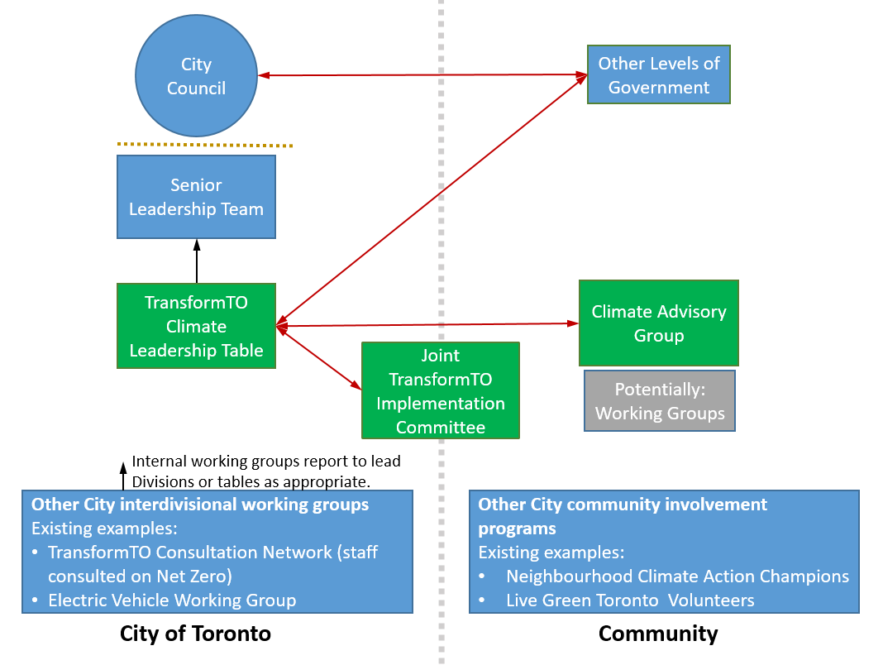

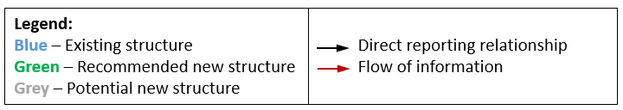

The Climate Advisory Group is:

- A non-legislative committee;
- Under the authority of the Executive Director of the Environment and Energy Division;
- Established to act in an advisory capacity. It may not direct City staff or make binding decisions on the Toronto government. Any advice or recommendations that require formal action or implementation by City of Toronto staff must be considered and approved by City Council.

The CAG will be led by two Co-Chairs. The role of the Co-Chairs will be to:

- Approve agendas in advance of the meetings;
- Chair meetings of the CAG; and
- Be the primary contact for the CAG and CAG Secretary.

Membership

It is estimated that the CAG will have approximately 20 Members, with the final number determined by the City based on interest and other factors. The CAG will be comprised of representatives of organizations and individuals. The CAG will include Members representing the sectors with the greatest emission-reduction in the coming years in order to meet Toronto's 2030 community-wide interim targets. Sectors can include buildings, energy, transportation, finance, and waste. The City will include representation from Indigenous communities, youth and equity-deserving groups such as the Black community.

The City will seek interested parties to participate on the CAG, and Members will be selected through the City's public appointment recruitment mechanism.

Qualifications for membership:

Members should collectively bring the following skills and experience to the CAG:

- Understanding, skills, expert knowledge or experience with a sector that emits GHGs in Toronto;
- Lived experience and an understanding of diverse neighbourhoods and communities;
- Knowledge in one or more areas of GHG emission reduction, climate resilience or climate planning;
- Reflect the cultural and social diversity of Toronto's community;
- A climate champion mindset and a desire to inform and mobilize sectors and communities to collectively achieve a future Toronto that is zero-carbon, equitable, healthy, prosperous and resilient.

Qualification for membership of all CAG Members must include approval by the City of Toronto.

Support for Members:

An honorarium will be made available to Members for each meeting they attend.

Support will be made available to Members in order to reduce barriers to participation. Support may include compensation for care of children or other dependents during meetings, transportation cost reimbursement, translation, accessibility supports, as well as cultural and other supports.

Term

Members will be appointed for a term of just over three years, ending December 31, 2025. This term is set to coincide with implementation of the TransformTO Net Zero Strategy Short-term Implementation Plan 2022-2025. CAG Members may be re-appointed for up to two additional 2.5-year terms. Membership on the CAG is voluntary and a public service.

CAG Members may not send a delegate.

Any Member wishing to resign from the CAG will submit their resignation in writing to the CAG Secretary. CAG Members who miss three (3) consecutive meetings without notifying a Co-Chair and the Secretary will be deemed to have resigned.

Meetings

- The CAG will meet a minimum of every three months;

- CAG support staff will set meeting dates in advance and send out agendas, materials and minutes of previous meetings in advance of meetings;

- Meetings will be participatory and will involve discussion and feedback. Attendance at meetings will be restricted to CAG Members, staff and guests as invited;

- [Time of day when meetings will be held and/or a location(s) where meetings will be held];

- CAG support staff will attend all CAG meetings and provide support as required;

- Each meeting of the CAG and any sub-groups will have an agenda and minutes. In the event that sub-group meetings are held without CAG support staff, agendas and minutes will be provided by the Co-Chairs to CAG support staff within one week of the meeting taking place.

Procedures

It is recommended that CAG meetings and business be conducted in accordance with the City of Toronto's Simplified Rules of Procedures for Advisory Bodies. (https://www.toronto.ca/legdocs/mmis/2019/di/bgrd/backgroundfile-131426.pdf)
(It should be noted that, in contrast to the Simplified Rules, the CAG does not provide its recommendations directly to a Council Committee or City Council. The CAG's reporting structure is outlined in the Mandate and Roles and Responsibilities sections of these Terms of Reference.)

In the event the CAG wishes to adopt alternative Rules of Procedures, it is recommended that the CAG's support staff consult Governance & Corporate Policy staff prior to final approval by the CAG.

For decision making, where possible Members will work towards consensus (a group decision-making process in which group Members develop and agree to support a decision in the best interests of the whole). In some circumstances it will be beneficial for the CAG to provide a diversity of opinions, and working towards consensus will not be necessary. Voting will only take place in exceptional circumstances.

The CAG Member Co-Chairs will be appointed or elected by the CAG at the first meeting of the CAG or after the seat is vacated. CAG Members wishing to serve as Co-Chair may nominate themselves, or have someone nominate them. If more than one Member is interested and one position is available, an election with a simple majority will be held.

Quorum

The minimum number of Members required to be present at a meeting in order to do business will be half of the regular membership plus one.

Committees

The CAG will have the authority to create working sub-groups. Any sub-groups will:

- Be established as deemed necessary by the CAG to fulfill its mandate effectively, with the approval of the Executive Director, Environment and Energy Division;
- Be made up of Members from the CAG;
- Be established from time-to-time to achieve a specific objective;
- Be time-limited; and
- Report through the CAG.

All CAG sub-groups do not have delegated authorities to make recommendations, provide advice to staff, or make requests of the CAG Secretariat staff, without the CAG's prior approval.

Appendix 1: Background

City Council Direction

At its meeting December 15 to 17, 2021, City Council endorsed the TransformTO Net Zero Strategy and Short-Term Implementation Plan 2022-2025 by adopting the report, TransformTO – Critical Steps for Net Zero by 2040 (report 2021.IE26.16).

The TransformTO Net Zero Strategy envisions a future Toronto that is zero-carbon, equitable, healthy, prosperous and resilient. Through the Strategy, City Council set a target of net zero greenhouse gas (GHG) emissions community-wide by 2040 and ambitious interim targets for 2030. City Council also directed staff to establish external advisory groups to provide valuable advice and a forum for collaboration.

Council decision Part 1h, resulting from Council adoption of the report, directed the Director, Environment and Energy:
to centre the voices of equity-deserving groups, including youth, civil society organizations, labour and workers' rights organizations, academia, Indigenous rights holders and urban Indigenous communities by:
1. establishing a Climate Advisory Group that centres the voices of equity-deserving groups, and includes youth, civil society organizations, labour and workers' rights organizations, and academia and work with Indigenous rights holders and urban Indigenous communities to share knowledge and learnings to inform climate action and reporting back to City Council on a terms of reference developed by city staff and the Climate Advisory Group.

Background Report

The following report resulted in the creation of the Climate Advisory Group:
TransformTO – Critical Steps for Net Zero by 2040 (report 2021.IE26.16).

The report can be found on the City's website at:
http://app.toronto.ca/tmmis/viewAgendaItemHistory.do?item=2021.IE26.16

