**Date:** July 15, 2023

**Applicant:** John Smith, Project Manager

ABC Environmental Ltd.

123 First Street,

Toronto, ON M1N 2O3

**Recipient:** Jane Doe

Permits & Enforcement

Transportation Services, City of Toronto

456 Yonge Street, Toronto, ON M4N 506

**Subject**: **City of Toronto Cut Permit Application - Letter of Intent for the Installation of Monitoring Wells at 789 Main Street**

Dear Jane,

The following Letter of Intent is provided to support the application for a City of Toronto Cut Permit to undertake additional environmental characterization work in the vicinity of 789 Main Street and is required information for Transportation Services. Please see appendices for supporting documentation.

**1.0 Brief Background**

The proposed work area is located adjacent to our client’s property at 789 Main Street and includes Main Street right-of-way from Oak Avenue to the entrance to the fuel outlet (the Site). The proposed work is related to ongoing environmental work being conducted on behalf of our Client and is intended to further characterize petroleum hydrocarbon (PHC) impacts at the Site in accordance with Section 4.1 of the Technical Standards and Safety Authority (TSSA) Environmental Management Protocol for Fuel Handling Facilities Sites in Ontario. The monitoring and sampling program is part of the Site's Contaminant Management Plan (CMP) that TSSA has approved and outlined in previous annual reports provided to the City of Toronto by our Client (see Attachment F – Supporting Regulatory Documents).

**2.0 Scope of Work and Schedule**

The proposed scope of work includes the advancement of twelve (12) boreholes to a maximum depth of ten (10) metres below grade (mbg); seven (7) of which will be advanced within the roadway, with the remaining five (5) advanced within the sidewalk, or immediate adjacent boulevard along the north side of the roadway. Up to three (3) boreholes will be completed as monitoring wells with flush-to-grade aluminum casings with a diameter of 0.2 metres within the right-of-way (see Attachment B –Site Plan Drawing & Attachment C – Cross-Sectional Plan Drawing). Up to nine (9) smaller diameter (0.05 meters) boreholes will be used to advance high-resolution site characterization tooling, such as a Laser Induced Fluorescence probe, to further characterize and define zones of contamination, and will not be completed as monitoring wells. The smaller diameter boreholes will be backfilled with bentonite chips to mitigate potential migration of contamination within the borehole annulus, and the surface will be restored with the cored keyholes or quickset concrete. The proposed locations are determined based on the 2022 Annual Report for groundwater and soil analysis to further delineate the contaminants of concern within the City's right-of-way in the direction of historical groundwater flow. Borehole locations identified (Attachment B & C), are subject to change pending receipt of public utility locates or based on observations made during the drilling program.

Four (4) existing monitoring wells in the eastbound curb lane and one existing well in the westbound passing lane (see Attachment B) are intended to be re-drilled and re-installed as part of this work. No new road cuts will be required for these reinstallations.

Work will be performed under the supervision of our consultant, Environmental Testing Inc., to monitor the groundwater levels, collect groundwater samples to further characterize the PHC impacts at the Site, and their subcontractor, Environmental Drilling Inc. will be responsible for the drilling and installing of boreholes and monitoring wells. The first phase of this work is tentatively scheduled to be completed over a 5-day period from October 30 to November 30, 2023, and will include the nine (9) smaller diameter boreholes (see Attachment C). Drilling of larger diameter boreholes with monitoring well installations will be scheduled 1 to 2 months later (see Attachment G – Schedule). Any change in schedule will be identified to the City of Toronto.

**3.0 Closing**

This letter summarizes our intent to complete work on behalf of Petroleum Inc., which requires the application of a City of Toronto Cut Permit. We trust that this letter and supporting material satisfies the requirement for the Cut Permit.

Any change in work scope will be identified to the City of Toronto if applicable. If further information is required to support this application, ABC Environmental Ltd. will revise this application.

Sincerely,

John Smith

John Smith, Project Manager

ABC Environmental Ltd.

123 First Street,

Toronto, ON M1N 2O3

Per: Alice Jones, Manager, Petroleum Inc.

456 Second Street, Toronto, ON M2O 3P4

Alice.Jones@PetroleumInc.com

647-246-9753

Submitted Separately: [As per Contents of the Letter]

Attachment A Cut Permit Application Form

Attachment B Site Plan Drawing

Attachment C Cross-Sectional Plan Drawing

Attachment D Certificate of Insurance

Attachment E Traffic Control Plan

Attachment F Supporting Regulatory Letters/Documents

Attachment G Schedule (in Gantt chart or Table format)

|  |  |
| --- | --- |
| *Date of Revision:* | *February 05, 2024* |
| *File Name:* | *Letter of Intent_Sample Letter_v4_20240205.docx* |
| *For Comments/Questions:* | *Transportation_CROWMP_Admin@toronto.ca* |

**Attachment B: Site Plan Drawing**

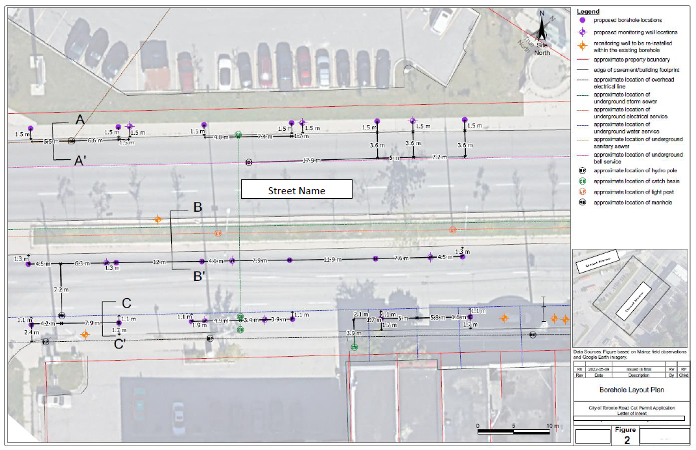

**Attachment C: Cross-Sectional Plan Drawing**

